This is a copy of the Blind Match Racing World Championship Notice of Race published in PDF format by World Sailing on 7th May 2018. It is being supplied as a Word Document for accessibility reasons and the content is an exact duplication of the PDF. However, the official document is the PDF version.

1 ORGANISING AUTHORITY
The Organising Authority (OA) will the Royal Northern & Clyde Yacht Club in conjunction with World Sailing.

2 VENUE
The venue will be Rhu, Dumbartonshire, Scotland, UK

3 EVENT GRADING
The event has applied for World Sailing Grade WC.

This grading is subject to review by World Sailing. The event may be re-graded when there is clear reason to do so.

4 PROVISIONAL PROGRAMME
4.1 Schedule
(a) Race office open from 1000 on 1st Sept.
(b) Registration from 1st Sept.1000 until 1700.
(c) Ophthalmological examinations start on 1st Sept 1000 until 1700.
(d) Practice from 1200-1700 on 1st Sept. and 0900-1500 on 2nd Sept.
(e) First briefing at 2nd Sept.1600.
(f) First meeting with umpires following the first briefing.
(g) Opening Ceremony on 2nd Sept. at 1800.
(h) Racing days from 3rd Sept. to 7th Sept.
(i) Time of the first attention signal each day will be 0950.
(j) The latest time for an attention signal on the last day of racing will be 1400.
(k) Prize giving on 7th Sept. at 1830.
4.2 Unless excused by the OA, attendance at the following is mandatory:
(a) Initial briefing.
(b) Daily briefing.
(c) Prize giving.

4.3 Competitors attention is drawn to the planned pre-event race clinic (28-30th August), details of which are available at www.rncyc.com/bmrwc2018-preevent-clinic

5 SKIPPERS ELIGIBILITY
5.1 A team shall conform to the requirements for the ‘Three-Person Keelboat’ as in Paragraph 3.4 of Appendix 1 to Part 1 of the Para World Sailing Race Management Manual 2017-2020 – see http://sailing.org/tools/documents/FinaldraftRMM270318V2-%5b23696%5d.pdf
5.2 Only teams invited by the OA will be eligible to enter this event. To apply for an invitation, a team must complete the entry form on the event website www.rncyc.com/bmrwc2018 by 25th May.

All competitors in a team:
(a) shall be IBSA classified, provable by Blindness Grading Form completed and signed by an accredited Ophthalmologist issued within 6 months of the start of the event;
(b) shall meet the eligibility requirements of World Sailing regulation 19.2;
(c) shall be affiliated to a World Sailing Member National Authority;
(d) shall have an World Sailing Sailor ID code;
(e) Shall be from a country that is a Country Member of Blind Sailing International or be an Associate Member of Blind Sailing International.
5.3 The registered skipper shall helm the boat at all times while racing, except in an emergency.
5.4 Invitations to entered skippers will be at the discretion of the OA in conjunction with World Sailing and Blind Sailing International, by 25th May. To remain eligible a skipper shall confirm acceptance of the invitation in writing, (e-mail is acceptable) to be received by the date specified on the letter of invitation issued by the OA, and payment of the entry fee (see NoR 6.2 below).
5.5 All competitors shall obtain an World Sailing Sailor ID by registering online at www.sailing.org/isafsailor. Skippers shall inform the OA of their World Sailing Sailor ID at registration.
5.6 World Anti-Doping Code Regulations will apply. Competitors are reminded of the World Sailing Rules and Regulations concerning the use of banned methods and substances, which are contained in the World Sailing Anti-Doping Code. Drug testing may take place during this event. Additional information is available at https://www.wada-ama.org.
5.7 Competitors under 18 years of age shall present a signed and completed parent (guardian) consent and declaration form at registration. The forms can be downloaded from the event website: www.rncyc.com/bmrwc2018
5.8 Late entries, after 25th May, will be accepted at the discretion of the OA, in conjunction with World Sailing and Blind Sailing International.
5.9 World Sailing Eligibility shall apply. Each competitor shall be registered as a World Sailing Sailor on the World Sailing website. Unless otherwise approved by the IOC or the World Sailing Board in accordance with Regulation 19.12, each competitor shall be a national of the country of the Member National Authority (MNA) which enters the boat or endorses the person in charge (as defined by RRS 46). Each competitor shall present proof of their nationality or the approved waiver when requested. Regulation 19.12 does not apply to crew substitutes.
5.10 A recommendation to remove the eligibility criteria described in NoR 5.9 above has been submitted to the World Sailing board. If this is subsequently passed, then NoR 5.9 and 5.10 will be deleted in an amended NoR.

6 ENTRIES
6.1 Entering
(a) The team shall be entered on completion of registration, ophthalmological examination, and the payment of all fees and deposits. All payments shall be made by credit card/local currency.
(b) A valid ophthalmological certificate for each one competitor shall be produced at the time of registration
6.2 Entry Fee
A non-refundable entry fee of £950 (GBP) shall be paid by 10th June.

6.3 Withdrawal
When a skipper accepts an invitation and later withdraws within two months of the event or leaves the event before the end without written approval from the OA, a zero score may be applied to their Ranking points for that event by World Sailing. (World Sailing Regulation 27.2)

6.4 Damage deposit
(a) An initial damage deposit of 250GBP shall be paid at registration, unless extended by the OA. This deposit is the maximum payable by the skipper as a result of any one incident.
(b) If a deduction from the damage deposit is decided by the OA, it may require that the deposit be restored to its original amount before the skipper will be permitted to continue in the event.
(c) Any remaining deposit after the event will be refunded within 10 days after the event.

7 RULES
7.1 (a) The event will be governed by the rules as defined in the RRS, including Appendix CBS (2016) and the World Sailing Race Management Manual for Para-Sailing Events 2017-2020. (Originally published, May 2017), including Appendix 1 - Blind Sailing Rules of Race Management
(b) The rules for the handling of boats will apply and will also apply to any practice sailing and sponsor races. Class rules will not apply.
(c) The RYA prescriptions and RYA Racing Charter shall apply, which shall be posted on the official notice board.
7.2 Major Alterations to the RRS
(a) Add to RRS 41: (e) help to recover from the water and return on board a crew member, provided the return on board is at the approximate location of the recovery.
(b) RRS CBS8.6 and CBS6.3 will be changed in the sailing instructions.
7.3 An IJ will be appointed, and approved by the NA in accordance with RRS Appendix N.

8 BOATS AND SAILS
8.1 The event will be sailed in Sonar type boats.
8.2 5 boats will be provided.
8.3 The following sails will be provided for each boat: Mainsail, Foresail.
8.4 Boats will be allocated by draw, either daily or for each round as decided by the race committee.

9 CREW (INCLUDING SKIPPER)
9.1 The number of crew (including the skipper) shall be three. All registered crew shall sail all races.
9.2 When a registered skipper is unable to continue in the event, the IJ may authorise an original crew member to substitute.
9.3 When a registered crew member is unable to continue in the event, the IJ may authorise a substitute, a temporary substitute or other adjustment.
9.4 All competitors may be subject to ophthalmological examinations at any time during the event. Competitors shall cooperate with the classification staff as requested.

10 EVENT FORMAT
10.1 Skippers will be seeded into a round robin or divided into groups based on a draw
10.2 The event will consist of the following stages:
Stage 1 -
Full round robin(s) or round robin(s) in groups (depending on entrant numbers).

Stage 2 -
Knock-Out Series which may consist of Quarter-finals, Semi–finals and/or Finals (depending on the number of entrants) with each Series being scored first to score 2 points.
10.3 The RC may change the format, terminate any stage or the event when, in its opinion, it is impractical to attempt to hold the remainder of matches under the existing conditions or in the remaining time scheduled. Early stages may be terminated in favour of later stages.

11 COURSE
11.1 The course will be windward/leeward with starboard roundings, finishing downwind.
11.2 The intended course area will be The Firth of Clyde or the Gareloch. The race areas are shown at Addendum A. An Admiralty chart of the racing area will be available for inspection at registration.

12 ADVERTISING
12.1 As boats and equipment will be supplied by the Organising Authority, World Sailing regulation 20.4 applies. Each boat will be required to display advertising as supplied by the OA.
12.2 (deleted)
12.3 Boats shall not be permitted the right to protest for breaches of any rules regarding advertising (amends RRS 60.1).

13 PRIZES
13.1 The winning team will be awarded the Title of World BMR Champion. World Sailing medals will be awarded to the 1st, 2nd and 3rd teams.
13.2 Additional prizes will be awarded at the discretion of the OA.

14 MEDIA, IMAGES and SOUND
14.1 If required by the OA, Television personnel and equipment (or dummies) supplied by the OA shall be carried on board while racing.
  - Competitors shall not interfere with the normal working of the OA supplied media equipment.
14.3 The OA have the right to use any images and sound recorded during the event free of any charge.
14.4 Personal details, such as the telephone numbers or email addresses of competitors, shall be used only for the purposes of communicating with competitors on matters concerning the event. Names, affiliations and likeness of competitors may be released for the purposes of publicity

15 COACH BOATS
15.1 The OA will provide ferry boats to put coaches on or off race boats. A hotel boat will kept on the race course area from which coaches may observe racing.
15.2 Any coach boats obtained by competitors shall conspicuously display identification of the team being coached. A coach boat is any boat that is under the direction or control of a person gathering information or giving material support for the benefit of particular competitors either on the water or off.
15.3 Any interference by a coach boat with the racing or event organisation may result in a penalty applied at the discretion of the IJ to the associated skipper or team

16 OTHER REQUIREMENTS
16.1 Each team is requested to provide a national flag approximately 150cm x 90cm for display from flagpoles.

17 RISK STATEMENT (DISCLAIMER)
Rule 4 of the Racing Rules of Sailing states: "The responsibility for a boat's decision to participate in a race or to continue racing is hers alone."
Sailing is by its nature an unpredictable sport and therefore inherently involves an element of risk. By taking part in the event, each competitor agrees and acknowledges that:
(a) They are aware of the inherent element of risk involved in the sport and accept responsibility for the exposure of themselves, their crew and their boat to such inherent risk whilst taking part in the event;
(b) They are responsible for the safety of themselves, their crew, their boat and their other property whether afloat or ashore;
(c) They accept responsibility for any injury, damage or loss to the extent caused by their own actions or omissions;
(d) Their boat is in good order, equipped to sail in the event and they are fit to participate;
(e) The provision of a race management team, patrol boats and other officials and volunteers by the event organiser does not relieve them of their own responsibilities;
(f) The provision of patrol boat cover is limited to such assistance, particularly in extreme weather conditions, as can be practically provided in the circumstances;
(g) It is their responsibility to familiarise themselves with any risks specific to this venue or this event drawn to their attention in any rules and information produced for the venue or event and to attend any safety briefing held for the event;

18 INVITATIONS
Entries will only be accepted from invited skippers. If you wish to be invited please register your request for an invitation as soon as possible with the OA by completing the entry form on the event website.

FURTHER INFORMATION
Royal Northern & Clyde Yacht Club | Telephone: +44 (0) 1436 820322
The Clubhouse | Email: blindmrworlds2018@rncyc.com
Rhu, G84 8NG | Event Website: www.rncyc.com/bmrwc2018
United Kingdom

References:
Para World Sailing Race Management Manual (RMM) 2017-2020
http://sailing.org/tools/documents/FinaldraftRMM270318V2-%5b23696%5d.pdf
Appendix CBS for Blind Match Racing (2016)
http://www.sailing.org/tools/documents/AppendixCBSCouncilApprovedNov2017-[23938].pdf
Addendum A
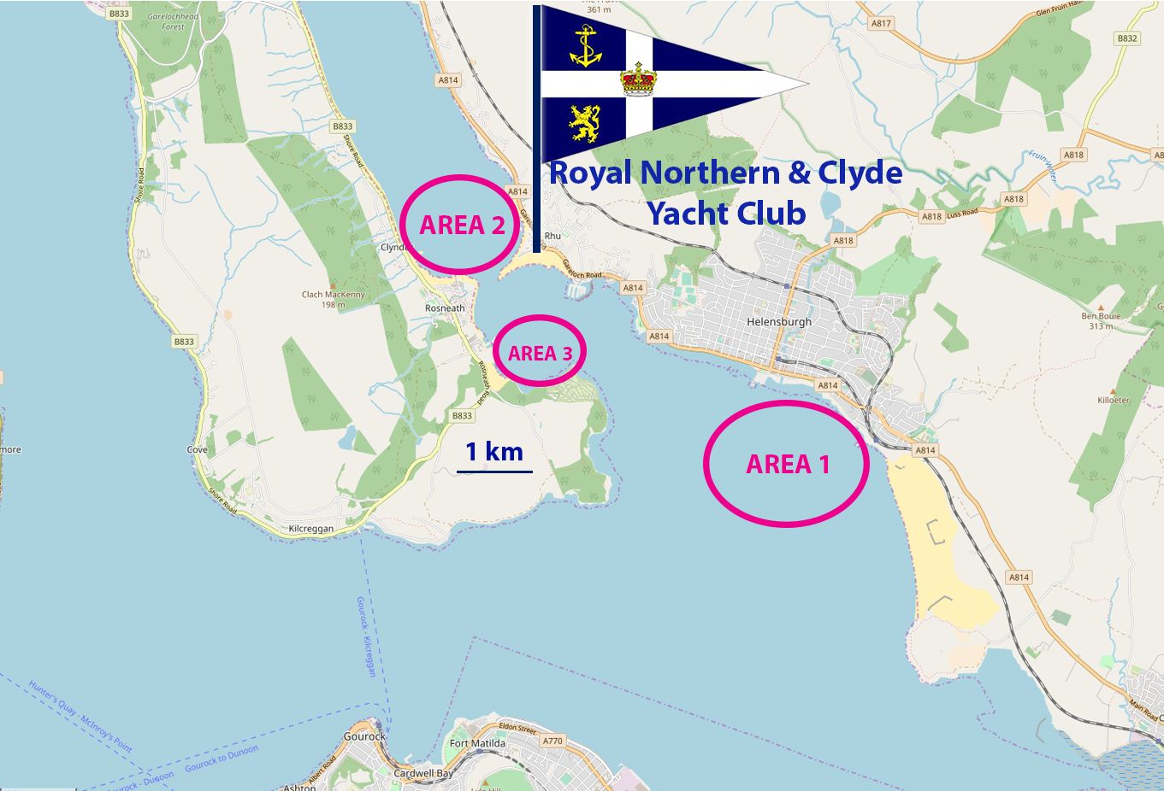

Map © OpenStreetMap contributors

