This is a copy of the Blind Match Racing World Championship Notice of Race Amendments published in PDF format on 26th July 2018. It is being supplied as a Word Document for accessibility reasons and the content is an exact duplication of the PDF. However, the official document is the PDF version.

Amendments to Notice of Race (cumulative) - 26th July 2018

5.2 (a) ​shall be IBSA classified, provable by Blindness Grading Form completed and signed by an accredited Ophthalmologist issued within 12 months of the start of the event;
5.4 Invitations to entered skippers will be at the discretion of the OA in conjunction with World Sailing and Blind Sailing International, by 25th May. To remain eligible a skipper shall confirm acceptance of the invitation in writing, (e-mail is acceptable) to be received by the date specified on the letter of invitation issued by the OA, and payment of the entry fee (see NoR 6.2 below).

5.8 Late entry is stated to be after 25th May

5.9 Deleted

5.10 Deleted
12.2 Deleted

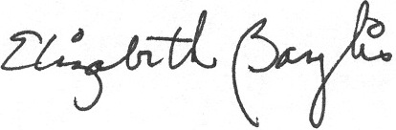
Signed: Liz Baylis
World Sailing Technical Delegate

