Chapter 1…The Pre-Start

The Pre-Start is unique to Match Racing, and requires much study and practice to become proficient. The boats have four minutes to fight each other for the better position off the starting line, and much can happen (good and bad) in those short four minutes.

PRE-START HOMEWORK
The higher the quality and amount of information you have about the starting line, the more precise and effective your tactics will be at the start. The chart below shows the various “lines” you need to know before the pre-start begins. Your tactics will vary depending on where you are in the starting area.

Information you need to gather before entering the Pre-Start:

- angle of line to the wind (which end is more upwind, if either)
- time it takes to sail from one end of the starting line to the other (usually around 25 seconds)
- laylines to each end (which will build in current effect)
- at full speed and at down speed (esp. the starboard layline to the Pin)
- line sights
- through both ends sighting along the line
- through both ends, sighting along the laylines to each end
- wind information (direction and velocity patterns)
- time it takes to do one “circle”
- What end and match number you are, and who you are racing next

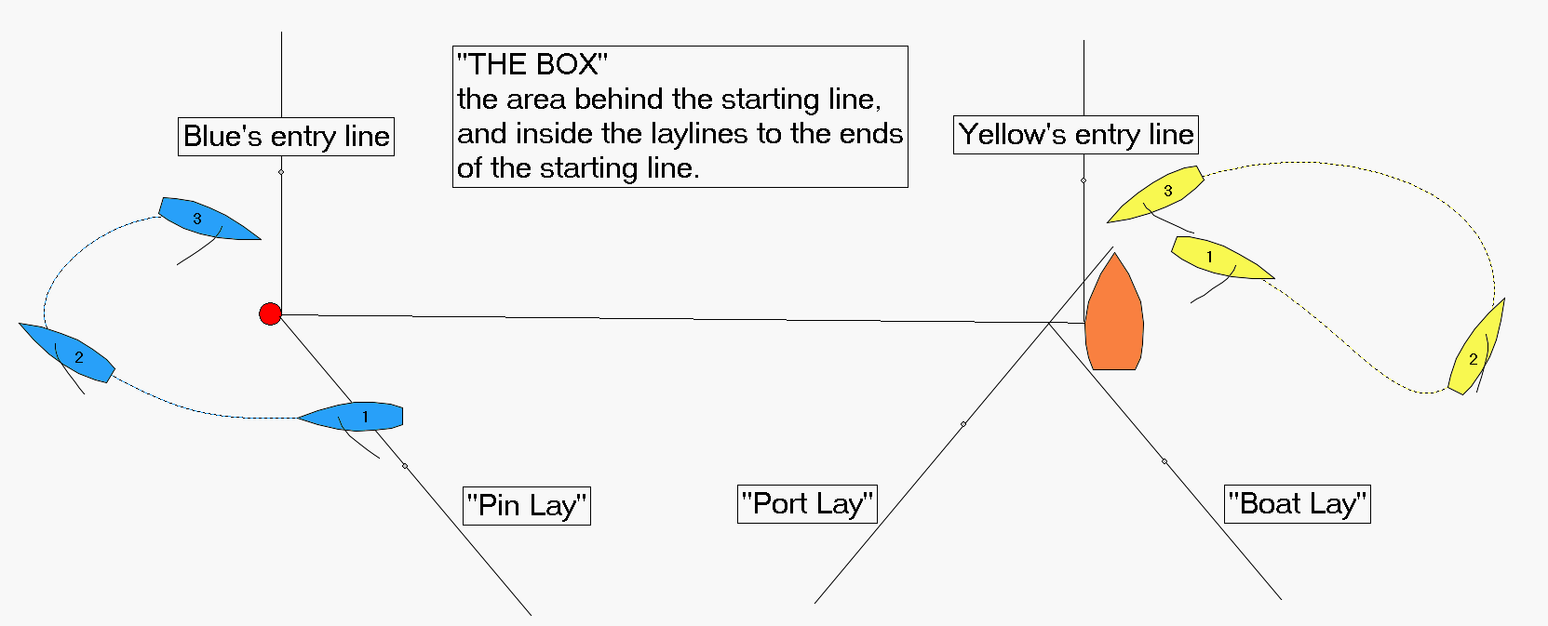

PRE-START GOALS (what’s the Point of the Pre-start?)
The point of the Pre-Start is to start the race in a better position than your opponent to take advantage of the first windshift and win the First Cross, or to get to the favored side of the first beat in a stronger position than your opponent; in other words, to get your First Choice. If you can start directly ahead of your opponent, or your opponent starts with a penalty, that is a bonus. Of course, it is your goal to not receive a penalty, nor to start directly astern of your opponent as well.

PRE-START PLAN (what is your First Choice?)
Before entering the Pre-Start, you have one basic decision to make: which side of the other boat do you want to start on (their Right or Left?). This will be determined by:

- which side of beat is favored (wind, current, etc.)
- is one of the ends of the starting line more upwind than the other
- how windy is it

Here are some general rules when making this decision:

- start to RIGHT of opponent when:
- the line is square or up to 5 degrees pin end favored
- it is not clear which side is favored, or the right is favored
- it is over 8 knots and pretty flat water
- it is a fairly steady wind
- you think you are faster and/or a stronger match racer than your opponent

- you can consider starting to LEFT of opponent when:
- you can start on opponent’s lee-bow with enough speed or bow-out to be able to force them to tack soon after the start, and then tack to windward and HANG on port tack all the way to the starboard layline

- you can start on opponent’s lee-bow and eventually cause them to tack (maybe because of a left-hand windshift or more favorable current) and you want to defend the left side because you are confident you will be able to eventually CROSS them when on port tack

- the pin end of the starting line is heavily favored (10 degrees or more), meaning you will be able to easily CROSS them at some point soon after the start

- it is under 8 knots and/or choppy

THE FOUR STARTING POSITIONS

- Close to Leeward – the leeward boat is close enough to the windward boat so that windward boat is forced to tack away before port layline to the windward mark

- Windward with a Gap – the windward boat has enough space (gap) between herself and the leeward boat to be able to live there all the way to the port layline to the windward mark

- Split Start – the two boats start on opposite tacks, usually at opposite ends of the starting line

- The Crush! – when one boat starts directly in front of the other boat

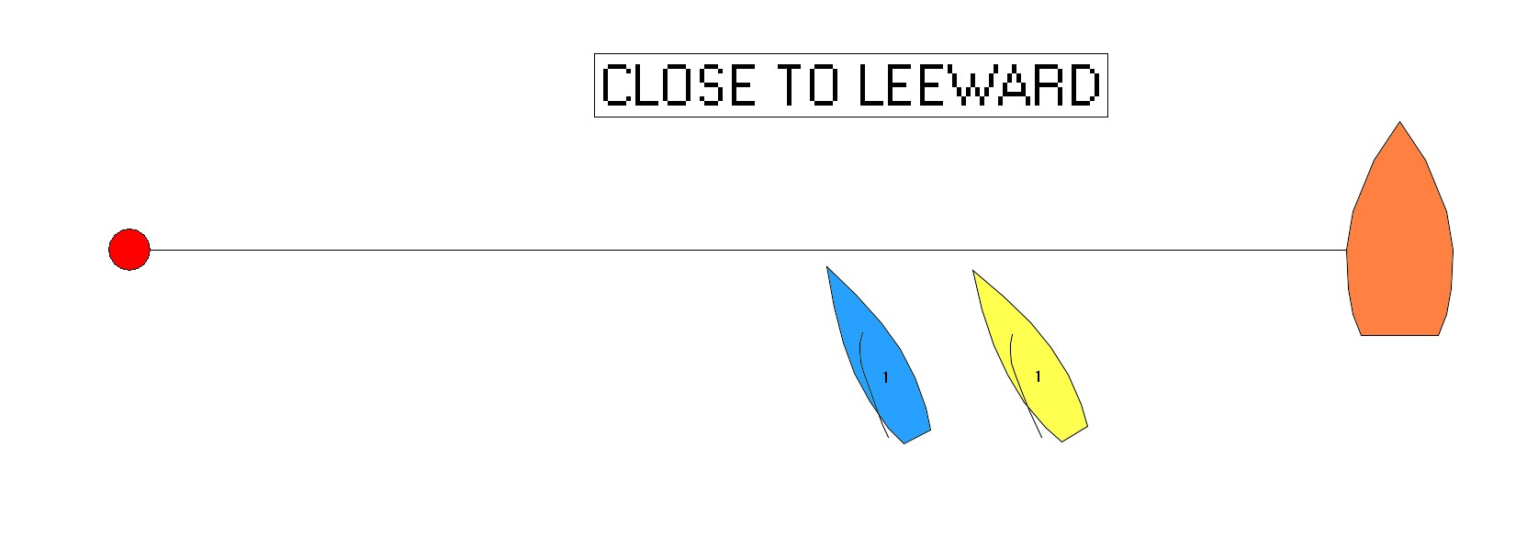
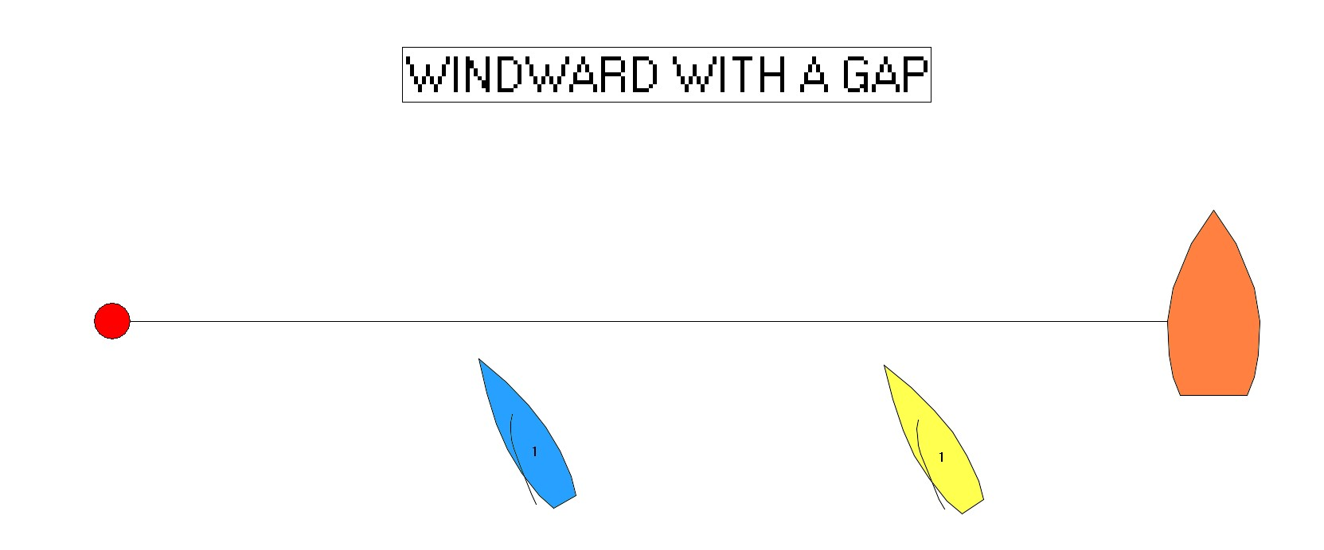
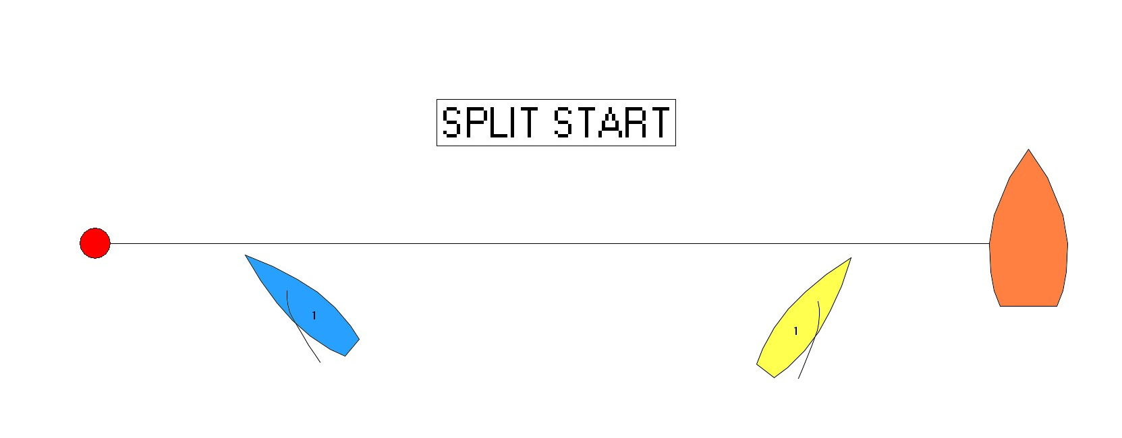
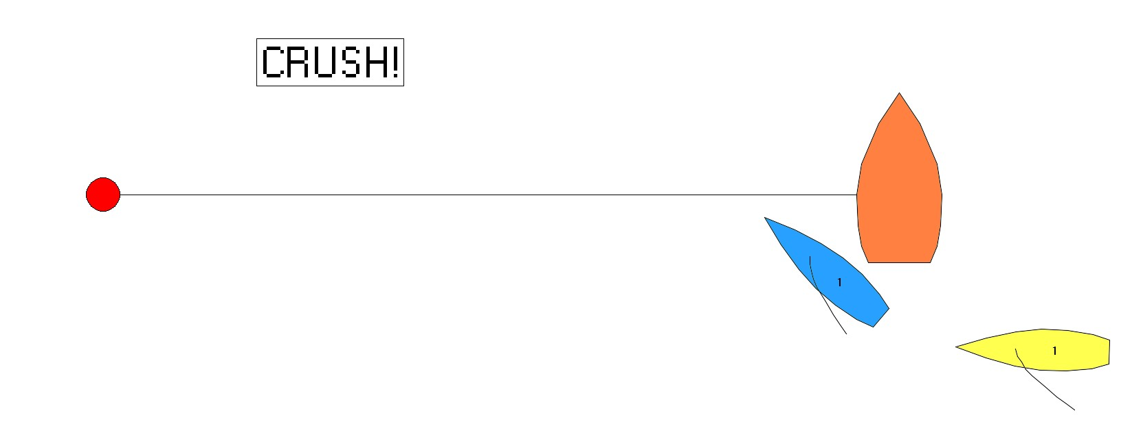

When you want to start to the RIGHT of your opponent (and assuming the start is not a Crush):

Windward with a Gap is the strongest position. The Split Start, with you on port tack, is the next strongest. Close to Leeward, with you as the windward boat, also gets you the right but is the weakest. The reason is that it ends up looking like the Split Start but the tack to port is done after the start and so you will have done one more tack than your opponent when the boats converge for the first time after the start.

When you want to start to the LEFT of your opponent (and assuming the start is not a Crush):

Close to Leeward, with you as the leeward boat, is the strongest position. The Split Start with you on starboard tack is the only other option.

PRE-START GLOBAL STRATEGIES / THOUGHTS
These are some general suggestions that almost always apply. If you keep these in mind, it will keep you out of major trouble:

- be to RIGHT of opponent until about 2:00 to start; then be to LEFT
- when near opponent, get off STARBOARD TACK as QUICKLY as possible; never extend on starboard
- “circle” in OVALS, extending on port tack each time to build speed
- come out of circle on BEST SPEED-BUILD ANGLE (will vary with boats, breeze and situation)
- have constant communication about:
- location in starting area (where relative to laylines, etc.)
- time to ends or middle of line (when sailing AWAY FROM the line)
- time to start
- time to burn (difference between time to start and time to line) when sailing TOWARDS the line

THE THREE PHASES OF THE MATCH RACE PRE-START
The Pre-Start begins at 4:00 minutes to start. It can be broken down into three distinct phases.

Phase 1) Entry & Initial Meeting Phase (from 4:00 ~ 3:00 min. to start)

Phase 2) The Middle Phase (from ~ 3:00 - 1:30 min. to start)

Phase 3) The Final Approach (from ~ 1:30 min. – 0:00 to start)

Each phase has its own objectives, strategies and tactics. Here are some thoughts on each Phase.

Phase 1) Entry & Initial Meeting Phase (from 4:00 ~ 3:00 min. to start)

To “enter” you have to be outside your pre-assigned end of the starting line at 4:00 to start, and then completely cross the starting line from the course side (windward side) to the other side between 4:00 and 2:00 to start. The Blue boat enters at the Pin end of the starting line on port tack, and the Yellow boat enters at the Committee Boat end on starboard tack.

OBJECTIVE for Entry

1) Enter (sail past your end) within three (3) seconds after 4:00 minutes to start, at full speed.

2) If you are not outside your end at 4:00, or do not first cross the starting line from the course side to the other side between 4:00 and 2:00, you will receive a penalty from the umpires. Once you get a penalty for one or both of these things, you no longer need to comply with those requirements.
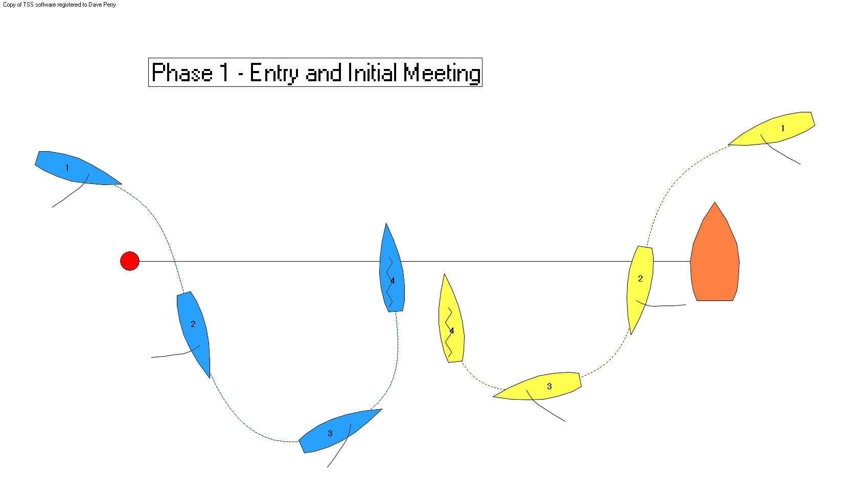
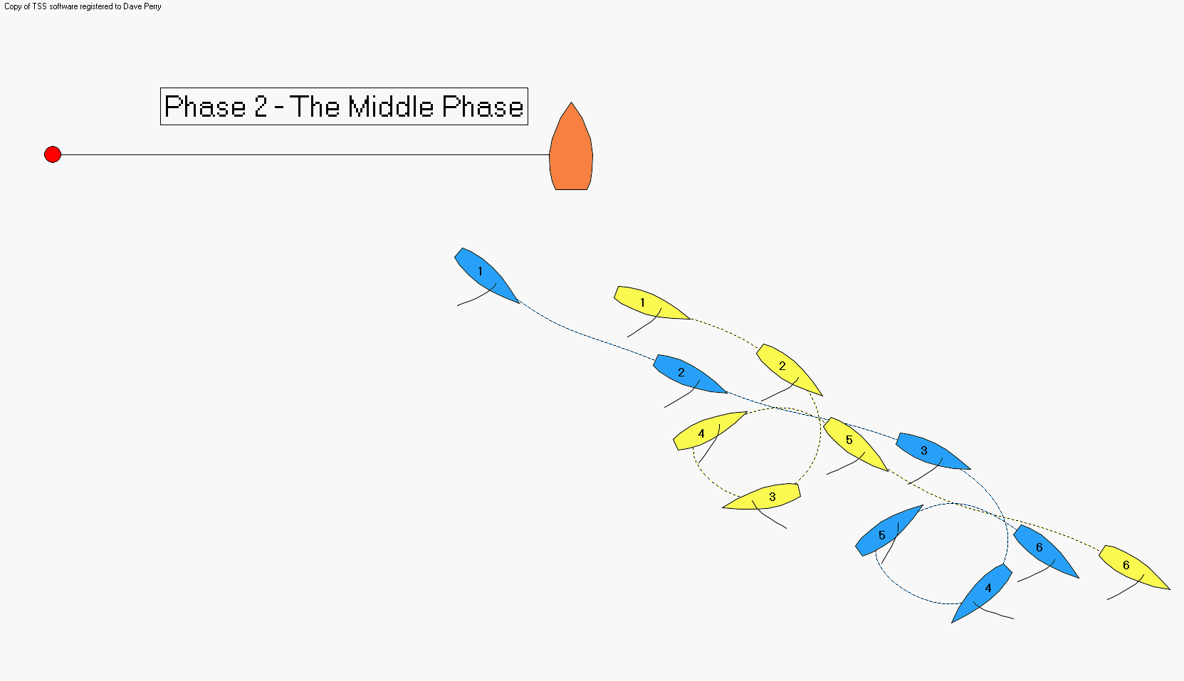
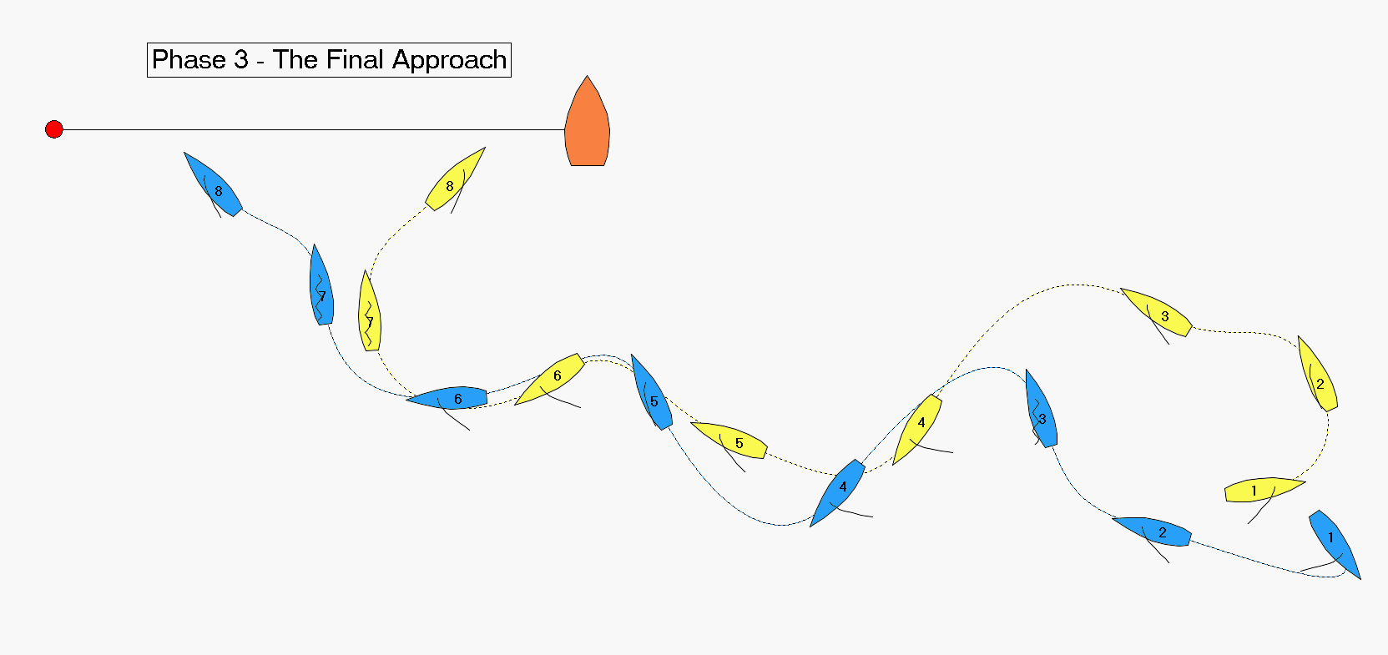
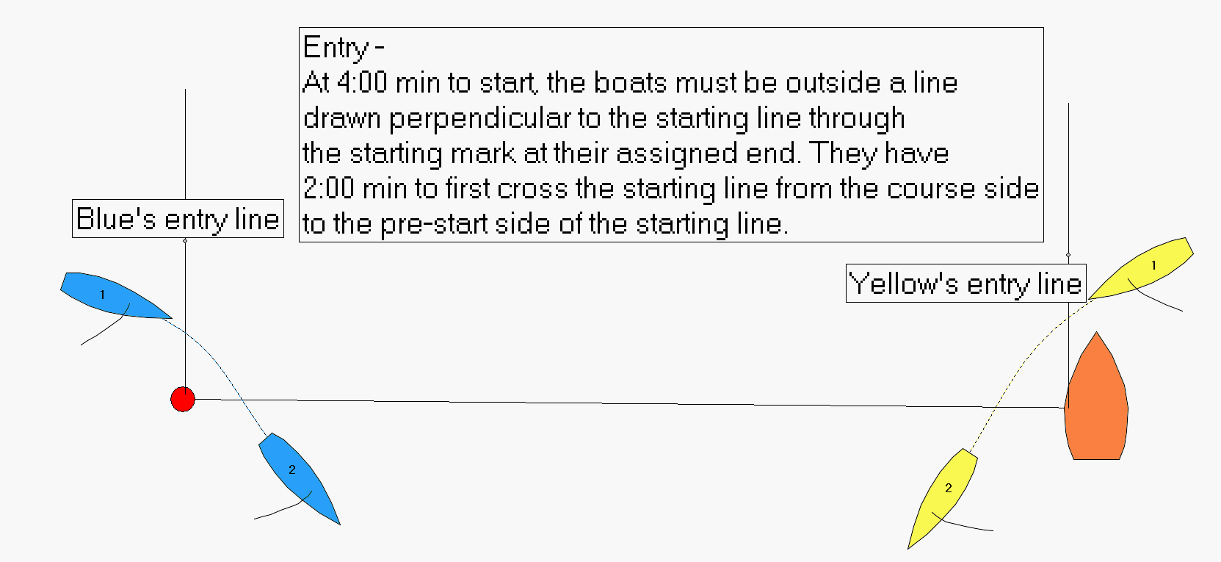
STRATEGIES & TACTICS for Entry
- Do timed loops (figure 8’s with no gybes); be at your end with between 1:00 minute and 40 seconds to start, sailing away from the line on a beam reach. Tack when you have sailed for exactly half the time from when you were at your end until you enter (4:00 min. to start). For instance, if you were at your end at 4:50 (50 seconds to enter), tack at 4:25.

- After passing your end, bear off to a broad reach at full speed (vang on, jib sheet outboard to the max, etc.)

- be sure your stern completely crosses the starting line; you have two minutes after the prep signal to do this (but do it as soon as possible)

- look over at the other boat to see if she is:
- late on her entry
- slower or faster than you
- crossing or not crossing you

- decide what opening move you are going to make

OBJECTIVE for Initial Meeting
- Starboard Entry (Yellow)
- Gain control of the port entry boat (Blue) – Keep to Blue’s right
- Keep control of the port entry boat (Blue) – Keep to Blue’s right
- Don’t end up being controlled by port entry boat (Blue)

- Port Entry (Blue)
- Avoid being controlled by starboard entry boat (Yellow) - Get to Yellow’s right
- Escape the control of the starboard entry boat (Yellow) - Get to Yellow’s right
- Gain control of the starboard entry boat (Yellow)

GLOBAL thoughts for Initial Meeting:
- Don’t get a penalty!

- Exit this phase in a neutral or controlling position to begin the Middle Phase of the Pre-Start:
- 3 to 4 boat lengths ahead of the other boat on port tack (you are the “leading boat on port tack”), or
- less than two lengths behind the other boat on port tack (you are the “trailing boat on port tack”)

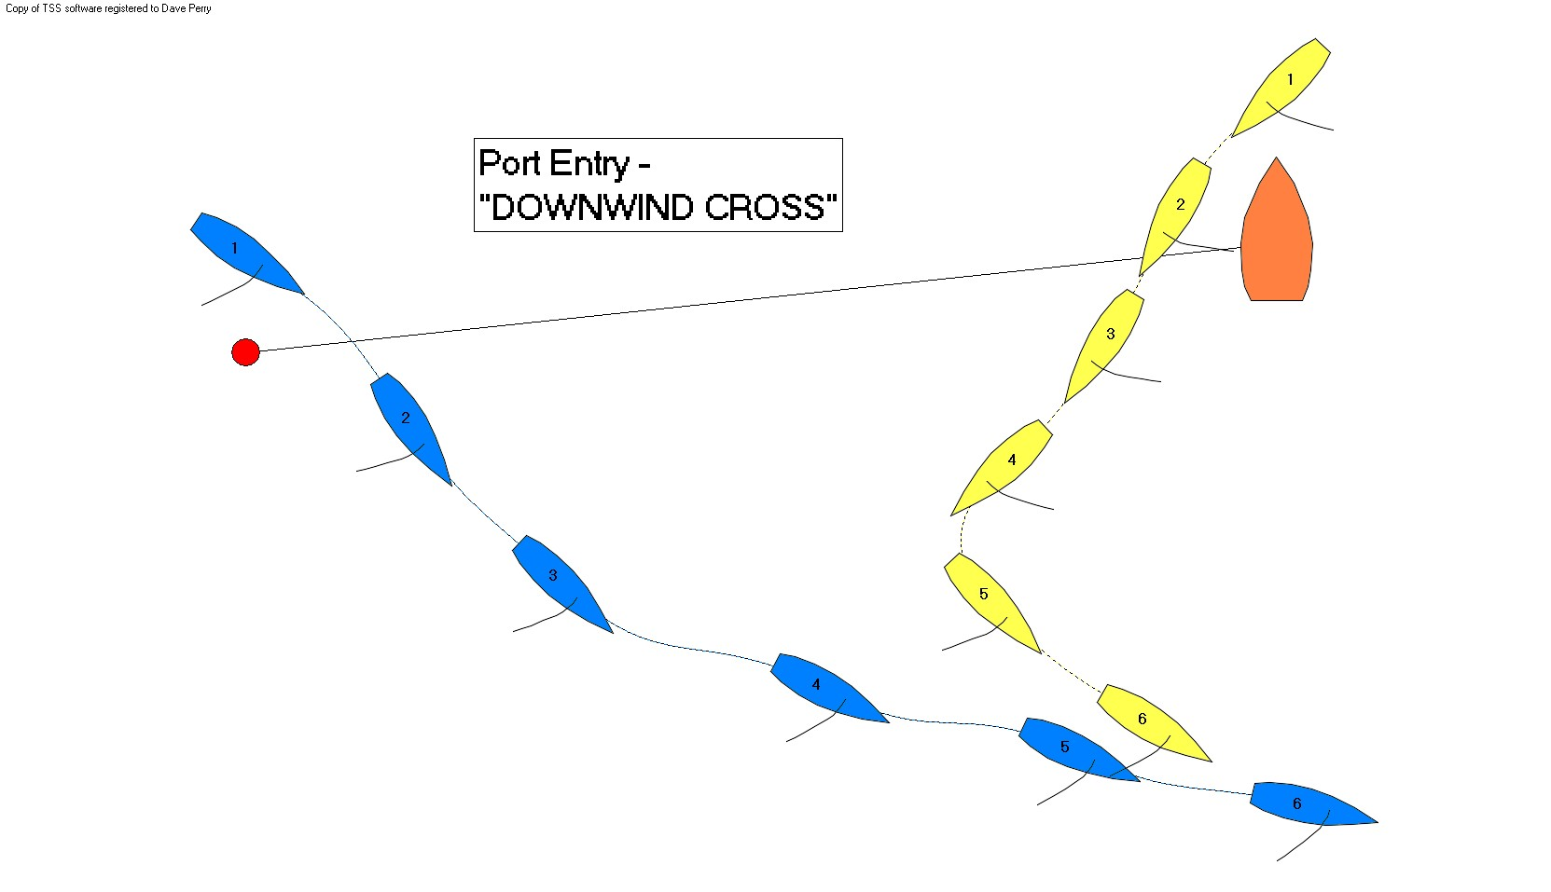
STRATEGIES & TACTICS for Initial Meeting

The Blue Boat (entering from the Pin End)

- If the Pin End is more downwind than the Boat End, or Yellow is late or slow at her entry, Blue can often cross downwind of Yellow (Downwind Cross).

  - This avoids the Dial-Up, but often results in Yellow gybing into a strong, often controlling, position astern of Blue.
  - To see if you are crossing, watch the land in front of Yellow’s bow; if more is appearing, you are crossing. But remember that Yellow can turn down farther if needed.
  - After crossing, and after Yellow has gybed, stay low; do not head up at all. Consider doing a circle to open up more space between you and Yellow.
  - When in doubt about crossing, take the Dial-Up (to avoid having to do a Dial Down).

- If the Pin End is more upwind than the Boat End, or Yellow is late or slow at her entry, Blue can often cross upwind of Yellow (Upwind Cross). (See Starboard Entry Tack & Follow, pg. 15, for Upwind Cross figure.)

- Once Blue has completely entered (crossed the starting line), she should luff quickly to a close-hauled course.
- If she crosses Yellow, Yellow will tack to leeward or astern of her. If Yellow tacks too soon, Blue may be able to bear away sharply and set up astern of Yellow in a controlling position.
- If Yellow tacks to leeward or astern and Blue cannot get astern of her, Blue needs to press down and sail over the top of Yellow. Blue’s goal is to pass as close to windward of the Race Committee Boat as she can, and then begin her Escape maneuver from there.

- If Blue cannot cross Yellow downwind or upwind, there will be a Dial-Down or a Dial-Up.

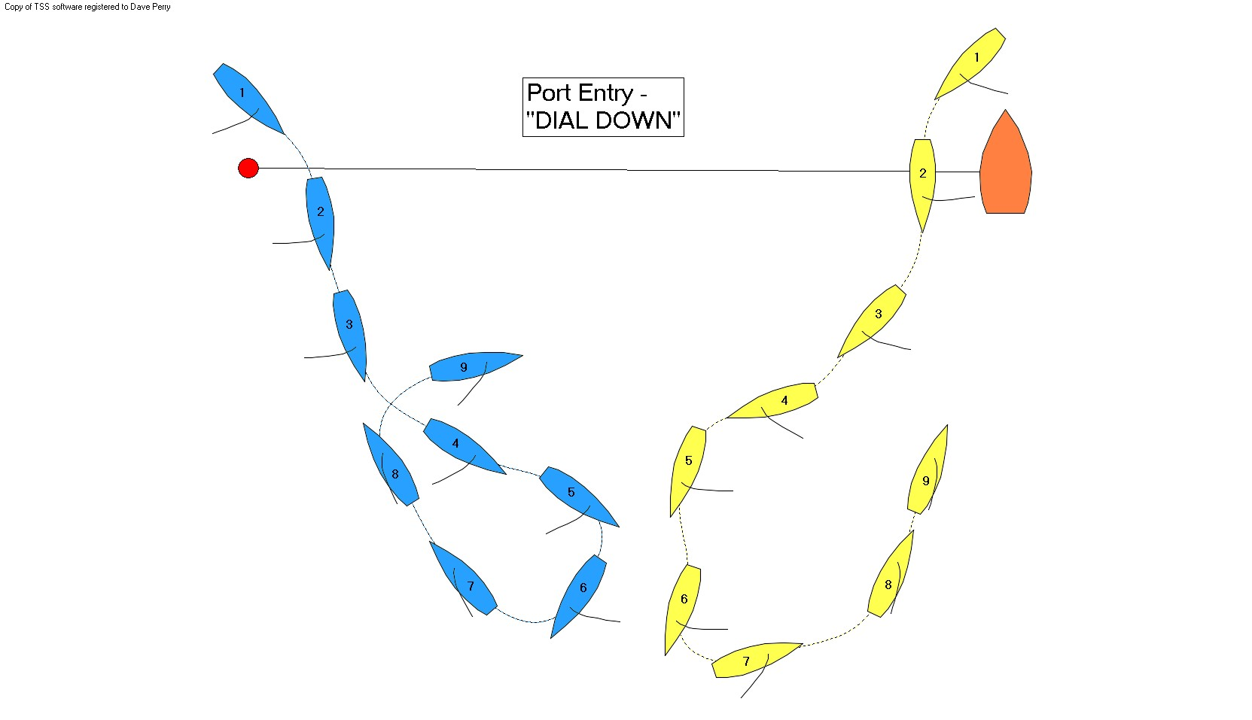
The Dial-Down
If Blue can’t cross Yellow, and Blue is too late to luff and cross Yellow or tack, Yellow will bear off and force Blue to gybe to keep clear. This is a bad outcome for Blue and should be avoided at all costs. If Blue is in this position:

- Blue has to gybe to keep clear of Yellow. Blue wants to be going as slowly as possible in this maneuver, forcing Yellow to overlap her on her port side (leeward side). Blue wants Yellow to be farther downwind if possible

- Blue should overtrim her mainsail and oversteer to slow down

- Watch Yellow’s boom; if it flicks over to her starboard side, she is on port tack. Blue should immediately gybe to become the leeward boat on port tack

- Once Yellow is securely locked on Blue’s port side (leeward side), Blue can luff, extend if needed, and tack to port to exit the Initial Meeting

The Dial-Up
The “Dial-Up” occurs when Blue and Yellow are converging, and Yellow begins aiming at Blue. This forces Blue to head up. Yellow continues to head up aiming at Blue, which causes Blue to tack to keep clear. Yellow then sails head to wind alongside Blue.

Blue’s Plays in the Dial-Up
There are three general plays for Blue, and this should be decided before the Dial-Up occurs:
- tack into near full-stop mode (Dial-Up; best in 7-10 knots); or
- tack into full speed upwind race mode (Dial-Up and Sail; best in under 7 knots); or
- tack and continue right into a gybe (Dial-Up and Gybe; best in over 10 knots).

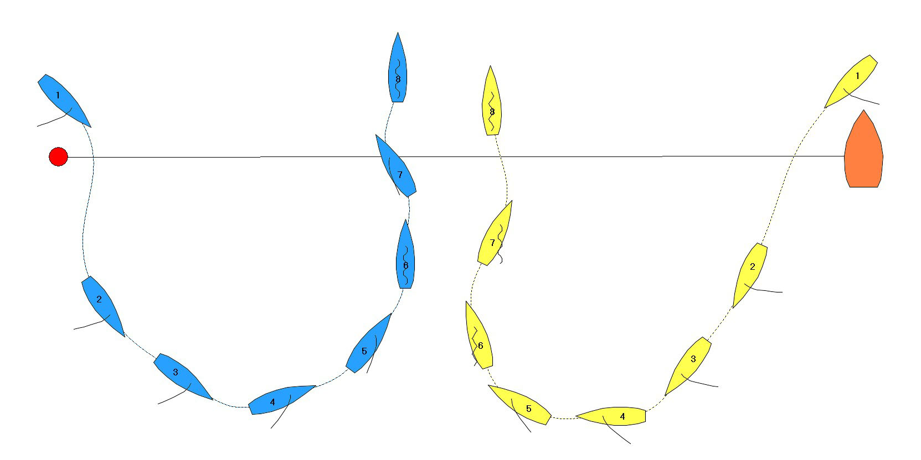
Dial-Up and Stop (7-10 knots)

- After entering and closing to within 4-5 lengths, be prepared to begin the luff that will lead into the tack to keep clear. Don’t get a penalty here by delaying too long.

- If Blue is faster or even in speed coming into the Dial-Up, she can slow by luffing her jib. She can further burn speed by spinning the boat faster in the tack, and/or by backing her mainsail once she is head to wind.

- After passing head to wind, Blue should go all the way down to close-hauled, then immediately back up to head to wind with bow at Yellow’s bow, or farther back if possible. By going to close-hauled, Blue becomes the right-of-way boat, and begins to put pressure on Yellow. Try to be the same speed or slightly slower (but not too much!), with ¾ of a length between the boats, or less if possible. Yellow will be unable to swing her bow astern of Blue, and may drift down and foul her.

- Be sure the jib sheets are free to run as far as the clew wants to blow out to each side. Any tension, even caused by friction, can “trim” the jib and cause the bow to move in a way not desired.

- When downspeed, the bow is controlled by pushing the jib to one side or the other (usually by a crew member on the bow), and by pushing the boom out (pushing the boom out to starboard causes the boat to pivot onto port tack). It is also controlled by active tiller movement (note “match race sculling” is “repeated movement of the helm to propel the boat forward.” Rule C2.16).

When to exit…
- Blue should exit the Dial-Up when:
- she is at risk of fouling Yellow
- she has the opportunity to escape the control of Yellow
- she has the opportunity to gain control over Yellow

How to exit…
- match Yellow’s tack to port tack (watch Yellow closely and react by backing your jib immediately)
- match Yellow’s speed build on starboard tack; i.e., stay to leeward of S on starboard tack
- sail close-hauled on starboard tack, extend and tack and cross Yellow
- tack first and pass astern of Yellow (very common as Yellow often over-runs Blue)
Dial-Up and Sail (under 7 knots)
- Blue does a normal tack and comes out with sails and boat trimmed for max upwind close-hauled sailing (traveler up, boat flat, etc.).
- Yellow will trim and attempt to hang to windward. Eventually Yellow will drop in astern and Blue can safely tack. Try to extend 1-2 lengths farther than needed to tack and cross, if you can do so before 2:30 to start.
- When Blue tacks, watch Yellow. If she tacks too soon, Blue can bear off sharply and take up position behind Yellow, and become the trailer
- Otherwise, Blue needs to reach down over the top of Yellow and to pass as close to windward of the Committee Boat as possible.

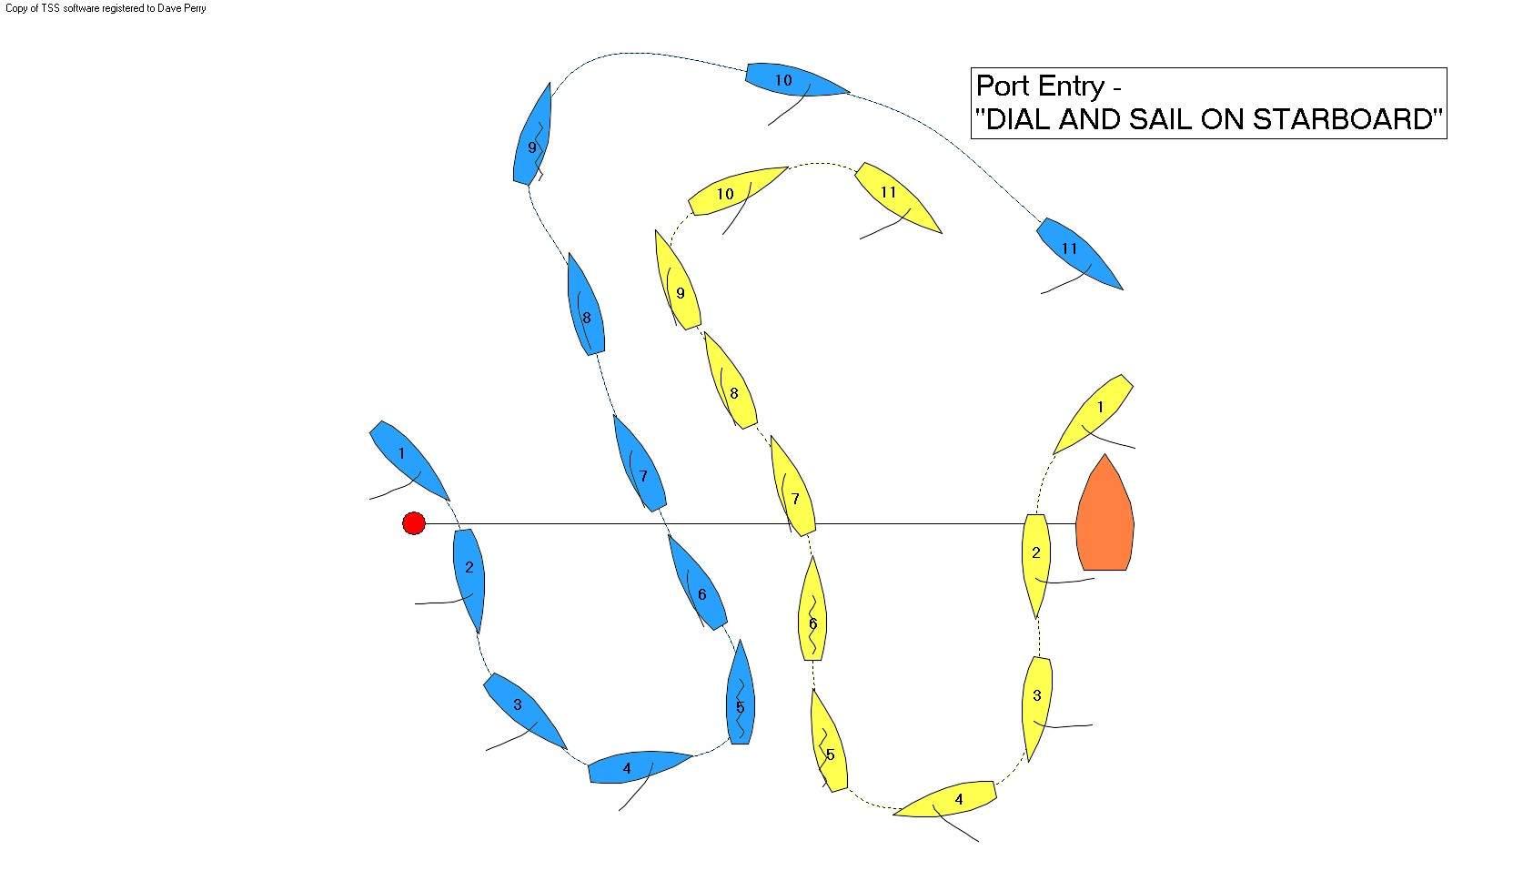
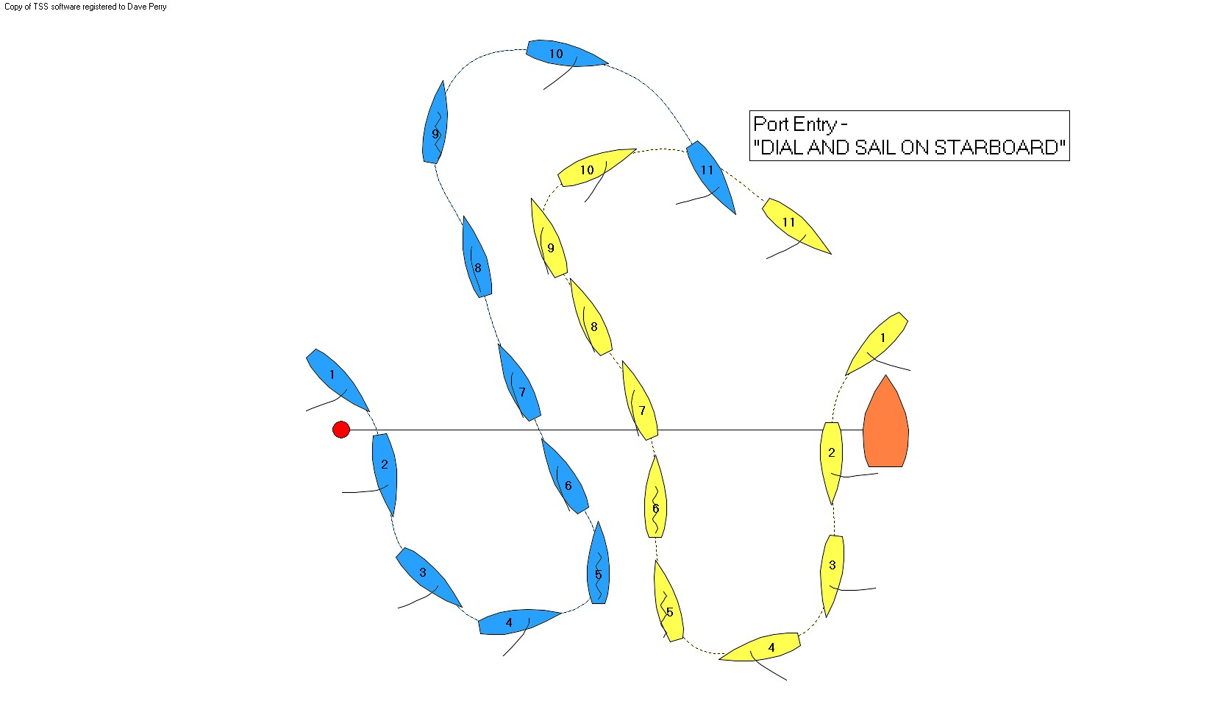

Dial-Up and Gybe (over 10 knots)
- Blue tacks and continues bearing away right into a gybe, never hesitating for a moment unless S can turn down inside her and defeat her gybe. Blue has the element of surprise on her side for this move.
- Back the jib, ease the main, and then roll the boat hard to windward for the bear away.
- If Yellow can defeat the gybe, it turns into a Dial-Down.

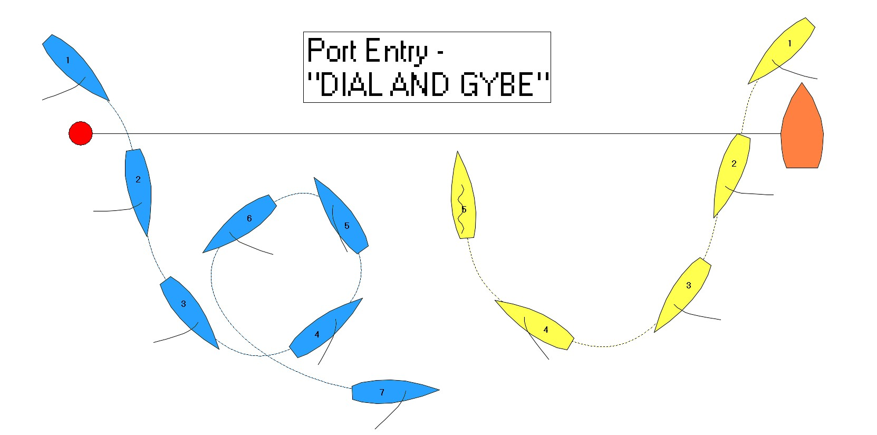

The Yellow Boat (entering from the Committee Boat End)

1) If the Pin End is more downwind than the Boat End, or Yellow is late or slow at her entry, Blue can often cross downwind of Yellow (Downwind Cross).

- Yellow should sail as deep as possible, including winging the jib, to try to prevent Blue from crossing
- If Blue will cross, Yellow should keep her speed and gybe when slightly above Blue’s centerline
- If Blue luffs, Yellow can set up close astern and to leeward, and possibly prevent Blue from gybing
- If Blue will cross by four lengths or more, Yellow can gybe immediately after entering. Often this will cause Blue to luff thinking they are safe. Yellow can then gybe and create a Dial-Up or closer Downwind Cross. (See Downwind Cross figure, pg. 7.)

- 2) If the Pin End is more upwind than the Boat End, or Yellow is late or slow at her entry, Blue can often cross upwind of Yellow (Upwind Cross). (See Starboard Entry Tack & Follow, pg. 15, for Upwind Cross figure.)

- When Yellow knows the Pin End is favored, she should enter (completely cross the starting line) and then immediately luff to close-hauled to try to prevent the Upwind Cross.
- If Blue can cross, Yellow should tack so that she is overlapped to leeward of Blue by several feet. If Yellow tacks too soon, Blue can sharply bear away and set up astern of her.

3) If Blue cannot cross Yellow upwind or downwind, there will be a Dial-Up or a Dial-Down.

The Dial-Down
Often Yellow can aim behind Blue’s transom letting Blue think she has the Downwind Cross, and then bear away when it is too late for Blue to luff and keep clear of Yellow. Often Blue simply tries the Downwind Cross but can’t make it. Either way, this turns into a Dial-Down.

- Once Blue gybes, Yellow should immediately overtrim her mainsail and try to slow down so her bow is clear to turn up inside Blue if Blue tries to luff and tack.
- Yellow is stronger when Blue is farther downwind.
- When Blue luffs up on starboard tack, Yellow has two choices: luff and try to set up to windward of Blue and prevent her tack; or gybe and sail upwind on port tack, and then tack and use her starboard tack advantage to keep Blue pinned to the left (see diagram for Port Entry – Dial Down on page 8).

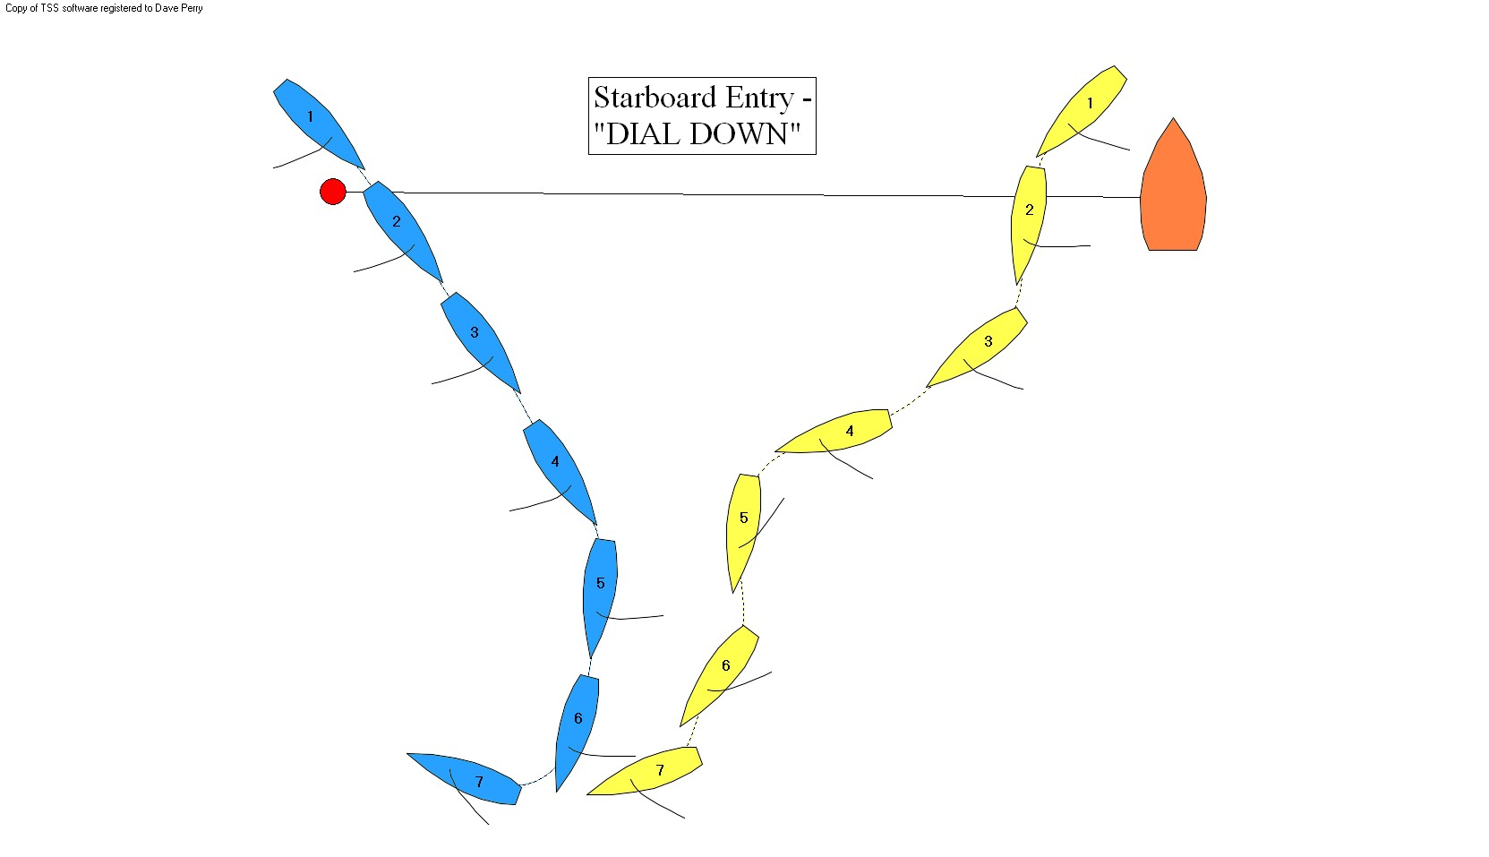

The Dial-Up
When Blue cannot cross Yellow upwind or downwind, Yellow is in control of Blue and wants to make her tack. She does this by slowly starting to luff and aim at Blue, which causes Blue to luff and turn away from Yellow, eventually tacking.

Yellow’s Three Plays in the Dial-Up
There are three general plays for Yellow, and this should be decided before the Dial-Up occurs:

1) Do a Dial-Up and Stop
2) Do a “Fake Dial-Up” (best in over 12 knots)
3) Let Blue have the Upwind or Downwind Cross and tack or gybe right in behind them

Dial-Up and Stop
- After entering and closing to within 4-5 lengths, Yellow initiates the Dial-Up by aiming at or behind Blue; this causes Blue to luff sharply and begin her tack to keep clear. Yellow can adjust her speed and course to get into her “controlling position.”

- If Yellow is faster or even in speed coming into the Dial-Up, she can slow by luffing her jib. She can further burn speed by passing head to wind and sailing momentarily on port tack. She can also burn speed by backing her mainsail once she is head to wind and/or by turning down and up sharply.
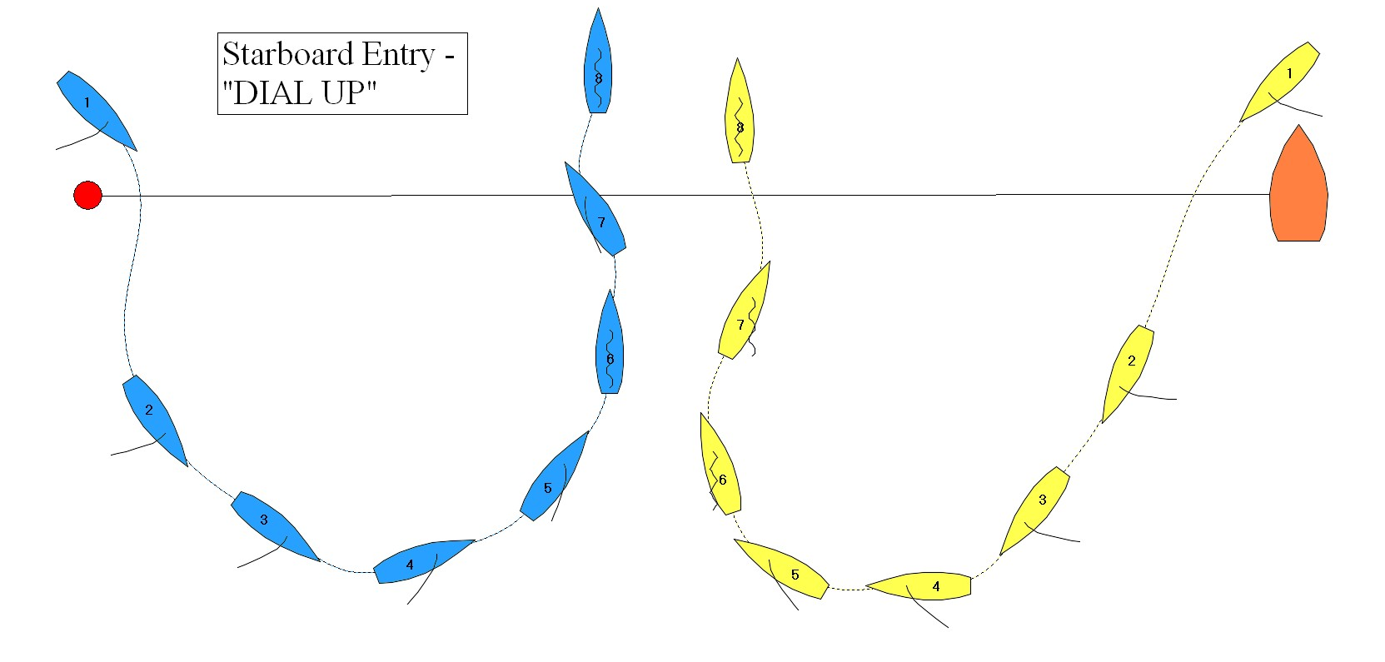

- Yellow wants to end up with her bow at the mast of Blue, with about 1 length between the boats, and very similar in speed. This is an excellent “controlling position.” Yellow can live safely to windward, but Blue cannot tack and pass astern of Yellow. It is better to be too far aft than too far forward relative to Blue.

- While Yellow is doing the Dial-Up, the Tactician on Yellow watches Blue carefully, noting if Blue gets down to a close-hauled course on starboard before coming back up to head to wind (in which case Blue has the right of way).

- If Yellow is the right-of-way boat, Yellow maintains the “controlling position” as long as she wants to or can. Be sure the jib sheets are free to run as far as the clew wants to blow out to each side; any tension, even caused by friction, can “trim” the jib and cause the bow to move in a way not desired. Once slowed, trim the main in fairly tightly to help keep the bow into the wind.

- When downspeed, the bow is controlled by pushing the jib to one side or the other (usually by a crew member on the bow), and by pushing the boom out (pushing the boom out to starboard causes the boat to pivot onto port tack). It is also controlled by active tiller movement (note “match race sculling” is “repeated movement of the helm to propel the boat forward.” Rule C2.16).

When to Exit…
- Yellow should exit the Dial-Up when:
- she gets too close to Blue and at risk of getting a penalty
- she is too far forward on Blue
- Blue is slow or her bow is stuck on starboard tack
- it is time to go to make her final approach to start

Standard Exits…
- Yellow goes onto port tack and extends while building speed
- Yellow goes onto starboard tack, builds speed briefly, then tacks to port tack
- If Blue starts to tack astern of Yellow, Yellow builds speed on starboard tack and passes to windward of Blue and gybes in astern of her.
- If Blue trims in and starts sailing upwind, Yellow should match her trim and try to prevent her from tacking. If Blue can tack, Yellow tacks to leeward with a slight overlap
- If Blue trims in and tries to sail downwind and gybe, Yellow matches and tries to prevent the gybe. If Blue can gybe, Yellow gybes in astern of her.
The Fake Dial-Up (best in over 12 knots)

- After entering and closing to within 5 lengths, Yellow initiates the Dial-Up by aiming at or above Blue; this causes Blue to luff sharply and begin her tack to keep clear. Yellow forces Blue to get to close-hauled on starboard, then bears away sharply, passing one length astern of Blue.
- If Blue immediately tacks back to port, Yellow does the same, and ends up trailing Blue as closely as possible.
- If Blue remains on starboard, Yellow either luffs and takes a position astern of Blue, waiting for Blue’s next move; or uses her speed to tack across Blue’s transom and then tack back to windward of Blue.

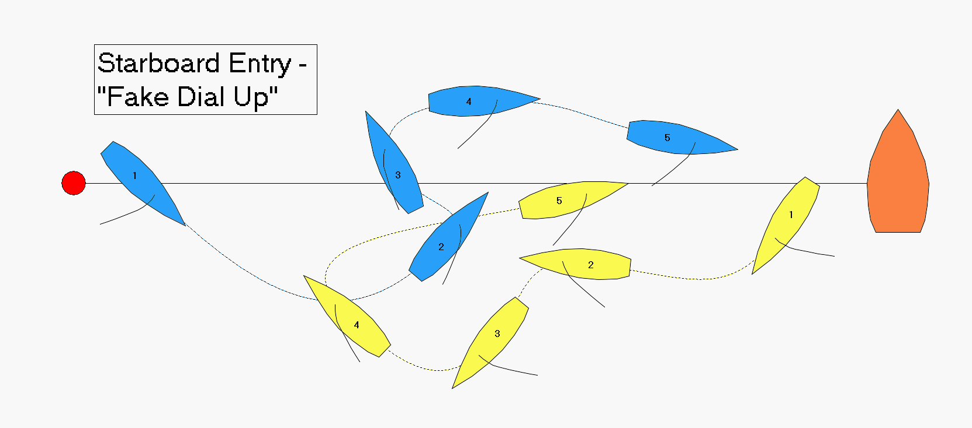

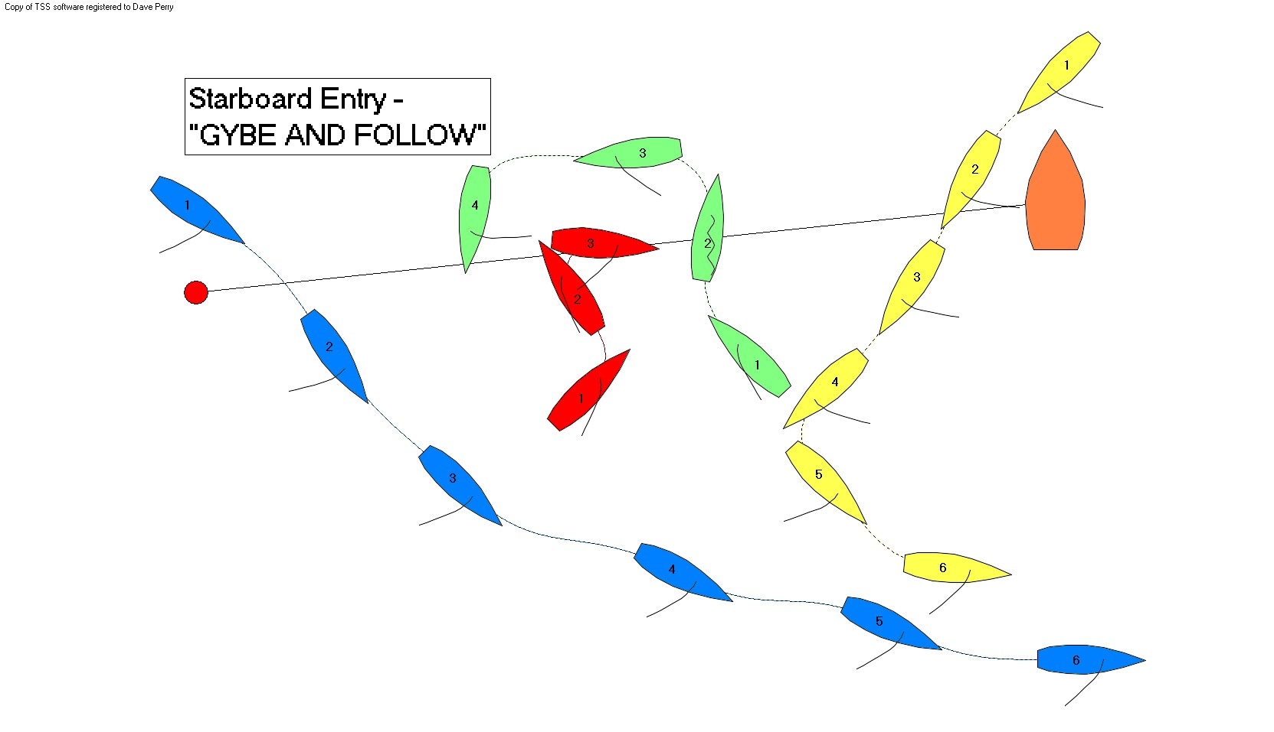

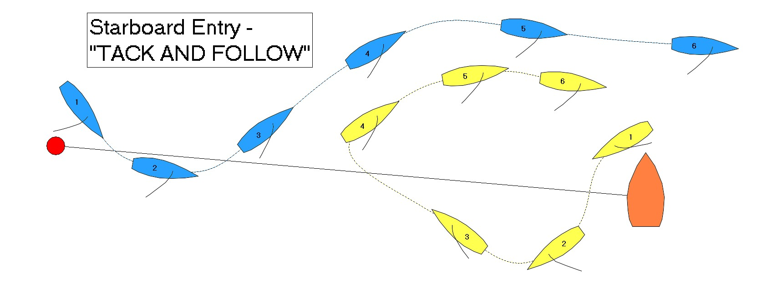

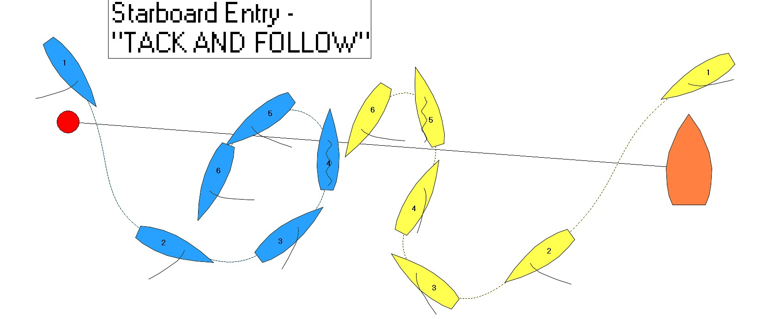

Phase 2) The Middle Phase (from ~ 3:00 - 1:30 min. to start)

Once the Initial Meeting has occurred and the boats are on the same tack, usually with one behind the other, you are into the “Middle Phase”. In this phase, either one boat will be in Control of the other and the other is trying to Escape from being controlled, or neither boat will be in control in which case the boats will begin Circling. The Middle Phase ends with the transition to the Final Approach.

OBJECTIVE for Middle Phase

- Get control of the other boat
- Escape from being controlled by the other boat
- Set up for Final Approach
  - Review First Choice (Right or Left of other boat?)
  - Do you want to Lead or Push?
  - Know time and distance back to the starting line
  - Know where you are relative to the laylines
- Avoid getting a penalty on yourself

STRATEGIES & TACTICS for Middle Phase

The Playground
The “Playground” is the area to the right of the Committee Boat above the starboard tack layline to the Committee Boat and below the extension of the starting line. This is where the Circling normally takes place, and is the best place to be if trying to Escape being controlled by the other boat.

Entering the Playground
- There are two “entrances” to the Playground: below (to leeward of) the Committee Boat or above (to windward of) it. When the two boats are on port tack after the Initial Meeting, either the leading boat will be safe to bear away and gybe without fouling the other boat (usually a length or more ahead), or she will not be (usually less than a length ahead).

- There is a special rule regarding gybing for match racing (rule C2.6, 13.2) which basically says that after the boom crosses centerline, the gybing boat has to keep clear until her mainsail has filled.

- If the leading boat is worried that she cannot gybe without fouling, she is “under pressure”. If she is not worried, then she is “neutral”. If the leading boat is “neutral”, she should enter the Playground below the Committee Boat, pass the Boat layline by 2-3 lengths and gybe and make her first circle. If she is under pressure, she should enter above the Committee Boat, go 2-3 lengths MAX, and use “Houdini” (described under “Control / Escape”).

- Regardless of which way the leading boat enters the Playground, it is usually safest for the trailing boat to follow the leading boat.

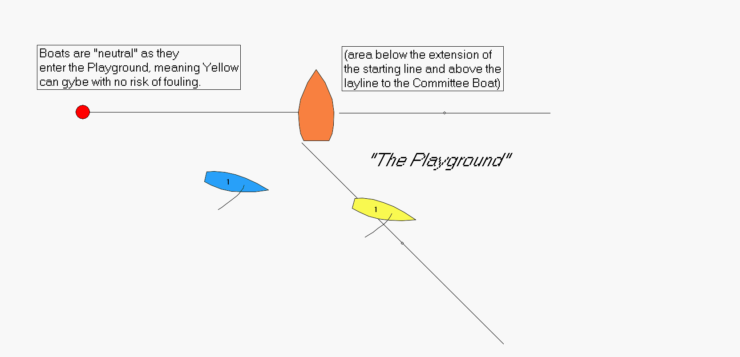
Circling
- When leading on port, enter the Playground (sail past the Boat layline), bear away and gybe onto starboard and, in one continuous turn, smoothly tack to port to leeward or just astern of the trailing boat. Do not stop turning until you are on port tack! Be sure to use your sails and weight to optimize your turn.
- Stop your turn on port tack on the best speed-build angle (near close-hauled in light air, beam reach in medium air, and broad reach in heavy air).
- After the circling boat tacks, the new leading boat extends on port (when possible sailing a lower course than the trailing boat) until the distance between the boats stops increasing, then the leading boat can start their circle.
- If done correctly, the “circles” are really “ovals” and the boats will both move towards the right.
- The trailing boat can try to prevent the leading boat from gybing by bearing away towards the leading boat as the leading boat bears away to gybe:
- If the leading boat does not complete her gybe (mainsail does not fill) before the trailing boat has to alter course to avoid – penalty on the gybing boat (rule C2.6, 13.2).
- If the leading boat does complete her gybe (mainsail fills), the trailing boat luffs and passes astern of the gybing boat. If the gybing boat continues turning in her circle, the leading boat sails as fast and as low as possible, extends on port, and does her gybe. NOTE: the trailing boat should never gybe to windward of the gybing boat!

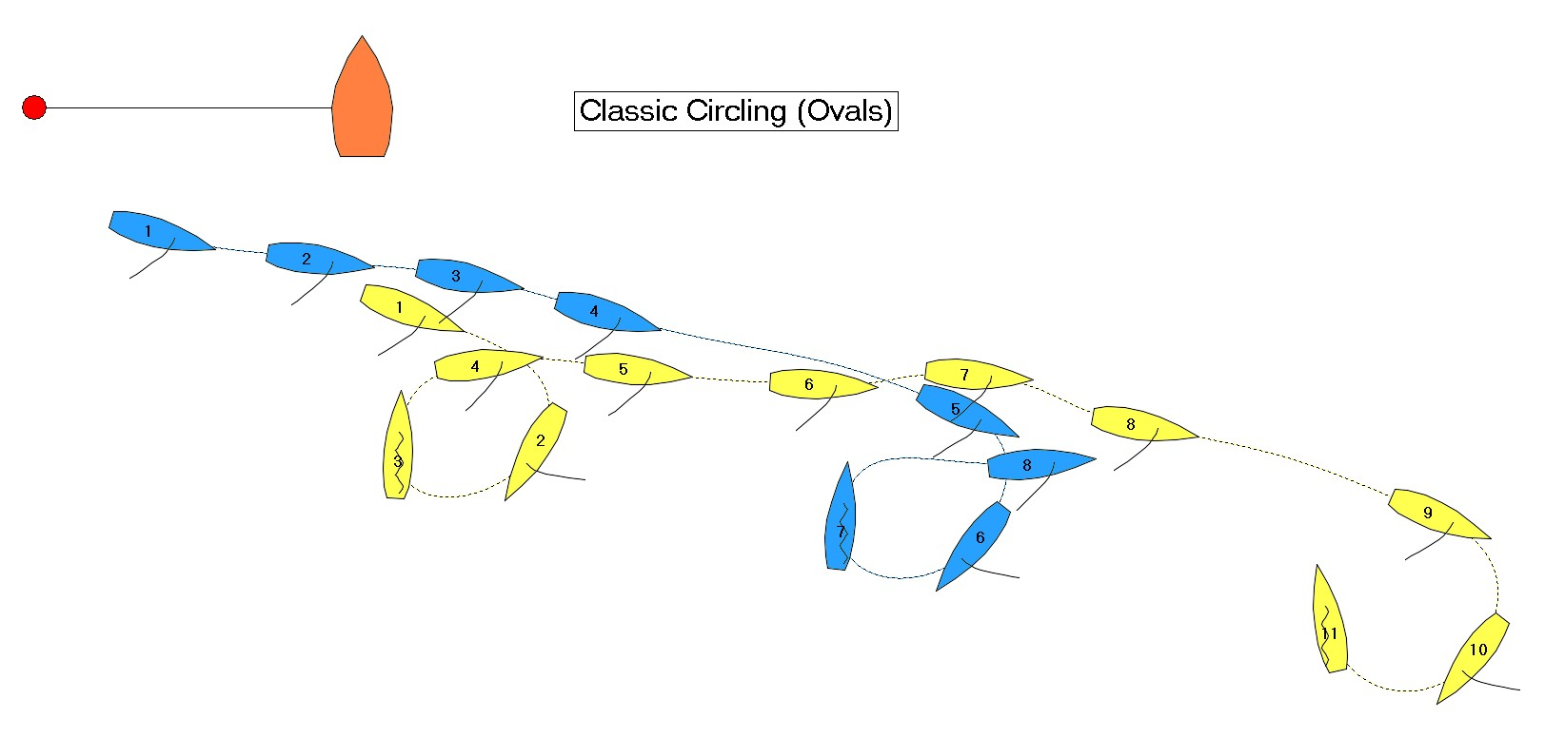
Flat-lining
If the gybing boat stops turning after her gybe, even for 2 seconds, and sails straight on starboard tack, that is called “flat-lining”. The trailing boat should immediately tack, with her jib backed. She will now be controlling the other boat in a very strong position.

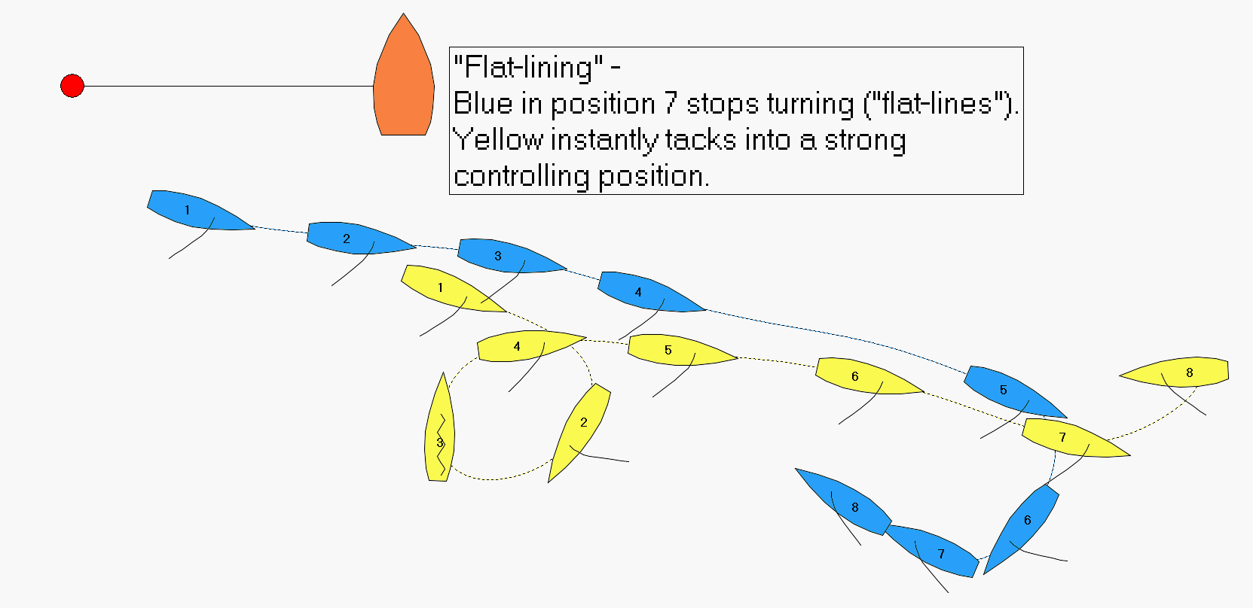
Control / Escape
When one boat is preventing the other boat from tacking or gybing, she is in “control” and the other boat is trying to “escape”. Here are some thoughts for each boat.

When you are the controlling boat
- it is easier to control the other boats when both boats are on starboard tack.
- keep about a half a length back and slightly below the boat ahead’s centerline when below a beam reach, and above the boat ahead’s centerline when above a beam reach.
- never get your bow “locked” to windward of them, such that if you lose your bow you will slide down and hit them.
- If you are on starboard tack and both get SLOW, tack away and roll into a gybe and come right back at your opponent. She will still be on starboard trying to build speed, OR will have just turned onto port tack. Aim right at her! The leader may try to back her main to escape; once her main is backed, you automatically tack away and roll into a gybe.

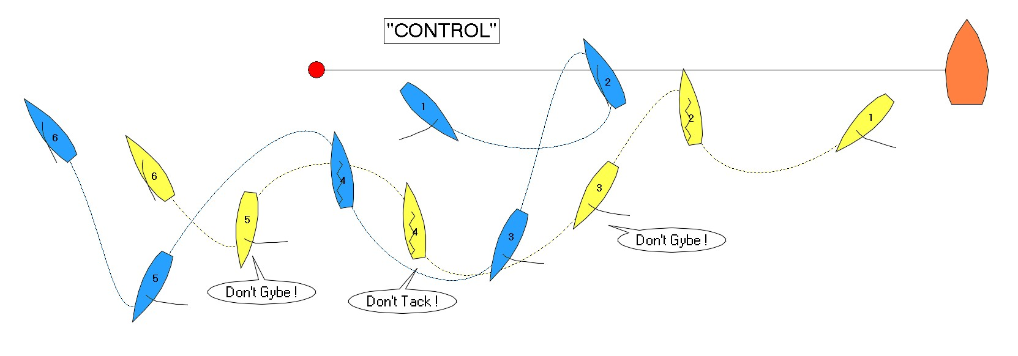
When you are trying to escape
1) If the boats are on port tack, it is generally easy for the boat ahead to escape. Just bear away to dead downwind, throw the boom over (giving the boat astern room to respond) and off you go.

2) if you can’t get to a dead downwind course without fouling, use “Houdini”.

Houdini (named for the most famous escape artist)
- Works best when the boats are on port tack. Suddenly stop the boat by turning head to wind as fast as possible and backing your main for 3-5 seconds during and after your turn. Stay on port tack head to wind with your mainsail trimmed in tightly. React to whatever the other boat does.
- If the other boat overlaps you on one side, sail away towards the other side.
- Houdini works best 2-3 lengths to the right of the Committee Boat
- If forced to sail away on starboard tack and you still are being controlled, circle the Committee Boat clockwise, and react to whatever the other boat does.

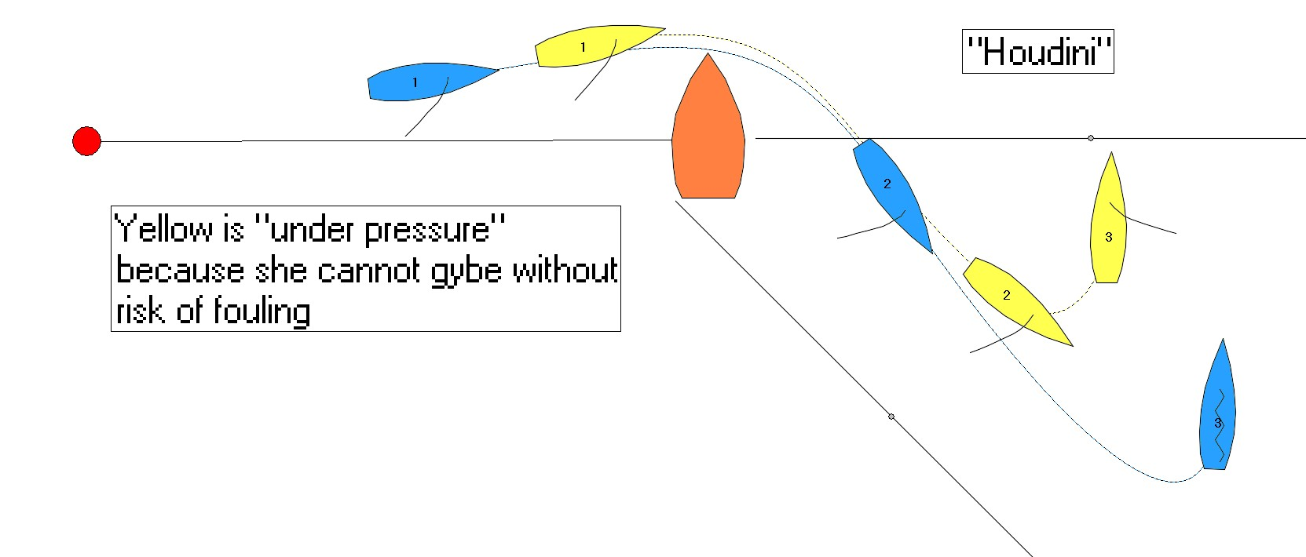
3) The problem is greater for the boat ahead when the boats are on starboard tack. Here are some thoughts to help escape when you are controlled on starboard:

- Often the best first move is to aggressively STOP! See what the trailer does, and go from there.
- Or WRIGGLE like mad…use lots of aggressive UPS and DOWNS to try to cause the trailing boat to make a mistake.
- Use your UPS and DOWNS to close the separation between the boats. The closer the trailer is, the harder it is for him to control you without getting overlapped with you. If he does overlap you, you can simply turn the other way and escape.
- Once the boats are close, go close-hauled and sail away from him; then tack across him. He’ll generally tack to leeward or astern of you, but at least you are on port tack.
- Head for a nearby “pick” (a stationery object such as a race committee boat, umpire boat, spectator boat or another boat waiting to start) and go around it.

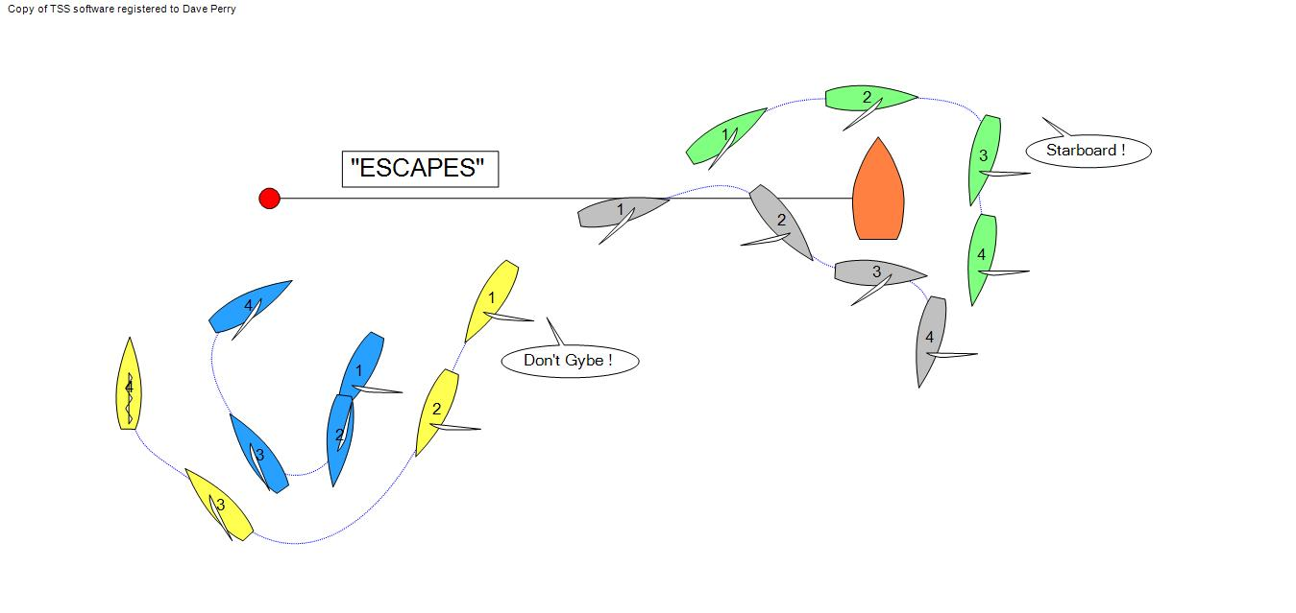

The Transition to the Final Approach

- Provided neither boat has gained control over the other in the Middle Phase, the pre-start will boil down to the Final Approach, which is the Lead / Push back to the starting line.

- Both boats will have to decide whether they want to “lead” back to the start (i.e., be ahead of their opponent on starboard tack) or “push” (i.e., be astern of their opponent); and whether they want to lead now or make one more circle. These are perhaps two of the most frequent – and most important and difficult – decisions you will have to make in the pre-start.

- The boat leading away from the line on port tack gets the choice of when to make the final Turn Back, and the trailing boat gets to choose whether they want to Lead or Push.

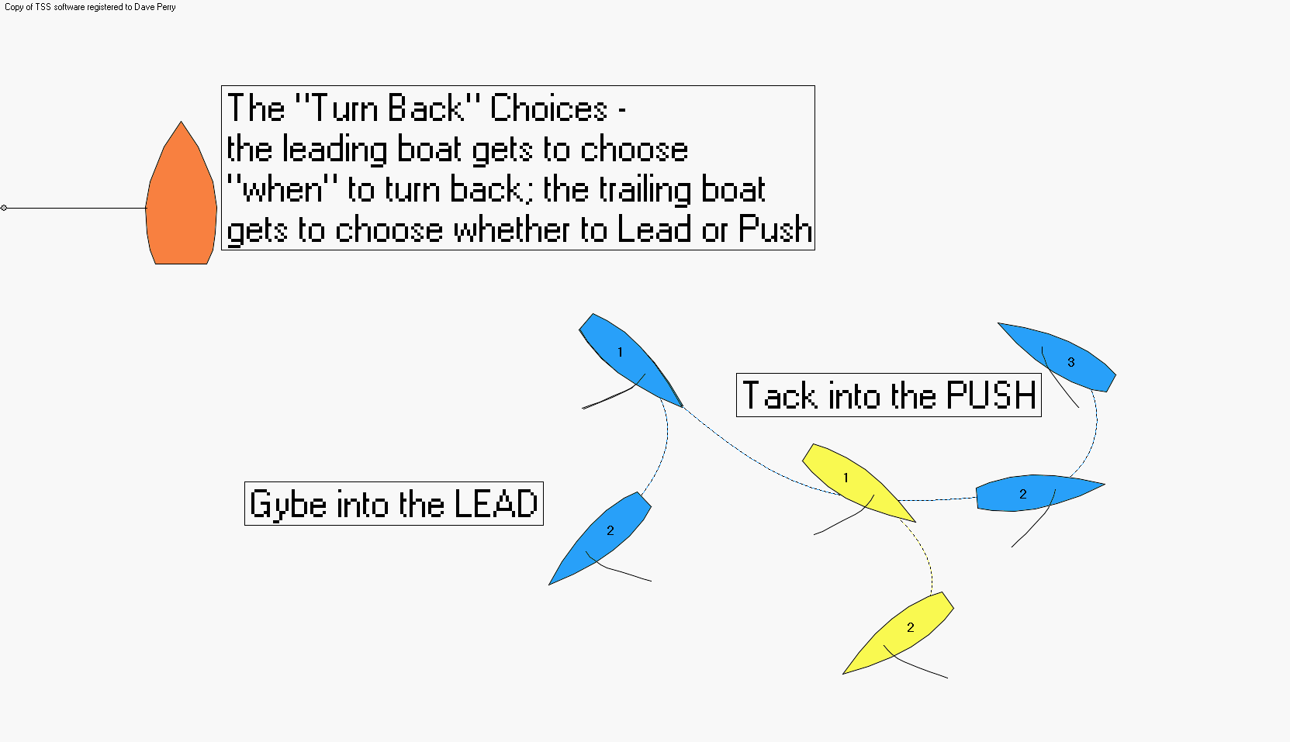
Turning Back
- The boat leading away from the line on port tack will make the decision when to Turn Back for the starting line (because the trailing boat is happy to keep going until both boats would be late coming back).
- The Turn Back maneuver is a gybe and sail deep on starboard tack. That will be the signal to the other boat that the circling is over and the transition to the Final Approach is beginning.
- Below are some thoughts on “when” to make this maneuver.
- If the trailing boat gybes and follows the leading boat, the leading boat is the Leader and the trailing boat becomes the Pusher; and sailing deep with the Pusher close behind is a strong position for the Leader.
- If the trailing boat tacks and sets up to windward of the leading boat, the leading boat is still the Leader, but has to make a decision. If the Pusher starts sailing upwind, does the Leader go upwind also, or stay sailing deep? The lower down in the Playground the boats are, the more the Leader needs to sail upwind with the Pusher; otherwise the Pusher will be able to sail over the top of the Leader and become the new Leader.

Becoming the Leader or Pusher
- The trailing boat generally has the choice of being the Leader or the Pusher.
- If the trailing boat wants to be the Leader, then when the leading boat gybes, the trailing boat should gybe in front of her, trying to complete her gybe about one length clear ahead. Gybe into the Lead.
- If the trailing boat wants to be the Pusher, then when the leading boat gybes, the trailing boat remains on port tack until her transom just passes the leading boat’s transom, and then she immediately tacks so that she is clear astern of the leading boat. Tack into the Push.
- After tacking, the Pusher should immediately aim directly at the Committee Boat, which will usually force the Leader to come up higher in the Playground (“Push from Above”). Just before the Pusher becomes locked in to windward of the Leader, the Pusher bears away and threatens to hook the Leader, and the pushing game begins.

Some general guidelines and thoughts in deciding *when* to Turn Back, and whether to Lead or Push:
- Keep constant feedback coming on how far in sailing time you are from the starting line. As you get more advanced, you can call the time back to the Boat End, Middle of the Line, or Pin, depending on your starting strategy.

- Keep a constant discussion going on your boat: lead back or circle??? If you know you will be late if you do another circle, LEAD BACK.

- You can kill approximately 2X the amount of time you are from the line.
  - In other words, if you are 1 minute from the line, you can lead back at 2 minutes to go, because you can kill 2 times the 1 minute you are from the line.

- You can kill even MORE time in light winds (under 7 knots); so in light air, LEAD BACK; but it is harder to kill time in heavy air, so in heavy air, PUSH BACK

- LEADING BACK is the stronger, more controlling move; when in doubt, LEAD BACK. Leading back is also the harder move, so you need to practice it.

- If you want to start to your opponent’s left, then LEAD BACK; if you want the right, then PUSH

- When deciding *when* to Turn Back, if you want to LEAD BACK, you have to turn back early enough that the trailing boat will choose to PUSH, but not so early that you will find yourself leading back too early! If you want to PUSH, turn back slightly later than you would if you wanted to LEAD.

Phase 3) The Final Approach (from ~ 1:30 min. – 0:00 to start)

At some point in most pre-starts, both boats will be on starboard tack heading back towards the starting line. This typically occurs somewhere between 1:30 – 1:00 to start. One boat will be the LEADER and the other the PUSHER. This is the most critical phase of the pre-start, and the one that determines which boat gets the right, and which the left.

OBJECTIVE for Final Approach

1) Get your First Choice (start to right or left of the other boat)
(usually the Leader gets the left and the Pusher gets the right)

2) Be in Control of the Final Approach
  - If Pusher:
    - Push opponent back to the starting line and to the pin end too early
    - Become overlapped to leeward of opponent (“hook them”) and force them to tack to port, tack with them and hold them out past the layline to the Committee Boat
    - Block opponent away from your First Choice

  - If Leader:
    - Make opponent late to the starting line
    - Become overlapped to leeward of opponent (“hook them”) and force them to tack to port, tack with them and hold them out past the layline to the Committee Boat
    - Block opponent away from your First Choice

3) Avoid being controlled by the other boat

STRATEGY & TACTICS for Final Approach

Lead/Push Terminology
Hook – when the Pusher gets her bow overlapped to leeward of the Leader (the Leader has been “hooked”)
Locked – when the Pusher gets her bow trapped to windward of the Leader and can’t bear away
3:00 o’clock line - a line directly abeam to windward (90 degrees to windward) of you (12:00 is straight ahead).
Scoop – when the Pusher sails over the top (windward side) of the Leader and becomes the Leader
Shift Right – when one boat becomes overlapped to the right side of the other; that boat has “shifted right”
Luff & Linger – when the windward boat sails just past head to wind and holds that position
Runway - assume you are on starboard tack in the middle of the line. The “runway” is the time and space between you and the Committee Boat end of the line; i.e., the maximum amount of time after you tack to port tack that you could kill and still start on port tack at the Committee Boat end

HOW TO LEAD / PUSH
The essence of leading / pushing is precise boat speed control and handling. Practice slowing and accelerating at various speeds (often from 1:00 – 0:30 to go is done very downspeed), and using your sails (especially) your jib to help turn the boat when slow.

Leader…general thoughts
- get game LOW…you want to be as close-hauled as possible when you are leading back
- get game SLOW – late is great. Do it with STEERING, not SLOWING (i.e., sail a longer distance at a higher speed – keep momentum in your keel)
- keep opponent within ¼ of a boat length if possible, but with no risk of being hooked
- when pusher luffs (turns up), be slow to match that turn; when the pusher bears away (turns down), match that turn exactly (skipper of the Leader needs to turn around and face the bow of the Pusher)
- never let your opponent HOOK you (overlap you to leeward) unless you WANT them to
- if opponent overlaps you to windward, keep them behind “the 3:00 o’clock line”
- if the Pusher gets locked to windward, luff up to head to wind
- never sail closer than about 1 length to the layline to the Pin end.

Pusher…general thoughts
- keep game HIGH – “Push from Above” (that means that the Pusher should sail to windward of the leader on a close-hauled course, but far enough to windward so his bow is not stuck or “locked” to windward!)
- if the Leader lets the Pusher get past “the 3:00 line”, the Pusher can consider “scooping” the Leader (sailing over the top and becoming the Leader). Do this ONLY if you want to LEAD!
- push aggressively on a reaching course, using lots of “ups” and “downs” to make the Leader maneuver
- try to “hook” the Leader (overlap him to leeward); if you do, slowly luff until he has to tack away onto port
- if you make him tack, tack with him immediately unless he has “runway” to start OR you are extremely slow such that he’ll sail away and get back onto starboard before you can get up to speed on port
- if you aren’t going to “hook” him, then you’ll “shift right” on him at some point. Do it when the Leader is in a “down” turn; then take a BIG BITE to windward (big luff) and open the separation to windward.

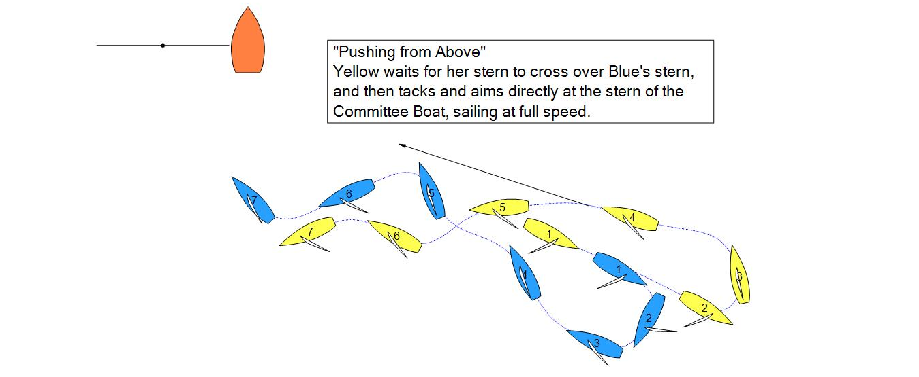
You need to hear constantly:
- Time to middle of the starting line (or one end or the other depending on where you want to start)
- Time to start
- Time to burn (difference between the time to start and the time to the starting line)
- Location and time relative to starting line, laylines and “runway”

Rules When Hooking and Luffing

At position 1...Yellow is clear astern of Blue and must keep clear, under rule 12 (clear ahead – clear astern).

At position 2, the boats are overlapped. Yellow is the leeward boat and Blue must keep clear, under rule 11 (windward – leeward). Because Yellow established the overlap, her actions gave her the right of way, so she must initially give Blue "room" (space and time) to keep clear, under rule 15 (acquiring right-of-way).

From position 2 to 4...Yellow is changing course, so she must give Blue "room" to keep clear for as long as she is changing course, under rule 16.1.

If Blue reacts immediately yet there is contact shortly after position 2, Yellow is likely to be penalized.

Otherwise Blue is at risk of penalty if she is not continually changing course away from Yellow from position 2 on.

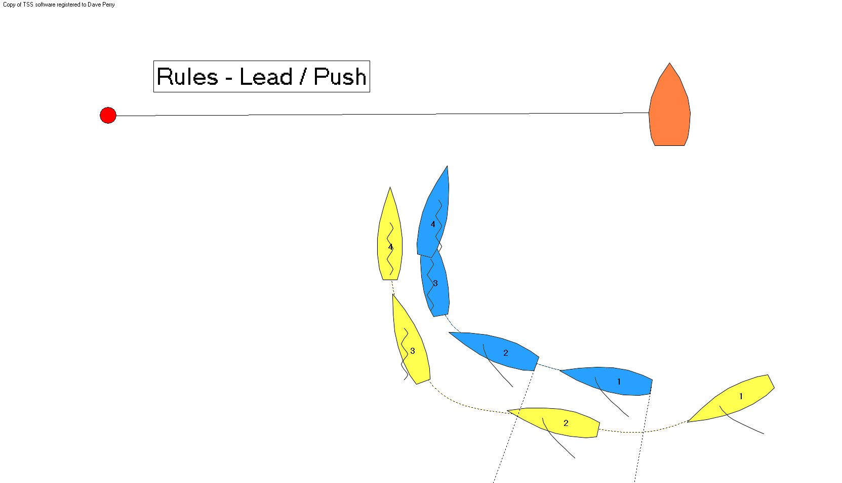

“SHIFT RIGHT”

The Leader: often you are LEADING BACK, but want to start to the right of your opponent. At some point after you have passed the port-tack layline to the Committee Boat end of the starting line, you will want to LET your opponent “hook” you (overlap you to leeward). This is called “shifting right” (i.e., getting to the right side of your opponent). The moment you are hooked, you need to immediately turn past head to wind and then stay there (“Luff & Linger”). You will do this when you are sure you have enough “runway” to be able to start on port tack. You will also do this when you are sure you are both late to the starting line. It generally happens between a third and a half of the way down the starting line.

The Pusher: when you are PUSHING BACK and want the right, continue to threaten to hook the Leader until she is past the port layline to the Committee Boat; then overlap her to her windward side (get “locked”). When she luffs, sail past head to wind (Luff & linger) until you can bear away and start on port tack.

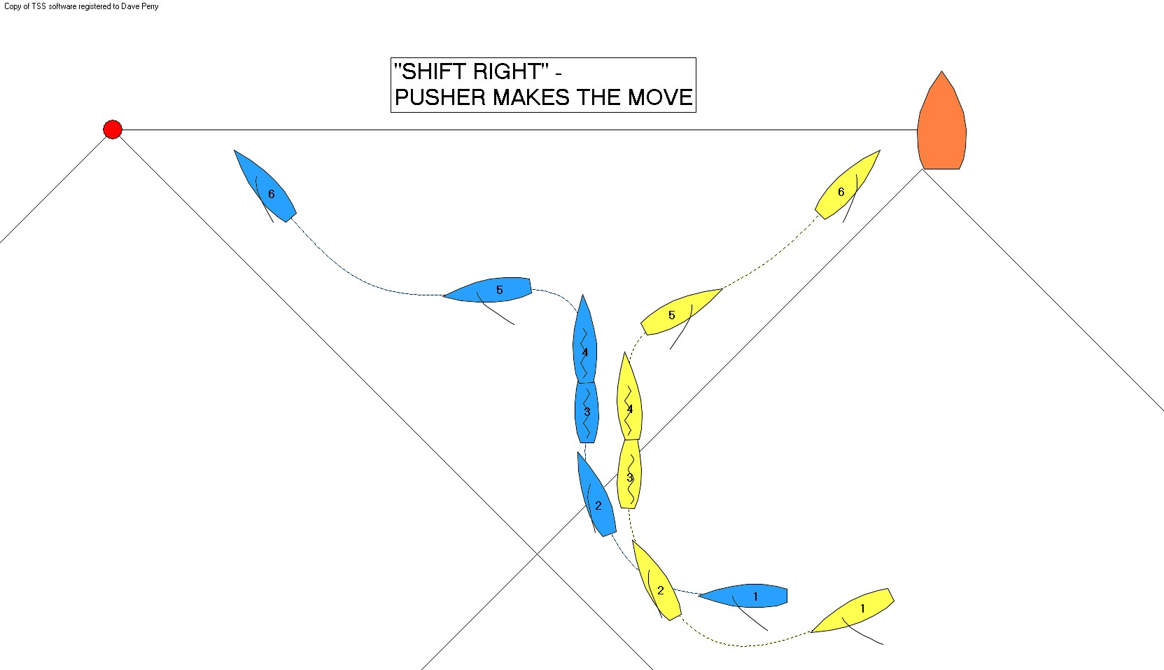

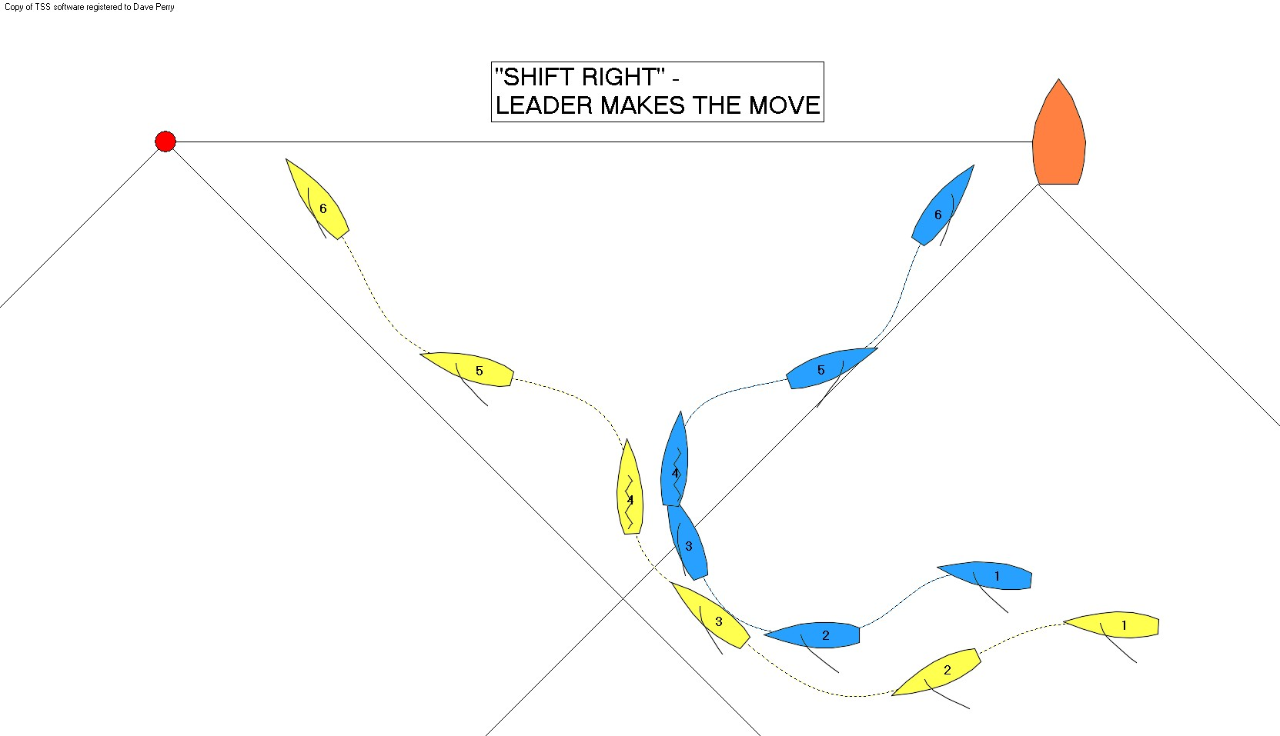
The Four Starting Positions (see page 2)

Close to Leeward – This happens when the Pusher is close to the Leader, and the boats are on time or slightly late for the start; or when the Leader is on time for the right-hand third of the starting line.

Windward with a Gap – This happens when the Pusher can take a big bite to windward (big luff) while the Leader’s bow is down. It also happens when the Leader gets “hooked” and tacks to port tack, and the Pusher immediately tacks and follows. The Leader often then gybes immediately so as not to get controlled, and the Pusher extends on port tack and tacks up to windward of the Leader.

Split Start – This happens when the “shift right” happens more than a third of the way down the starting line, and the boat on the right tacks to port with less than about 15 seconds to start.

Crush! – This happens when the Pusher is astern of the Leader trying to push, and the Leader is late to the starting line; or when the Leader is above the Committee Boat layline and the Pusher is locked to windward of her.

