Chapter 2…The Upwind Leg
The typical match race course has four legs. Usually legs 1 and 3 are upwind legs. Here are some strategies and tactics for the upwind legs.

Information it is useful to know before beginning the Upwind Leg:
- what is the angle of the wind to the rhumbline (the straight line between the leeward and windward marks)
- is the wind direction steady, oscillating, persistently shifting one way, or randomly shifty
- is the wind strength steady or changing up and down
- is there more pressure on one side of the leg than the other
- what is the current situation
- what color mark are you racing to

OBJECTIVES FOR THE UPWIND LEGS

If ahead:
- stay ahead of opponent; try to grow your lead
- force them to less favorable side
- force them to closer layline
- minimize distance sailed by using shifts and better wind pressure
- be in position to give them bad air, or force them to make extra tacks, near windward mark

If behind:
- minimize loss; try to round windward mark within two (2) lengths of leader
- minimize distance sailed by using shifts and better wind pressure
- maximize clear air into windward mark
- try to pass opponent if possible

If relatively even (i.e., one boat has a piece of the other):
- be in position to “lee-bow” opponent
- when in doubt, defend, or take, the right-hand side of the leg
- minimize distance sailed by using shifts and better wind pressure

STRATEGY THOUGHTS FOR THE LEADER:
- if you can pin your opponent to one layline or the other, do so
- if you aren’t sure which side of the beat is favored, be to the right of your opponent until you are sure (because the starboard-tack boat has the right-of-way and therefore is much stronger)
- it is difficult to be on your opponent’s wind on both tacks; tack on their wind on the tack you want to extend on, forcing them to tack away to the side you think is less favorable
- as you get near a layline, let your opponent get their bow out so they reach the layline first and must either overstand or tack, which lets you tack right on their air
- try to approach mark on port tack for easiest spinnaker set and exit from mark

STRATEGY THOUGHTS FOR THE TRAILER:
- keep dragging the game back to the middle of the upwind leg; don’t get to a layline before your opponent does
- get out of phase with your opponent and in phase with the wind.
- as you are nearing a layline, after a tack, get up to speed as quickly as possible and tack back before the layline
- on the first leg, avoid starting a tacking duel; minimize loss and attack on the downwind leg! If you are within a couple of lengths at the first mark, you can catch up or pass on the run. On the second beat, you need to be more aggressive if you are more than a couple lengths behind, because it is harder to pass on the run to the finish.
- if you will be following the leader into the mark, try to force the leader to come in on the starboard layline (last chance to use your starboard advantage when they tack, and forces them to do a tack set)

TACTICAL THOUGHTS FOR THE LEADER:

If you are to right of opponent and both on starboard tack
- work hard to maintain separation so you are not forced to tack away (set boat up for height)
- your goal is to arrive at port-tack layline without being forced to tack away (but if you even think that you are about to drop back, tack away and save your starboard advantage for later use)
- As you near layline, begin to open gauge between the boats and let your opponent pull forward, i.e., sail higher and slower
- Overstand slightly before tacking (it is better to tack too late than too early)
- Sail high after tacking to try to drop the opponent into your bad wake and air and extend lead

NOTE: If your opponent tacks first, tack directly on their wind or on their lee-bow, defending the right hard.
If you tack on them and they tack back to starboard tack, go to max speed build (no more!) and tack back with them. The greater the separation between the boats, the easier it is for your opponent to get out of phase with you.

If you are to right of opponent and both on port tack
- It is a speed race to the starboard-tack layline. If you cannot force your opponent to tack away before you reach the layline, then here are some thoughts:
- if you do not have a piece of your opponent but are within a couple lengths:
- in light to medium air, do not tack; keep the race close and try to pass them downwind
- in medium to heavy air, you can tack and see what they do; if they tack on you, you can tack right back. You will lose a little because of the two quick tacks, but you will be out of phase with the chance to gain on the right.
- if your opponent can lee-bow you after you tack, tack before you are within 4-5 lengths of the starboard layline, force them to lee-bow you, and keep that game going
- if your opponent can’t lee-bow you, go all the way to the starboard layline and tack.

If you are to right of opponent and on opposite tacks

Minimize the separation between the boats.
- Sail on the lifted tack and watch the puffs.
- When in doubt, defend the right.

If it is a close race, go to the nearest layline and prepare to begin the downwind leg one right ahead of the other.

TACTICAL THOUGHTS FOR THE TRAILER:
If you are on the same tack and in clear air
- Never let your opponent hit your air (watch your shroud telltales); if necessary, bear away to keep air clear.
- as you approach a layline, try to close gauge and let your opponent move as far forward as possible without hitting your wind (watch your shroud telltales); i.e., sail higher and slower.
- When your opponent tacks for the mark, do not tack simultaneously; extend half a length or so. Sail high after tack until you locate opponent. Do NOT allow yourself to drop into their wake / bad air, or get pinned to windward of them!

If you are on opposite tacks
- try to get to your opponent’s right, all other things being equal, to get the starboard-tack advantage.

NOTE: if you are on port tack and your opponent is crossing ahead of you, momentarily pinch. This often delays the tack of your opponent enough so that when they tack you can foot off and get your wind AHEAD of their bow. This is especially useful if you are left of center on the leg.

NOTE: if your opponent tacks on your wind, extend a couple of seconds just into their wind shadow before tacking. This is soon enough that they won’t be able to tack back with you and get in phase with you, but it allows you to tack with less pressure on your rig.

Upwind Plays – Starboard Tack Boat

Lee-Bow

OBJECTIVE: Tack close to leeward of opponent, so that she cannot stay there for long and will be forced to tack away.

MANEUVER: Tack so that the tack is completed close to leeward of opponent. Will need quick acceleration coming out of tack.

RULES: The boat that is tacking must keep clear of the other boat from the time she passes head to wind until she is on a close-hauled course (rule C2.6, 13.1). She then gains the right of way as a leeward boat (rule 11) but must initially give the other boat room to keep clear (rule 15).

COACHING POINTS:
- when tacking from starboard tack to port tack, do it sooner than when tacking from port to starboard tack. Note that in match racing there is no rule 17 (sailing above proper course; rule C2.8)), which means that if the starboard-tack boat (S) is going slowly after her tack and the port-tack boat (P) can overlap her to leeward, P has luffing rights and can luff up to head to wind, giving S room to keep clear under rule 16.1 (changing course).
- put your bow down briefly after the tack to build speed more quickly; then switch into “high point” mode to force opponent to tack away if needed
- the boat being lee-bowed should put their bow down slightly coming into the situation to build speed; and then decide immediately whether to tack away immediately (usually the best option), or to shoot above close-hauled during the tack to gain gauge and try to live there for a longer time

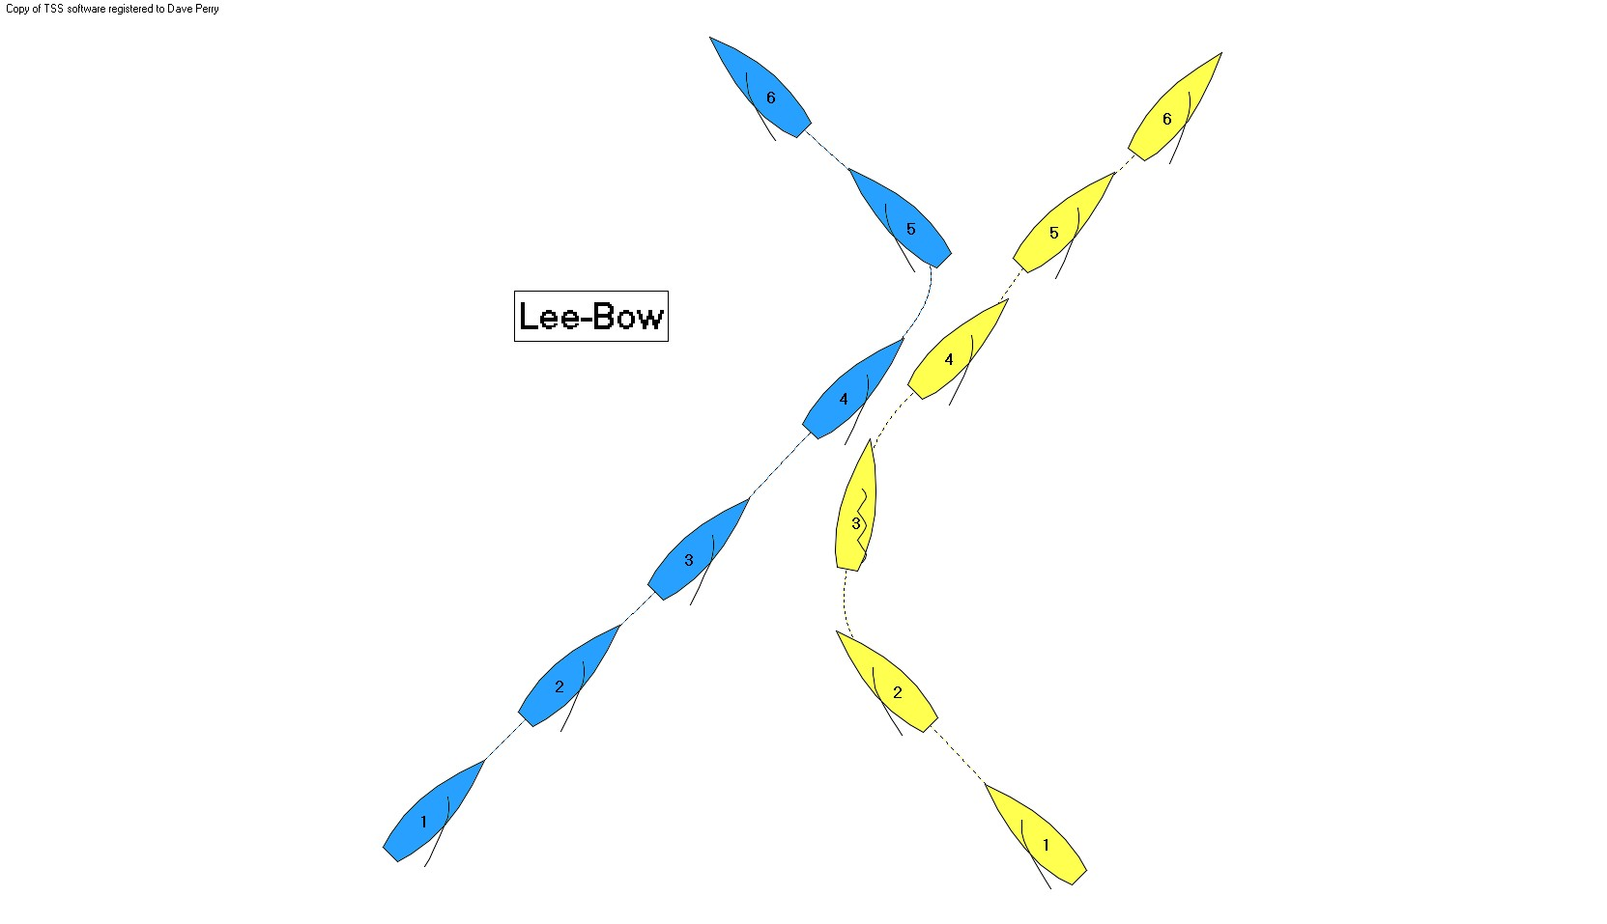

Dial Down

OBJECTIVE: Force the port-tack boat to tack, and then tack away to defend the right and keep the starboard advantage, or pin the opponent past the port-tack layline.

MANEUVER: Starboard needs to bear away into a position where Port can no longer bear away and pass astern. This is more typical when Port is slightly ahead of Starboard. The key is for Starboard to get her bow below Port's. Starboard cannot bear away to a course more than 90 degrees from the true wind.

RULES: As Port approaches Starboard, Port must keep clear under rule 10 (port/starboard). When Starboard changes course, she must give Port room to keep clear (rule 16.1). Starboard cannot bear away to a downwind course, i.e., to a course more than 90 degrees from the true wind (rule C7.2(a)(2), World Sailing Match Racing Call Book Index, and Calls D5 and D6).

COACHING POINTS:
- If Port tries to pass astern of Starboard, Starboard must be sure to begin heading back up so she is near close-hauled when Port arrives at her transom, giving her the option to Tack & Pin.
- If this happens near the windward mark, Starboard wants to be sure Port cannot duck her and then shoot up and make it around the mark.
- Generally the Dial Down is a weak move for Starboard, especially in boats under 30 feet. If Port succeeds in ducking Starboard with no penalty, Port gets the right and the powerful starboard tack advantage.

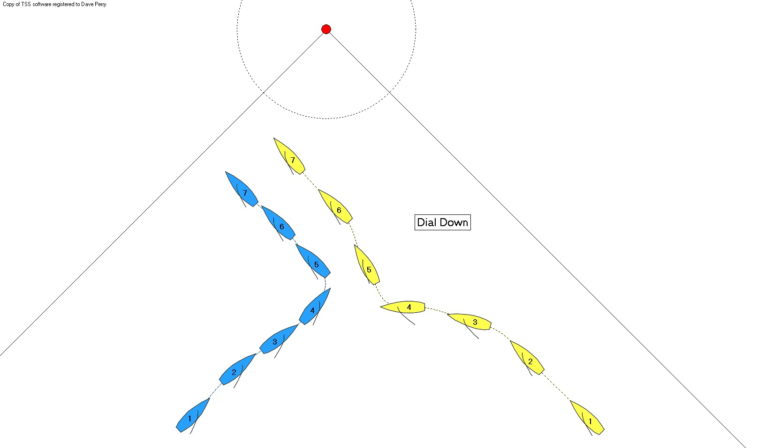

Tack & Pin (the “Soft Slam”)

OBJECTIVE: For Starboard to tack just to windward of Port and control her, or prevent her from tacking for a short time.

MANEUVER: Starboard crosses Port and then tacks within two seconds. Typically Port will luff and shoot up towards Starboard; Starboard must keep clear. Often the boats will remain near head to wind for a while. If Starboard tacks in the correct place, Port will be far enough away from Starboard so she cannot reach Starboard when she luffs. If Port tacks, she will be too close to assert her right of way (rule 15, acquiring right of way) and will usually pass astern of Starboard.

RULES: Port must keep clear of Starboard under rule 10 (port/starboard). Starboard remains the right-of-way boat until she passes head to wind. When Starboard passes head to wind, Port instantly becomes the right-of-way boat (rule C2.6, 13.1). Because Starboard gave Port the right of way, Port does not need to give Starboard room to keep clear under rule 15. When Starboard reaches a close-hauled course, she must continue to keep clear under rule 11 (windward/leeward).
If Port changes course after Starboard has passed head to wind, she needs to give Starboard room to keep clear under rule 16.1. However, as rule 17 does not apply in match racing (rule C2.8), Port can sail above her proper course, even if she becomes overlapped from clear astern after Starboard completes her tack.

COACHING POINTS:
- Starboard should count to two after Port’s bow reaches her transom, then tack.
- Starboard’s helmsperson should turn facing aft in the tack so she can watch Port’s bow the entire time.
- Both boats must be careful to avoid a collision, as both boats are at risk of penalty.

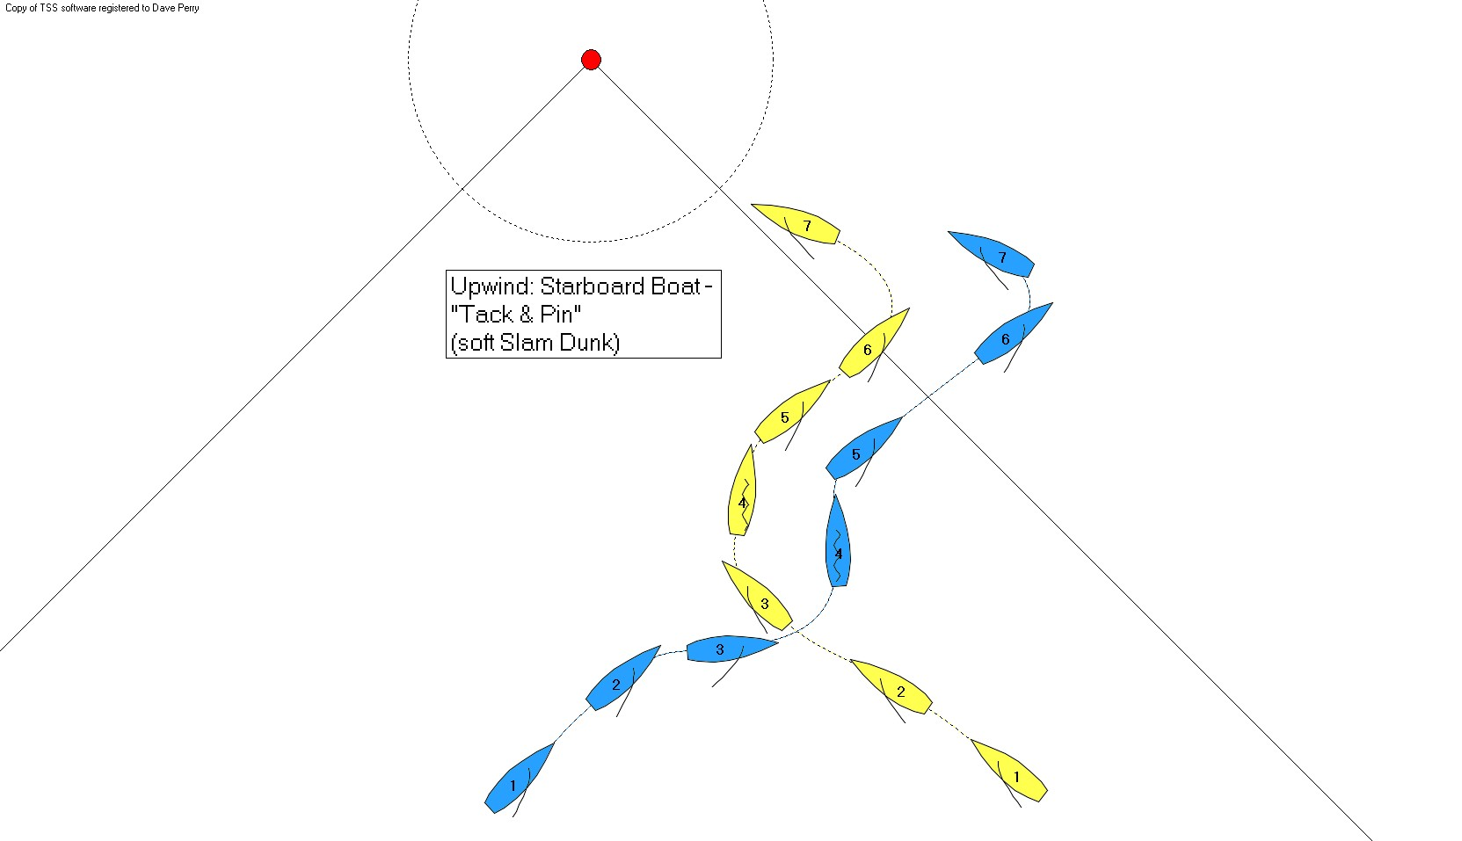

Fake Tack When Ahead

OBJECTIVE - to get in phase with trailing boat.

MANEUVER: Cross and tack on opponent. If opponent tacks immediately before you get too far past head to wind, come back down to course and sail in phase with opponent for as long as needed. This is a likely move near a layline.

COACHING POINTS:
- This move works well when the trailing boat is seen to be quick to tack away when being tacked on
- When tacking on your opponent, do a slow smooth turn and see if they tack away soon enough to allow you to stop your tack and get in phase with them.
- If you stop your tack, and your opponent stops their tack, simply stay head to wind directly in front of them, watching them, and matching whatever they do.

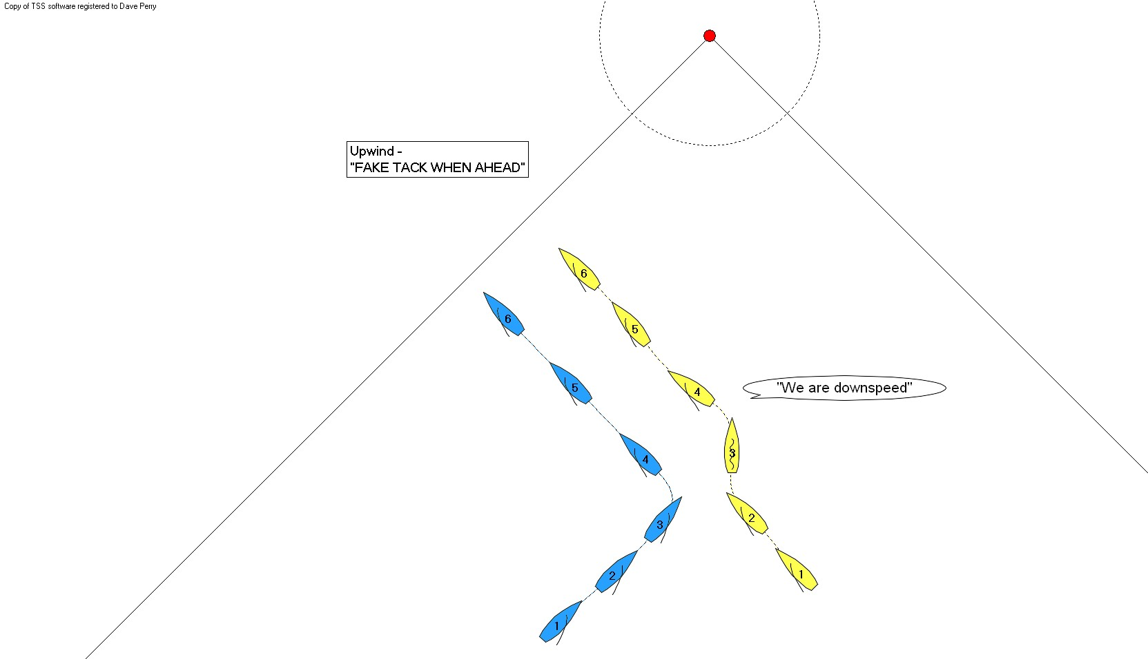

Fake Tack When Behind

OBJECTIVE – to get out of phase with leading boat

MANEUVER – Begin to tack and watch the leading boat. If she tacks simultaneously, when she passes head to wind return to close-hauled on original tack. This works well if starting behind opponent at the Committee Boat or Pin, or when rounding the leeward mark directly behind opponent.

Upwind Plays – Port Tack Boat

The Duck

OBJECTIVE – to get to the right of your opponent and gain the powerful starboard tack advantage

MANEUVER – Port bears away when a length or two from Starboard. Her goal is to be turning back up towards close-hauled as she arrives at Starboard’s transom.

COACHING POINTS:
- Starboard can only bear away to 90 degrees from the true wind to dial P down. (MR CALL D5 and D6); if S dials P down, P should continue ducking S because P can bear away more than 90 degrees.
- If P plans on tacking back to starboard, P should do an extra big duck early so as not to get pinned under S if she tries to Tack & Pin P.
- If P wants to try to break through to S’s right, P ducks a couple lengths away and then begins a slow luff “holding land” on S’s skipper (a point about 2/3rds of the way back along S’s port side). If S has borne away to hunt, S will have to luff up at some point. P luffs immediately “holding land” on S’s skipper and passes S’s stern as close as possible.
- If S tacks, P keeps bow down for speed until wind is ahead of S’s bow; then P sails high up under S and forces S to tack away. P extends one length and tacks. OR, P luffs aggressively up to head to wind, trying to slow S or force her to tack back to starboard. When P changes course, she must give S room to keep clear (rule 16.1).

NOTE: If P passes astern of S and S does not tack, P extends two lengths and tacks. That prevents S from being up to speed when S tacks to port tack and meets P (now on starboard tack).

NOTE: the elimination of rule 17 (C2.8) makes it hard for S to “slam dunk.” P can sail ABOVE her proper course at any time, even if she became overlapped on S after S completed her tack; i.e., P can luff S as long as she gives S room to avoid her (rule 16.1).

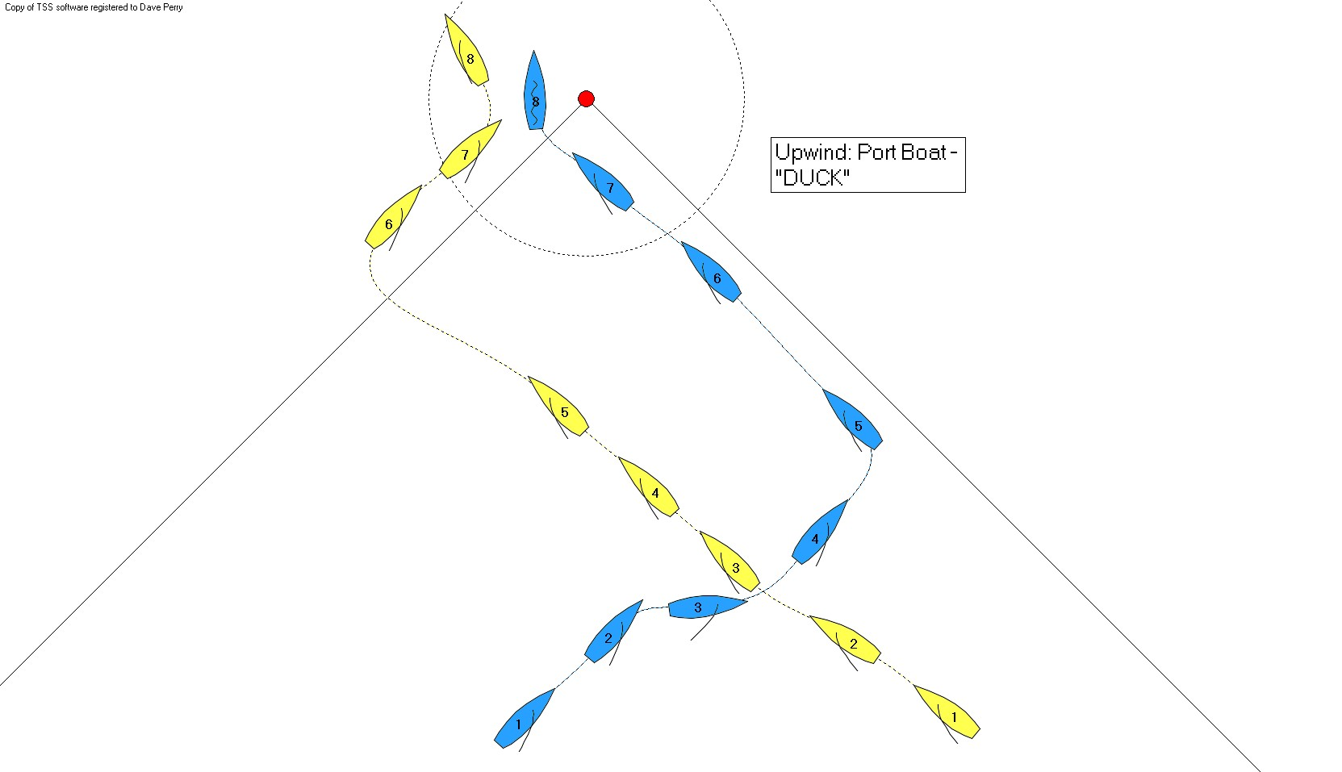

Late Duck
OBJECTIVE: For Port to put Starboard in a position where Port can duck Starboard and it is too late for Starboard to lee-bow Port.

MANEUVER: Port holds course, looking as if she is going to lee-bow Starboard. At the last moment, Port bears away sharply and passes astern of Starboard.

COACHING POINTS:
- the crew on Port should do what they would normally do in preparation for a tack
- Port’s helmsperson should aim for a point roughly 1/3rd of the way back along Starboard’s port side

Duck and Shoot
OBJECTIVE: For Port to counter Starboard's Tack & Pin, and force Starboard back onto starboard tack, giving Port the right and the starboard tack advantage.

MANEUVER: When Starboard crosses Port and then tacks almost immediately, Port luffs and shoots up towards Starboard. Port should be coming up to Starboard's transom as she is completing her duck. When she luffs, it is critical that Port not go past head to wind. Starboard must keep clear. Often the boats will remain near head to wind for a while. Eventually Starboard will go back to starboard tack. At that moment Port bears away and builds speed on port tack.

RULES: Port must keep clear of Starboard under rule 10 (port/starboard). Starboard remains the right-of-way boat until she passes head to wind. When Starboard passes head to wind, Port instantly becomes the right-of-way boat (rule C2.6, 13.1). Because Starboard gave Port the right of way, Port does not need to give Starboard room to keep clear under rule 15. When Starboard reaches a close-hauled course, she must continue to keep clear under rule 11 (windward/leeward).
When Port luffs, she needs to give Starboard room to keep clear under rule 16.1. However, as rule 17 does not apply in match racing (rule C2.8), Port can sail above her proper course, even if she becomes overlapped from clear astern after Starboard completes her tack.

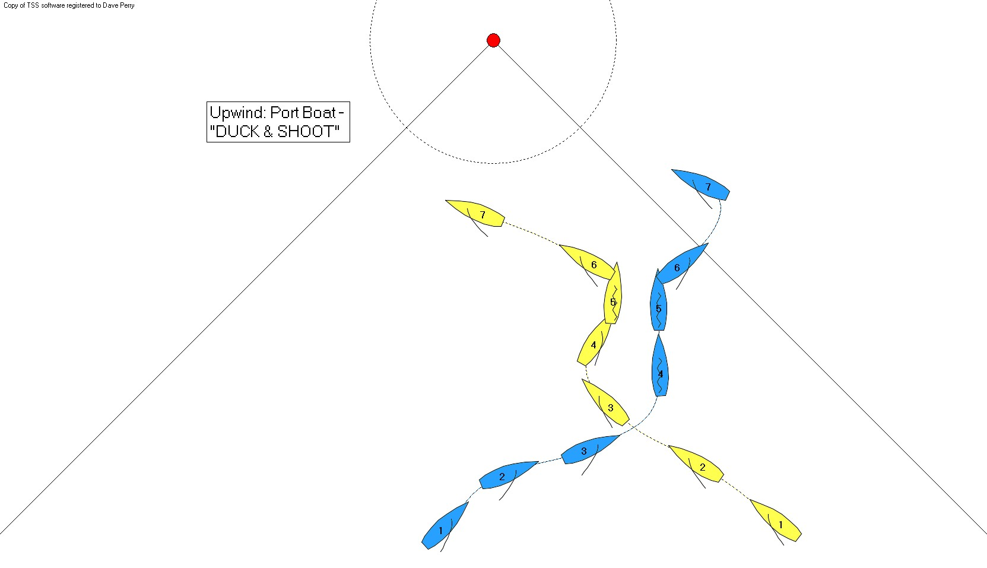

UPWIND PLAYS – COVERING MODES

"LOOSE" & "TIGHT" COVERS

OBJECTIVE: To stay ahead of opponent. In the "tight" cover, you give your opponent no clear air on both tacks. In the "loose" cover, you give your opponent clear air on one or both tacks.

MANEUVER:
In the "tight" cover, the boat is turned simultaneously with the trailing boat. Be ready for fake tacks, and prolonged sailing head to wind. Typically the boats will become downspeed.

In the "loose" cover, tack where your opponent has clear air and is more likely to continue sailing in that direction. This is typically done when the leader is well ahead in the race and wants to stay in the same general area on the race course as the trailing boat; or when the leading boat wants to force the trailing boat to sail on one tack and not the other.

