Chapter 3…The Windward Mark

The windward marks provide many opportunities to pass, and be passed by, your opponent. Also, many penalties are earned at the windward mark. Here are some strategies and tactics when approaching and rounding the windward mark.

OBJECTIVES FOR THE WINDWARD MARK:

If ahead:
- round ahead of opponent with no penalty
- be in better position than opponent to execute strategy at beginning of downwind leg

If behind:
- round ahead of opponent with no penalty, or
- round just behind opponent, and in better position to execute strategy at beginning of downwind leg

TACTICAL THOUGHTS

If both boats are approaching on port tack:
- The lead boat should sail as high as possible to cause their opponent to have to pinch or sail in their disturbed air and water. The lead boat can extend their lead a bit by doing this.
- The trailing boat should never become locked in to windward of the leading boat.
- If the trailing boat becomes locked in to windward of the leading boat, the leading boat should luff head to wind and stop the trailing boat; then bear away and extend their lead.
- Once the leading boat reaches the two-length zone clear ahead or overlapped on the inside of the trailing boat, the trailing boat must give her “mark-room” (rule C2.9, 18.2(a)), which includes room for the leading boat to bear away or gybe around the mark if either is the boat’s proper course (definition Mark-Room).

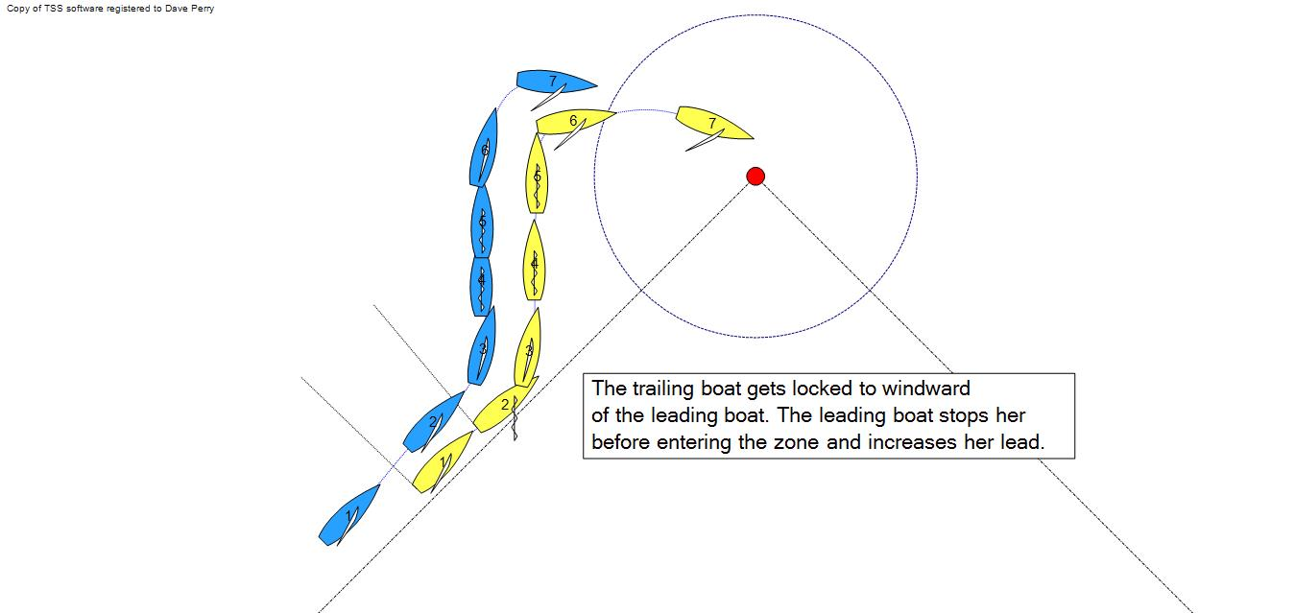
If both boats are approaching on starboard tack:
- If the two boats are overlapped when heading to the mark, the leeward boat should luff and then bear away to break the overlap before reaching the two-length zone.
- If the boats are not overlapped when the leading boat gets to the zone, the leading boat is entitled to room to tack around the mark (definition Mark-Room).
- If the boats are overlapped inside the zone, the inside boat is entitled to room to tack around the mark, so the outside boat must leave enough room for the inside boat’s stern to swing (rule 18.2(a)(1) and definition Mark-Room).
- If after the inside boat tacks there is space for the outside boat to fit between the inside boat and the mark, the outside boat is nevertheless not allowed to go in there (rule C2.9, 18.2(a)(1)).

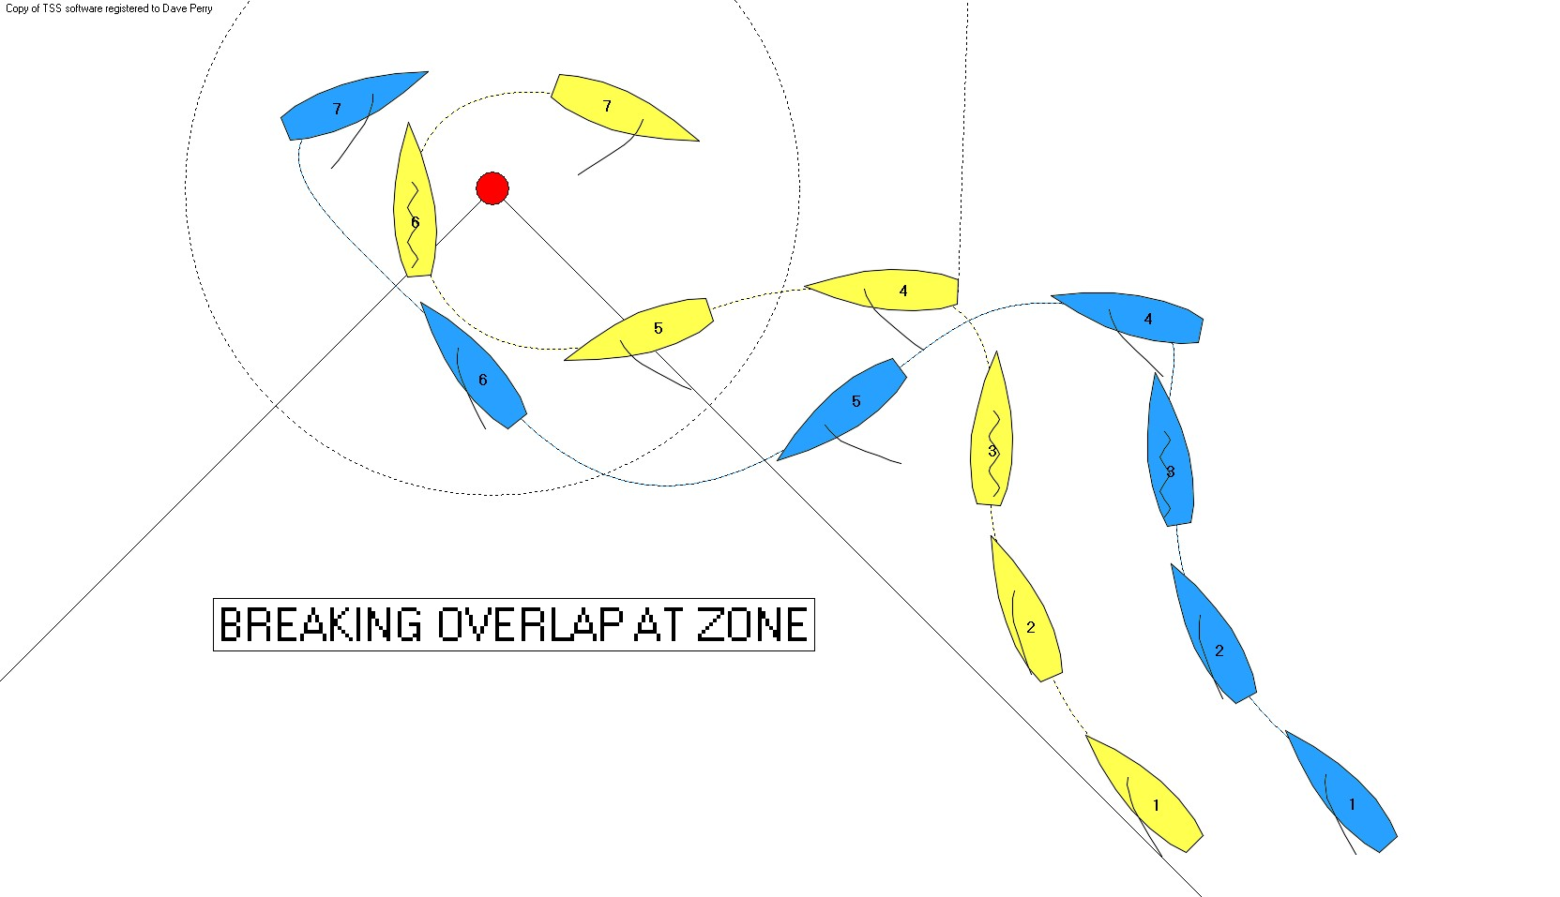

If the boats are approaching on opposite tacks:

- If you are on starboard tack:
- you can tack around the mark with no concern for tacking too close (rule C2.9, 18.2(a)(1) and definition Mark-Room)
- approach about one length below the starboard-tack layline so that you have space to complete your tack to starboard before your bow is at the mark; it will put you in a stronger position to begin the downwind leg
- you cannot dial your opponent down when in the zone (rule C2.9, 18.3(b))
- you cannot sail past the port layline if you will be affecting your opponent’s course while doing so (rule C2.9, 18.3(b))
- if your opponent tries to duck you, you can tack and “close the door” on them, including gybing if that is your proper course; they have to give *you* mark-room (rule C2.9, 18.2(a)(1)).
- once you’ve tacked to port, you do not need to round the mark. If your opponent becomes overlapped to windward of you, luff head to wind and stop them
- if while you are on starboard, your opponent tacks to starboard to leeward of you, you do *not* need to tack on the port layline; you can remain on starboard as long as your opponent remains on starboard. However once past the port layline you need to keep clear under rule 11 (windward/leeward). Note though that as long as you are in the zone, your proper course is to tack, and your opponent has to give you room to tack under rule C2.9, 18.2(a)(1).

Your primary objective is to tack around the mark ahead of opponent. Your secondary objective is to have them overlapped to windward of you when you round.

- If you are on port tack:
- approach one length over the port tack layline
- try to have your opponent slightly more advanced in the race than you so you can round on their stern or be to leeward of them after the mark
- never overlap your opponent to windward throughout the entire rounding
- your opponent cannot dial you down (though never try to duck her because you have to give her mark-room (rule C2.9, 18.2(a)(1)).

Your opponent is required to tack on the port layline. If she continues past the layline, you need to keep clear of her under rule 10 (port/starboard), but then protest her under rule C2.9, 18.3(b). She should receive a red-flag penalty.

Your primary objective is to round the mark close astern of your opponent, or slightly to leeward of them after the mark, and to use your better speed and spinnaker set preparation to end up close to leeward of them in a strong position to attack them after setting your spinnaker. Remember, with no rule 17 in match racing (sailing above proper course, rule C2.8), you can immediately luff your opponent once you get even a one foot overlap.

