Chapter 4…The Downwind Leg

The typical match race course has four legs. Usually legs 2 and 4 are downwind legs. Here are some strategies and tactics for the downwind legs.

Information it is useful to know before beginning the Downwind Leg:
- what is the angle of the wind to the “rhumbline” (the straight line between the windward and leeward mark or finishing line); i.e., what percent of the leg will be spent on each tack
- is the wind direction steady, oscillating, persistently shifting one way, or randomly shifty
- is the wind strength steady or changing up and down
- is there more pressure on one side of the leg than the other
- what is the current situation

OBJECTIVES FOR THE DOWNWIND LEGS

If ahead:
- stay ahead of opponent
- keep your wind clear (if possible, keep your wind ahead of opponent on the longer tack)
- minimize distance sailed by using shifts and better wind pressure

If behind:
- pass opponent; or at least round the leeward mark right behind them
- try to set up to be blocking the leader’s air on the longer tack
- minimize distance sailed by using shifts and better wind pressure

BOAT HANDLING THOUGHTS FOR BOTH BOATS
- try to exit the mark on a lower lane than opponent; swing wide/cut close when turning the mark
- as you are hoisting spinnaker in heavy air, sail extra low; as it fills, head up to optimum VMG angle

STRATEGY THOUGHTS FOR THE LEADER

if more than three lengths ahead, keep your wind ahead of trailer on longer tack to mark

if leg is 90% or more starboard tack or right side (looking downwind) has much better pressure, try to gybe before trailing boat has set their spinnaker
- in a close race (less than three lengths) where there is at least 20% port tack on the leg, it is generally better to stay on port tack as you exit the windward mark
- if the trailer also remains on port tack, deciding when to gybe to starboard tack is the toughest decision. The key is to gybe on the line where if the trailing boat crosses over and gybes to your left, you can soak (sail below VMG) and sail into the zone, but if the trailing boat gybes simultaneously with you (called a simo gybe), you can luff them enough so that if they roll you they cannot soak and sail into the zone. This place will come up before the layline, and is called the “Soak Line.”
- in light air, it generally pays to gybe well before the starboard layline, because if the trailing boat (B) gybes simultaneously (called a simo gybe) and then rolls the leading boat (A), it is critical that B cannot sail into the zone on starboard tack. That way, A can try to simo gybe when B gybes back to port tack and roll her back (“return the favor”) and lead her into the zone on port tack
- in medium air, it generally pays to gybe when 8-10 lengths from the starboard layline, because it is harder for the trailing boat to simo gybe and roll the leading boat and get down in front of her
- in heavy air, the leading boat can wait until 6-8 lengths from the starboard layiline, as it gets increasingly difficult for the trailing boat to simo gybe and roll the leader as it gets windier

- always be sure your wind is behind or ahead of your opponent; never sail in their disturbed air. Typically you want your wind ahead of them on the longer tack to the leeward mark.
- it is better to defend the left side (looking downwind) early for the starboard advantage, and then the right side (inside at the mark) late.
- try to approach the leeward mark on starboard tack for easiest rounding

STRATEGY THOUGHTS FOR THE TRAILER
- if you are within three lengths of leader at start of first downwind leg, you can catch up to them by the leeward mark, and even pass them!
- unless you can easily roll the leader on port, it is better to soak to leeward of their centerline so you are set up to simultaneously (simo) gybe when they do. After you have simo gybed, you then have the choice of trying to pass them on their left or their right (looking downwind).
- if you are well above the starboard layline to the leeward mark, it is better to try to pass on their left. As you get closer to the starboard layline to the mark, it is better to try to pass on their right
- from the moment you round the windward mark, always know whether you will want to gybe before, with or after the leading boat gybes; this is critical
- by gybing before them, you gain control of the right side of the leg (looking downwind) which on the first downwind leg is the “inside” position at the mark (better in lighter wind)
- by gybing simultaneously with them (simo gybe), you have the chance to block their wind and catch up or pass them (better if within one or two lengths of them)
- by gybing after them (crossing over), you gain control of the left side of the leg and have the starboard tack advantage all the way down (better in stronger wind and on the run to the finish); but also if within one length of them)
- try to block the air of the leading boat when she is on the longer tack to the mark. When attacking another boat’s wind, use THEIR telltales or masthead fly to guide you. Position yourself directly in line with THEIR wind indicators

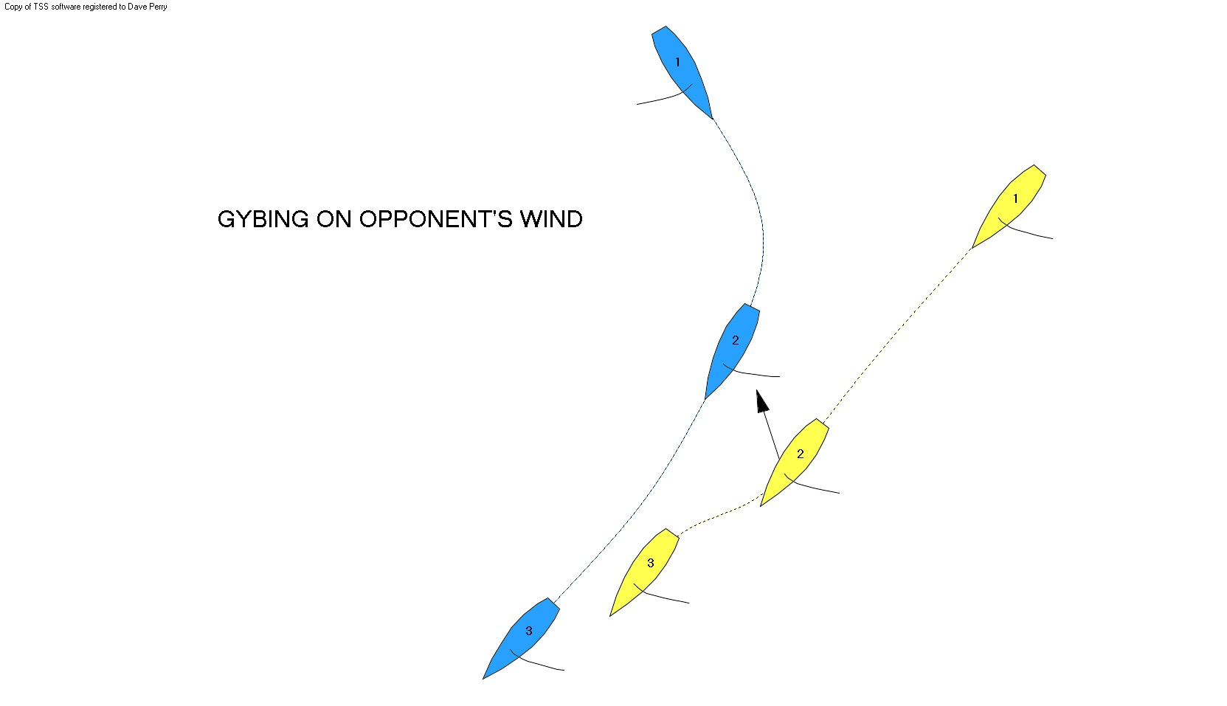

- try to position yourself so you get the best wind pressure first
- try to approach leeward mark on starboard tack for easiest rounding and fastest exit maneuver (usually a tack)
TACTICAL THOUGHTS FOR THE LEADER

The exit from the windward mark
There are three possible spinnaker sets: “bear away”, “bear away and immediate gybe”, and “gybe set”. Be sure to have decided which you will use *before* you round the windward mark.

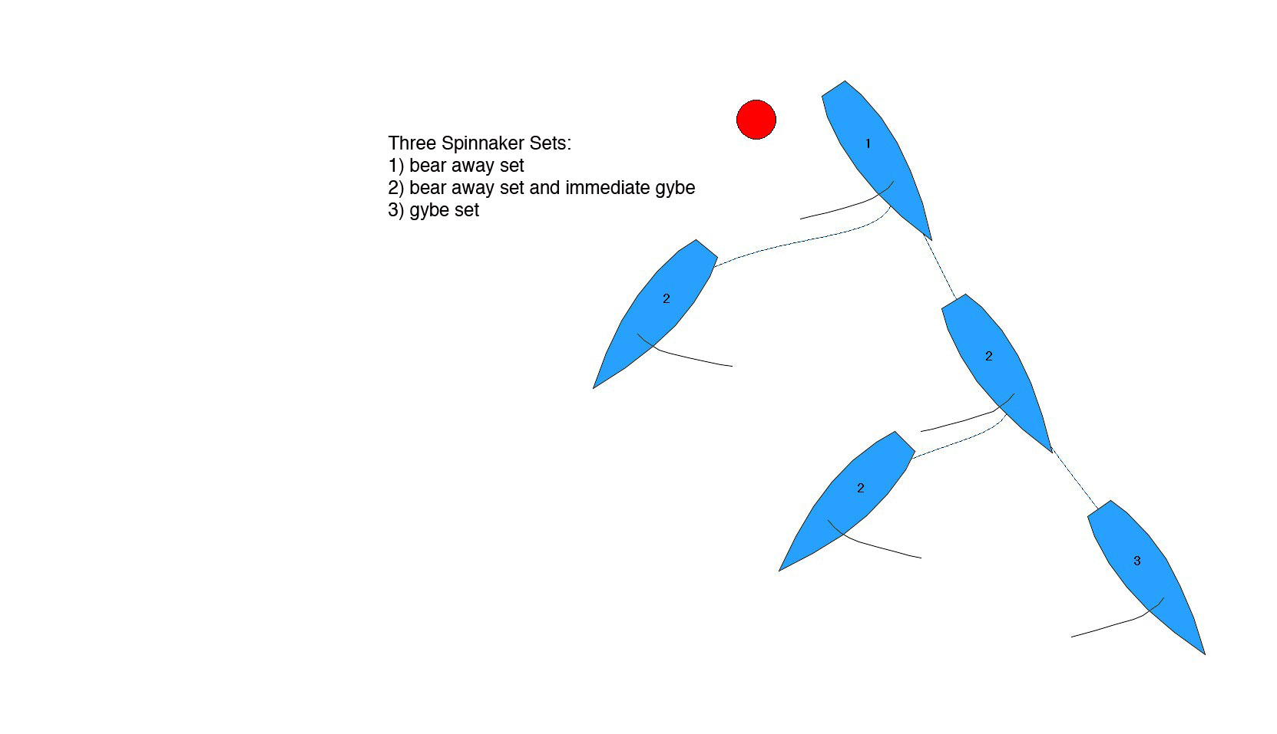

Here are some thoughts in making that decision:
- if you can nearly arrive at the leeward mark or pin end of the finishing line on one tack, get on that tack immediately
- if one side of the run is predominantly favored, go towards that side immediately
- if the leg will be 90% starboard tack or more, and the breeze is medium to heavy, consider the gybe set; otherwise, if you want to get onto starboard tack quickly, use the bear away set and immediate gybe. Gybe sets are difficult and costly in terms of boat speed, especially in light and medium wind
- on the run to the leeward mark, and all other things being equal:
- in over 8 knots, initially stay on port tack. It is very difficult for the trailer to block your wind, and if they gybe first, it will put you on starboard tack when the two boats converge later down the run
- in under 8 knots it is a harder decision…the advantage of remaining on port tack is explained above. The advantage of getting onto starboard tack first is two-fold:
- it is easier for the trailer to simo gybe and block the wind of the leader, roll them and soak down in front of them; so by beating them to the gybe, it takes that advantage away from them, and
- it sets the leader up on the inside for the rounding. What will happen is that later down the run when the boats converge, the leader can gybe onto starboard tack, either in front of the trailer or on the trailer’s wind, which can lead to rolling the trailer and pulling clear ahead at the zone. e mark.
- on the run to the finish, defend the left side (looking downwind) to always have the starboard advantage
- when in doubt, remain on port tack during the exit and save the starboard-tack advantage, but be sure to gybe before you get within a few lengths of the starboard-tack layline to the leeward mark (right-hand gate mark looking downwind, if using a gate) or the pin end of the finishing line.

If you remain on port tack and the trailer follows you and is within two lengths or so…

- try to get and keep your opponent to WINDWARD of your centerline.
- defend your left side! Keep your wind about one boat length ahead (no more / no less) of the trailer’s spinnaker (watch your windward shroud or backstay telltale or masthead fly religiously…the wind angles change constantly with variations in true and apparent wind angles and speeds). If your wind is two lengths ahead, bear away until it is about one length ahead, i.e., slide down towards the mark. If it gets less than one length, head up slightly, thereby bringing your apparent wind forward
- do not let your opponent overlap you to leeward because in match racing there is no rule 17 (proper course limitation, rule C2.8) meaning the leeward boat can luff you aggressively with only a one foot overlap.
- If your opponent is about to overlap you (perhaps they had a better spinnaker set), bear off to a dead downwind course (DDW) and just before they overlap you, throw your boom over. If they overlap you to your right, they will have to gybe and you can luff them aggressively. If they head up to cross your stern, immediately throw your boom back over and luff them aggressively on port tack (the old double-gybe maneuver).

If your opponent remains astern of you, keep asking the question: “if they gybe, what will we do?” To answer that question, here are some thoughts:
- if you are still a long way from the starboard-tack layline, and if wind and current is equal, then if they gybe, let them go and you gybe when your wind is safely BEHIND them and you are out of reach of their transom wake
- if you are near the starboard-tack layline (within 10 lengths or so), match their gybe (gybe simultaneously with them) and turn up to a close reach to ensure that your wind is AHEAD of them

NOTE: the skipper must be getting constant information on how close to the layline the boat is, and someone must be constantly watching the other boat and reporting where they are, how far in front the lead boat’s air is, and instantly saying when they begin their turn.

If the trailer is within two lengths of you and to LEEWARD of your centerline in perfect position to block your wind after you gybe:

- try to sail lower than them and move them to windward of your centerline (see above)
- at some point, you will have to initiate the next move. Here are some thoughts:
- wait until you are 10-12 lengths before the starboard layline. In other words, if you were to gybe there, you would not be able to soak and get to the zone of the leeward mark.
- try a fake gybe (bear away, pull the boom in, but leave the spinnaker pole attached). If the trailer “bites” and gybes, simply head up, build speed and gybe with your wind behind the trailer. If the trailer does not bite, simply head up and build speed. The trailer may be more to windward of your centerline now. Typically this only works well when the trailer is less than a length behind or so.

- in light air, gybe HOT, meaning onto a hot angle (higher than VMG). If the trailer simo gybes, then try to get your wind ahead of the trailer or luff them and stop them. In light air, make this gybe sooner than later!
- in heavier air, gybe DEEP, meaning onto a deep angle (lower than VMG). If the trailer simo gybes, try to get your wind behind the trailer. If the trailer tries to soak down to your wind, head up sharply and get your wind in front of them. In heavier air, you can wait until you are more like 6-8 lengths from the starboard layline
- in medium air, you can try gybing hot, gybing deep, or making two quick VMG gybes (gybe and then, if the trailer simo gybes, gybe right back)
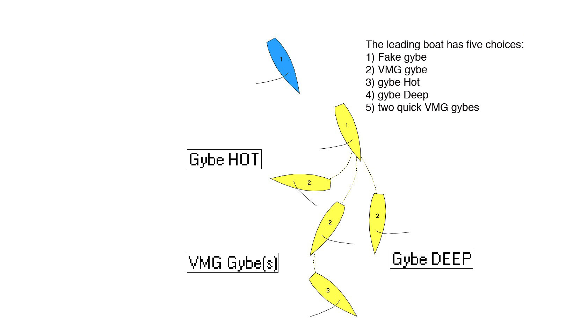

If you are on starboard tack and the trailer is following you and is within two lengths or so:

- again, keep the trailer to WINDWARD of your centerline, with your wind about a length ahead of them. You are in the “Power Position”
- if while on starboard, the trailer threatens to take your wind, you have two choices:
- simply gybe before they do take your wind. This leaves you with the starboard advantage, and is an especially strong move when racing to the finish, because you can finish on port tack. Under no circumstance can you let them overlap you to leeward (because they can luff you or sail you well past the port layline to the leeward mark. Or,
- head up to keep your wind ahead of them; and if necessary, luff them sharply (giving them room to keep clear under rule 16.1 (changing course); and to get their spinnaker down under MR Call G2)
- if they gybe, gybe simultaneously with them (“match them”) so your wind will be AHEAD of theirs on starboard tack and you’ll be protecting the left side of the run (looking downwind) and saving the starboard advantage for later.

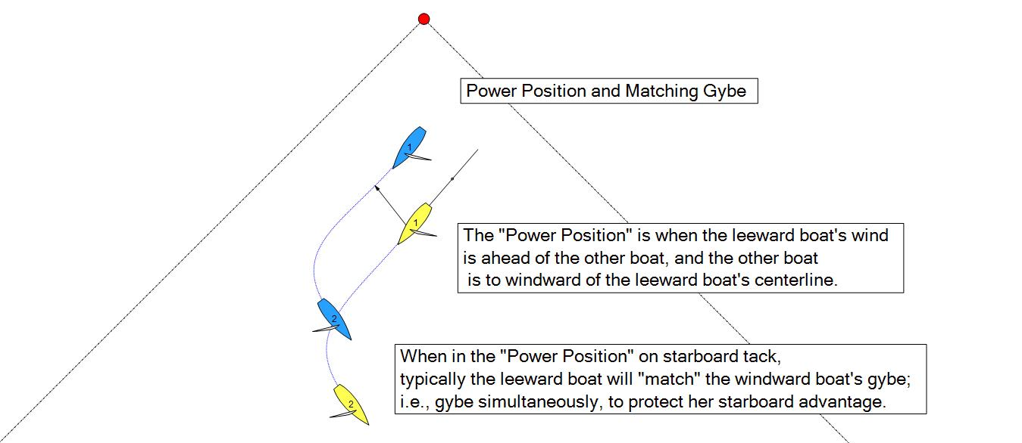

If you are converging on opposite tacks…

If you are on starboard tack:
- if you are within one length of the trailer, DO NOT LET THEM TAKE YOUR TRANSOM !!! Head up early cutting off their ability to get astern of you, then bear away and force them to gybe to windward of you. Because there is no rule 17 (sailing your proper course, rule C2.8) in match racing, you do not need to sail your proper course during that overlap, and can carry them as far past the port tack layline as you wish.
- If you are a couple lengths ahead:
- then early in the run defend the left (looking downwind); i.e., gybe so your wind ends up AHEAD of theirs (remember you will be down-speed after your gybe so gybe sooner rather than later!). Try to cross their centerline slightly before you gybe so they end up to WINDWARD of your centerline if possible.
- if you are within 10 lengths or so of the starboard-tack layline to the leeward mark, change sides with them if possible, i.e., try to cross ahead of them. If going to the finish, you may have to gybe to protect the left (looking downwind) and then gybe back near the starboard-tack layline to the race committee boat.

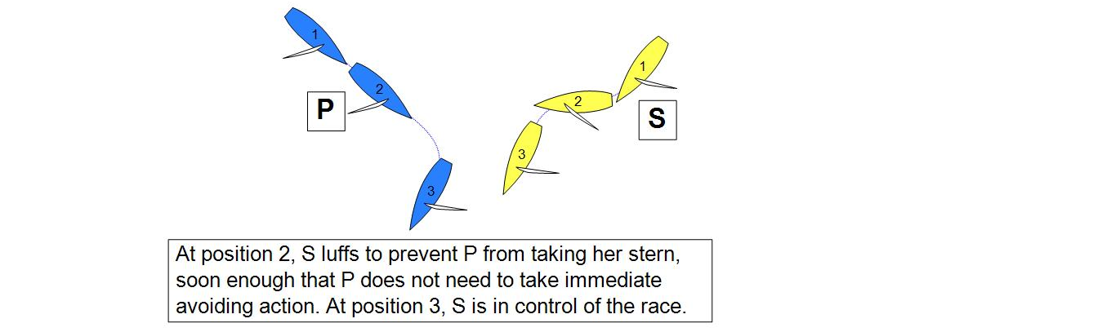

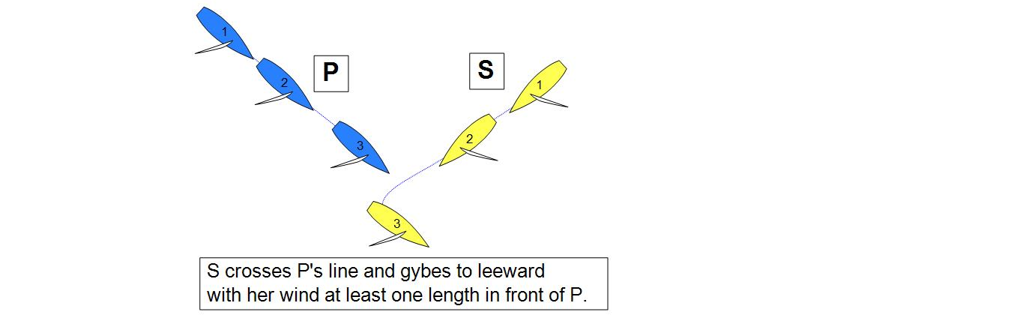

TRICK: if you decide to “switch sides,” the trailer will probably be looking to gybe and block your wind. As you approach, sail about 10 degrees below max VMG angle. The trailer may delay their gybe to be sure they gybe on your wind. As they gybe, immediately head up and pull your wind AHEAD of their spinnaker.

If you are on port tack: what you never want to do is gybe into a windward overlapped position, or just in front where the trailing boat can easily become overlapped to leeward of you. Because there is no rule 17 (sailing your proper course, rule C2.8) in match racing, once overlapped to leeward of you, the trailing boat does not need to sail their proper course during that overlap, and they can carry you as far past the port-tack layline as they wish.

- If you are on port tack and ahead, and not near the starboard-tack layline, and you can cross starboard (i.e., “switch sides”), then that is desirable. If you think starboard may gybe on your wind, try sailing extra low to try to sucker them into delaying their gybe; then head up quickly to pull your wind AHEAD of them
- If starboard hits your wind, gybe away immediately, extend to full speed, and gybe back again (or when the wind is most favorable for you to do so)
- If starboard lets you cross, gybe when you are sure your wind will be BEHIND theirs and that you are clear of their transom wake
- If you are within 10 lengths or so of the starboard layline, just cross starboard’s centerline (if you can) and gybe, making sure your wind will be at least one length AHEAD of theirs after you build to full speed. (The risk of going all the way through and gybing with your wind BEHIND them is that if the velocity increases or the wind shifts left allowing starboard to either sail into the zone on starboard tack, or have the eventual port-starboard convergence occur inside the zone, you have to give starboard room at the mark (even if overlapped on opposite tacks).
- If you cannot cross, then it is better to sail hot and pass astern of them, go two lengths, and then gybe onto starboard tack. From there you might sail into a position where they cannot gybe. And if they can gybe, then you can gybe on their wind, pull forward on them, and then gybe onto starboard and attack them.
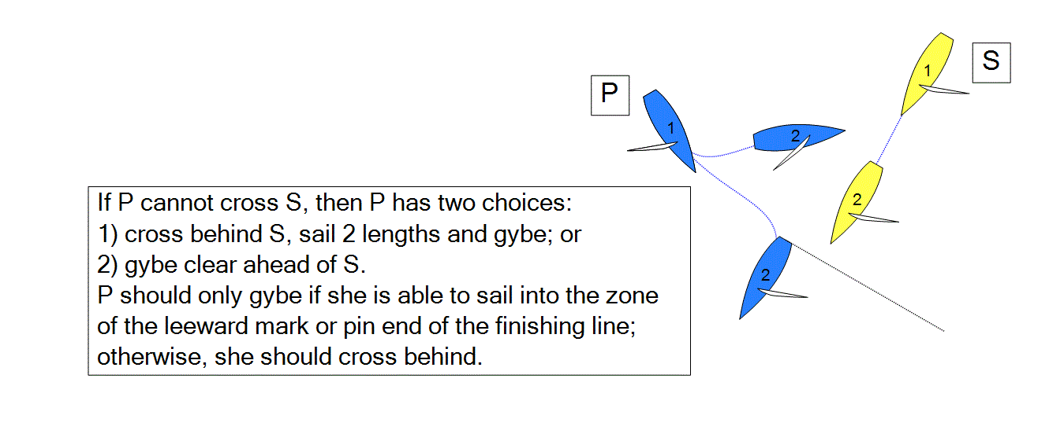

TACTICAL THOUGHTS FOR THE TRAILER

If you are behind at the windward mark…
- unless one tack is predominantly favored, plan to do a bear away set and be ready for an immediate gybe
- if the leader stays on port tack, try to out sail them through the spinnaker set and thereafter so you end up to LEEWARD of their centerline. Your goal is to overlap them to leeward and then luff them aggressively. Overlap them tightly so they cannot gybe, or far enough to leeward of them so that if they gybe on starboard, you can quickly luff and cross their stern. Watch out for them gybing right back as you cross over.
- resist the temptation to gybe if the leader gybes right after the mark. When the leader initiates the gybe right after the rounding, and the trailer gybes and follows, typically the leader ends up in the Power Position (wind ahead of the trailer and trailer to windward of the leader’s centerline). From here, the leader can keep her wind clear on both tacks for the entire leg
- if the leg will be a long port tack, consider heading up to try to force the leader to head up. When the two tacks are more even, work hard to get back to LEEWARD of their centerline and await their gybe. But don’t try too hard to force the leader up. If the leader doesn’t head up in response, the trailer just ends up farther to windward and in a weaker position.
- if you are more than three lengths behind, you have to do a better job than your opponent on sailing your boat low and fast, sailing the shortest distance to the next mark (sail on the headed tack) and getting the puffs first. Once you within 3 lengths, you can think more boat-to-boat tactics

When they gybe…
- if there is still a lot of port tack left in the leg, set up to pass them on their LEFT (looking downwind):
- if you are within a length or so, or more than three lengths back, or if you are to WINDWARD of their
centerline (which means you won’t be able to hit their wind on starboard tack), when they gybe “cross over”, which means switch sides by crossing their transom and gybing when your wind is clear BEHIND them and you are clear of their transom wake. This is usually in 1-2 lengths after crossing their centerline. The one exception is that in light air it can work to simo gybe and roll the leader, because the speed differential often lets you soak down in front of them after the roll
- if you are between 1-3 lengths behind and to leeward of their centerline, simo gybe when they gybe. You will either be on their wind, or close enough that they will luff to try to get/keep their wind ahead of you. Either way, you will close the distance between the boats. Then, just before you get locked to windward of them, bear away sharply or gybe and cross their transom (be careful your spinnaker clears their backstay or main leech!). If you choose to gybe, then gybe back once you are about 1-2 lengths to their left. You own them now!
- if there is not much port tack left, i.e., you are within 10 lengths or so of the starboard layline to the mark: simo gybe and block their wind if you can; otherwise cross over.
- if you cross over, gybe within a length of crossing their centerline; you may be able to use your starboard advantage before the leader can get to the zone;
and worst case you will follow them into the mark on starboard, have a good rounding, and plan to tack around the mark
- if you simo gybe and are blocking their wind, you have to make a quick decision: whether to try to pass them on their left or their right? The rule of thumb is: if you think you can roll them on starboard tack, pull clear ahead, and then soak into the zone on starboard tack, then pass them on their right…if not, set up to pass them on their left

- When in doubt, set up to pass on the left. If the trailer tries to pass the leader on the right and fails, typically the trailer loses a lot of distance in the effort, and often ends up with a penalty as well. And again, if the trailer sets up to pass on the left and doesn’t pass, the worst case is that they will round the leeward mark directly behind the leader and in a good position to tack around the mark.

if you are racing to the finish, always try to pass on the left unless you are 100% sure you can roll the leader on starboard, break the overlap, and sail into the zone of one of the finishing marks on starboard tack.

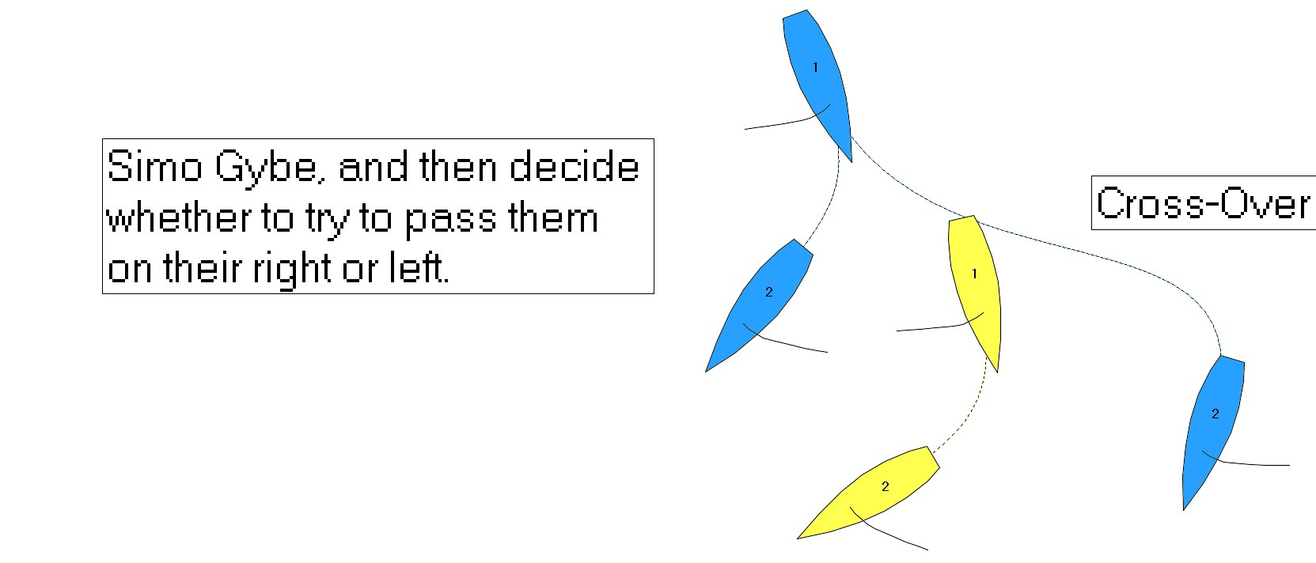

Global thoughts when catching up to the leader
- when you are closing in on the leader when both boats are on starboard tack, and assuming you won’t beat them to the zone: bear away and sail to LEEWARD of their centerline. You do NOT want to get pinned to windward of them.
- when you are closing in on the leader when both boats are on opposite tacks, and you are on port tack: plan early to cross over, i.e., luff and sail across the stern of the leader; do not get forced to gybe to windward of the leader

RACING TO A LEEWARD GATE
Racing to a leeward gate in match racing makes for a more interesting race course, and one that keeps the race closer for longer into the race. Here are some tactical thoughts when racing to a gate. For clarity’s sake, I will refer to the two marks as they appear when racing downwind towards them. The mark on the left (looking downwind) will be the “left-hand mark,” and the other the “right-hand mark.” (see leeward gate diagram)

Keep in mind that racing to the finishing line on leg 4 is the same as racing to a gate (each has four laylines), except that the boats will round the gate marks. The leading boat has the advantage of being able to choose which gate mark to round; the trailing boat has the advantage of being able to choose to round the same mark as the leader, or not. This makes the game much more interesting for both boats, and makes rounding behind the leader much less disadvantageous. When the trailer rounds the same mark as the leader (which they are forced to do with a single leeward mark), they have two not-great choices: stay on the same tack and sail in the disturbed air and water of the leader; or tack (often when downspeed after the rounding). The problem is usually that the leader will tack with the trailer, ending up in a very strong position to start the second beat.

With a second mark to choose from, the trailer will normally round the other mark than the leader did, starting the beat in clear air and water, and out of phase with the leader. This opens up far more tactical options for attacking and trying to pass, or stay close to, the leader.

The leeward gate is normally set approximately 3 lengths apart to minimize any bias if the gate is not square to the wind, and to reduce the chances of the leeward boat luffing above its proper course (rule C2.9, 18.3 does not apply at a gate) because she will quickly become the outside boat in the zone to the other mark and required to give the windward boat mark-room at that mark (rule C2.9, 18.2(a)(1)). (see leeward gate diagram)

When wouldn’t the trailer round the other mark than the leader did?
- If the bias in the gate is significant (10 degrees or more), the gain from rounding in clear air and water will be less than the loss of sailing the extra distance to round the other mark. When approaching the gate, decide whether one of the marks is noticeably more upwind than the other.

- But if the marks are relatively square to the wind, and one side of the beat is significantly favored, and the leader rounds the mark closer to that side, then rounding the other mark than the leader rounded and tacking immediately is a better way to get to the favored side. If you round the same mark as the leader, you will end up tacking almost immediately “away” from the favored side (to clear your air), and the leader will easily be able to prevent you from ever getting to the favored side if they want to.

How should the leader decide which mark to round?
There are many considerations that go into the decision on which mark to round, for both boats.
- is one mark more upwind, and by how much?
- is one side of the beat significantly favored?
- which rounding provides the easiest / fastest boat handling?

- To determine if one mark is more upwind than the other, you can watch boats ahead of you round and exit the gate, look at flags on nearby race committee boats, and eyeball the two marks yourself. And you will give some thought about the next beat about halfway down the run, again watching matches on that leg, thinking back on the leg you just sailed, and eyeballing the water.

- As for picking the easiest / fastest rounding, one consideration is that in light air a gybe around the leeward mark is very slow. Taking the rounding that doesn’t require a gybe will be faster in light air. This factor is reduced in more breeze, but gybing is always slower and more risky than not.
- If all things are pretty equal, rounding the right-hand mark will require one less gybe on the run and an easier rounding, and rounding the left-hand mark will position the leader to the right of the trailer, giving them the initial starboard-tack advantage. It is also easier to defend the inside position racing to the left-hand mark, as the inside position can be held on starboard tack.

In general, plan to round the right-hand gate mark (looking downwind) unless the left-hand mark is favored or the race is very close. Setting up to round the right-hand mark leaves the option to gybe and round the left-hand mark.

Setting up the approach to the gate
- The interesting thing about the gate is that it provides four laylines, or approaches, to the gate (see diagram). Before being sure which mark to round, gybe before arriving at any of the laylines, thereby keeping options open longer. Once a boat has passed the first layline to one of the marks, they will have overstood that mark if they later decide to round that one.

- Early in the leg, often the leading boat gybes to starboard first. If the trailing boat is within 1-2 lengths, they should not gybe. Instead they should cross over, sail 1-2 lengths and gybe. They will be in a strong position to attack the leader, or at least round the left-hand gate mark.

- Often when the leading boat gybes, the trailing boat matches the gybe, trying to take the wind of the leader and roll them. Often this fails, and the trailer is left to windward of the leader with the leader’s wind in front of them. This is a weak position with a single leeward mark. With the gate however, if the leader sails past the port-tack layline to the left-hand mark, the trailer can gybe on this layline with the initial plan to round the left-hand mark. And if the leader does gybe on this layline, the trailer can do the same, leaving them the option of later gybing on the starboard-tack layline to the right-hand mark and rounding that one in clear air.

- Furthermore, the trailer can gybe *before* the port-tack layline to the left-hand mark, getting them to the left of the leader looking downwind (if the leader does not match their gybe) with the possibility of using their starboard advantage later in the leg; and still having the option of gybing on the starboard-tack layline to the right or left-hand mark as they choose.

- If the leader does not gybe early in the leg, then they will have to decide whether to gybe on or before the starboard-tack layline of the right-hand mark. If they do, the trailer has the option of crossing over and gybing on the starboard-tack layline to either mark. If the leader passes the starboard-tack layline to the right-hand mark, then the trailer can choose to gybe on this layline and do a no-gybe rounding of the right-hand mark, while the leader will do a gybe rounding around the left-hand mark.

As there are more options for approaching and rounding the gate marks, more discussion needs to occur early in the leg about the plan and options.

Exiting the gate
- A conservative strategy when leading through the gate by a length or more is to round the mark and tack almost immediately. This puts you in phase with the trailer, and minimizes any leverage they may get after the gate.

- A split after the gate is similar to a Split Start. It often happens when each boat is unsure when to tack, and so the split gets larger. The larger the split, the greater the leverage, and the bigger the gain and loss will be in a shift or difference in pressure. Keeping the race close is usually in both boats best interest.

Some rule differences when using a gate
1) Rule C2.9, 18.3(b) does not apply at a gate mark (rule 18.3(b) is the rule that requires an inside, overlapped, right-of-way boat to sail no farther from the mark than her proper course when her proper course includes a gybe). So outside windward boats need to be careful. Of course, once either boat sails into the zone to the other mark, the leeward boat becomes the “outside” boat at that mark and must give the windward inside boat mark-room (room to sail to the mark). So there is risk involved with luffing someone in the zone, because the leeward boat may get a penalty for failing to give mark-room at the other mark. (see leeward gate diagram)

2) If the boats are approaching the left-hand mark (looking downwind) on opposite tacks, the inside starboard-tack boat does not need to gybe to round the mark (rule 18.3 does not apply), and if the outside boat wants to round the same mark, she should not get her bow locked such that she would be forced to gybe away to keep clear if the inside boat did not gybe around the mark.

3) If one boat (A) is clear ahead of the other (B) and if A sails into the area between the marks where the zones are overlapping, then A has reached the zone of both marks clear ahead and B owes her mark-room to both marks for as long as A stays inside both zones [rule 18.2(a)(2)]. A can change her course as much as she pleases; so B should stay clear astern of A until A is committed to going to one of the marks. Normally A won’t slow down when going through the gate, but if she has a penalty, she might use this opportunity to try to trap B.
