Chapter 5…The Leeward Mark / Finish

The final approach, rounding and exit at the leeward mark presents many opportunities to extend one’s lead, or to catch up to, pass and even get a penalty on the other boat. And the tactics when racing to the finishing line change from when racing to the leeward mark. Here are some strategies and tactics when racing to the leeward mark and finishing line.

OBJECTIVES FOR THE LEEWARD MARK

If ahead:
- round ahead with no penalty
- have better exit from mark to be in better position to execute strategy beginning windward leg

If behind:
- round ahead with no penalty, or
- round just astern of leader with ability to roll into a tack at full speed

Strategy thoughts for leader:
- get wind ahead of trailer on tack that allows you to reach the zone
- try to enter the zone on starboard tack for best possible rounding (for single leeward mark)
- if boats are overlapped on starboard tack and you are leeward boat with luffing rights, luff trailer so the boats do not enter the zone; then gybe and enter the zone clear ahead of trailer
- if you are approaching the trailer on opposite tacks and you are on starboard tack, be sure the intersection occurs before the zone, forcing them to gybe (and then luff them) or sail across your transom (giving you the inside position at the mark) (for single leeward mark)
- if you enter the zone clear ahead, make a slow wide rounding to be sure boat is cleaned up and ready to go upwind

Strategy thoughts for trailer:
- try to block the leader’s air on the longer tack to the mark
- try to enter the zone on starboard tack for best possible rounding (for single leeward mark)
- set up to left of opponent to try to prevent leader from gybing to the mark (easier to do when both boats are on starboard tack and you are just clear astern or overlapped to leeward). Push them well past layline, gybe and enter the zone clear ahead

OBJECTIVE FOR THE FINISH
- beat the other boat across the finishing line after completing any penalty

Strategy for Finish
- the starboard advantage is a stronger advantage, so if behind, attack on the left of the leader (looking downwind) if possible; if ahead, defend the left side
- determine which end of the finishing line is more upwind and finish there
- cross the finishing line perpendicular to the line, and shoot down from about one length before crossing

TACTICAL THOUGHTS

If both boats are approaching the leeward mark on starboard tack

If ahead or overlapped on the inside:
- defend the inside position aggressively
- if clear ahead at the zone, you can sail as wide from the mark as you want, as long as you stay within the zone. Sailing wide gives you more time to clean-up and allows you to come to close-hauled before arriving at the mark for a “cut close” passing of the mark
- if overlapped on the inside without the right of way, you are permitted to sail your proper course to and around the mark until you have left the mark astern (see the definition Mark-Room)
- after rounding, have the main trimmer look aft and tell the skipper when the trailing boat tacks. Typically the leading boat tacks simultaneously with the trailing boat (see Exit Thoughts below)

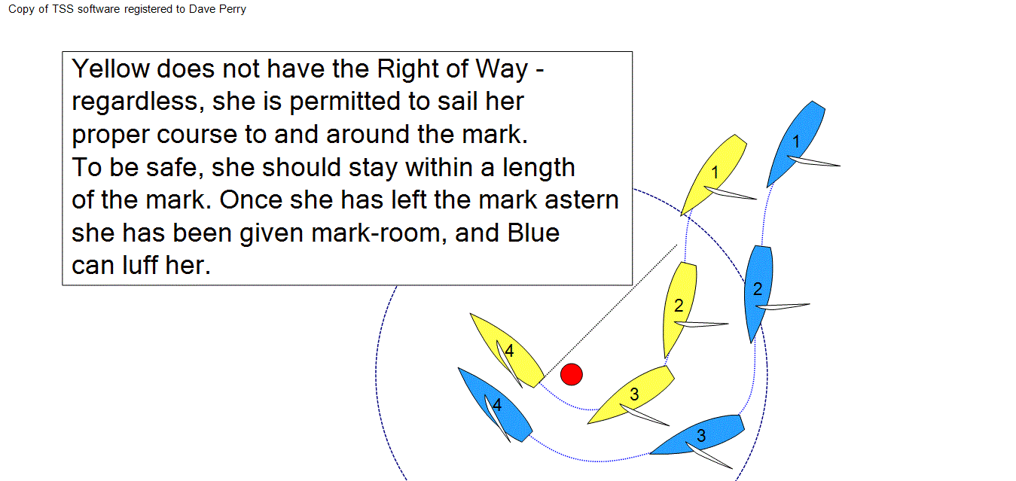

If behind or overlapped on the outside:
- drop your spinnaker early and set up for a better rounding than the leader
- if clear astern, plan to follow the leader around the mark and roll into an immediate tack
- if overlapped on the outside, keep your bow far enough away from the leader’ transom and prepare for a “swing wide/cut close” rounding and roll into an immediate tack (if rounding a single leeward mark).
- An alternative is to keep your bow close on the outside of the leader and then luff her as her stern passes the mark, causing her to tack away onto port tack

If both boats are approaching the leeward mark on port tack

If ahead or overlapped on the inside:
- defend the inside aggressively
- if clear ahead at the zone, you can sail as wide from the mark as you want, as long as any part of your boat stays within the zone. Sailing wide gives you more time to clean-up and allows you to come to close-hauled before arriving at the mark for a “cut close” passing of the mark
- if the trailing boat is overlapping you on the outside while you are in the zone of a single leeward mark, rule C2.9, 18.3(b) requires that you sail no farther from the mark than needed to sail your “proper course” until you gybe. Be careful not to take too much space and risk getting a penalty
- after rounding, have the main trimmer look aft and tell the skipper when the trailing boat tacks. Typically the leading boat tacks simultaneously with the trailing boat (see Exit Thoughts below)

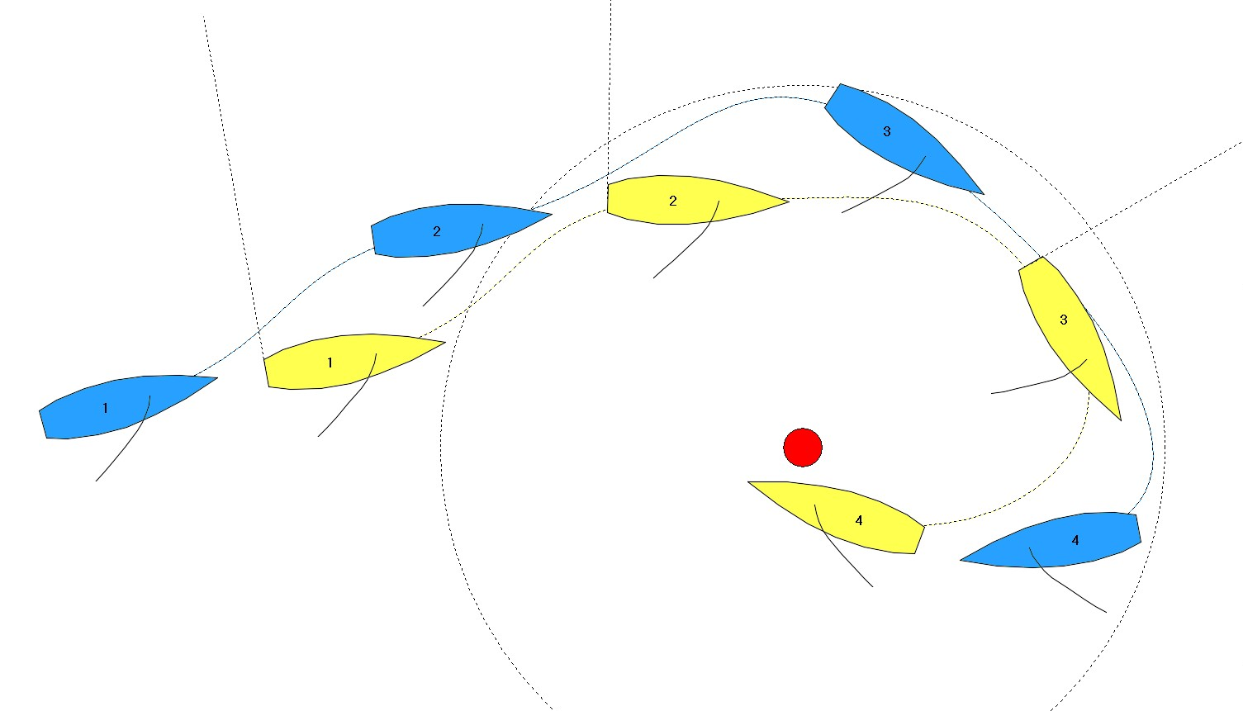

If behind or overlapped on the outside:
- drop your spinnaker early and set up for a better rounding than the leader
- if clear astern, plan to follow the leader around the mark and roll into an immediate tack
- if overlapped on the outside, try to keep the overlap on the inside boat until about a length from the mark and protest her if she takes too much room (wider than her proper course); then widen your course and prepare for a “swing wide/cut close” rounding and roll into an immediate tack (if rounding a single leeward mark).
- An alternative is to keep your bow close on the outside of the leader and then luff her as her stern passes the mark causing her to tack away onto port tack

Exit Thoughts
At a single leeward mark, typically the leader will remain on starboard tack as she exits the rounding, and the trailer will tack as she rounds the mark or shortly thereafter. Usually this is a big advantage for the leader, because when the trailer chooses to tack back to starboard, the leader can tack right on them and force them to tack back when downspeed. The leader then builds speed and tacks back, and gains as a result. Or the leader can simply cross over and take the powerful right-hand side with its starboard-tack advantage.

Occasionally it is better for the leader to tack first
Here are some times when it may be better for the leader to tack first after rounding the leeward mark:

- when the right is heavily favored
- on a shifty day when rounding in a left-hand shift
- when the leg is 80% or more port-tack
- when you have a penalty, as it gives you the starboard advantage up the leg

When the leader should and shouldn’t simo tack with the trailer
- not in light air; it is too easy for the trailer to get their bow out due to the larger tacking angles
- usually in medium air, but it depends on the quality of the rounding, relative speeds of the boats and the water at that moment
- always in heavy air, because the leader usually ends up bow forward due to the narrow tacking angles
- after tacking simo, typically the leader will sail slightly lower and faster than the trailer to get into a safer bow forward position
- if the leader wants the right, and chooses to simo tack, and if the trailer then immediately tacks back to starboard, the leader can simply take the right, or can tack again on the trailer. If the trailer tacks immediately back to port, the leader can sail a “speed build” distance and tack, or can match the third tack. At that point she should take the right.
- If the leader wants the left, she can match the trailer’s first two tacks, but should extend to the left if the trailer tacks a third time (back to port).

