Chapter 6…Penalty Plays

Match Racing has a unique delayed penalty system that makes the game very exciting for sailors, umpires and spectators. Basically, when a boat protests during the race, which includes the pre-start, the umpires make a decision right then and there, which can include giving a boat a penalty. The boat can choose to take the penalty at any time during the race after starting and before finishing. If the other boat gets a penalty later in the race, that penalty cancels the first one. It is not uncommon for one of the boats in the match to be carrying a penalty during the race. Here then are some strategies and tactics each boat can use when one of the boats is carrying a penalty.

OBJECTIVE FOR BOAT WITHOUT THE PENALTY
- if ahead, stay ahead
- if behind, stay about two (2) lengths behind the leader (no closer; no farther away) – called “Play 2”

OBJECTIVE FOR BOAT WITH PENALTY
- get far enough ahead to be able to take the penalty and finish ahead of opponent
- get an off-setting penalty and finish ahead of opponent

Penalty requirements
NOTE: in match racing, legs 1 and 3 are the “Upwind Legs” and legs 2 and 4 are the “Downwind Legs, regardless of the direction of the wind at the time.

- Upwind Leg – must gybe and return to a close-hauled course [rule C7.2(a)(1)]; i.e., about a 270 degree turn
- Downwind Leg – must tack and bear away to a course that is more than 90 degrees from the true wind [rule C7.2(a)(2)], and the head of the spinnaker must be below the gooseneck before the boat passes head-to-wind [rule C7.3(a)]. Note, a “tack” is close-hauled to close-hauled (see MR Call N6).
- No part of the penalty can be taken in the zone of the windward or leeward mark; but it can be in the zone of a finishing mark [rule C7.3(b)]

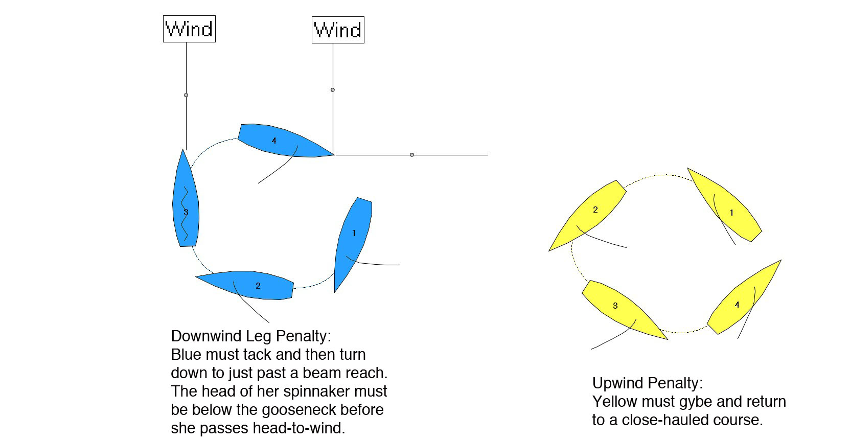

STRATEGY THOUGHTS

General strategy
When you receive a penalty in the pre-start or on leg 1 or 2, forget about it! You need to have the lead in the race before you can deal with your penalty. Race leg 1 and 2 as hard as possible. About a third of the way up leg 3 (second windward leg), start discussing whether you have enough of a lead to take your penalty and still be ahead, or not. Then decide your tactics.

If you have enough lead to take penalty and remain ahead of opponent
- if you do it on an upwind leg (leg 1 or 3)
- you need about a 3-4 length lead (~ 9-12 seconds) to be able to remain ahead of opponent
- gybe when being headed and were planning on tacking, or
- gybe from port to starboard tack onto the starboard layline near the windward mark, so you have the starboard advantage after you complete your penalty

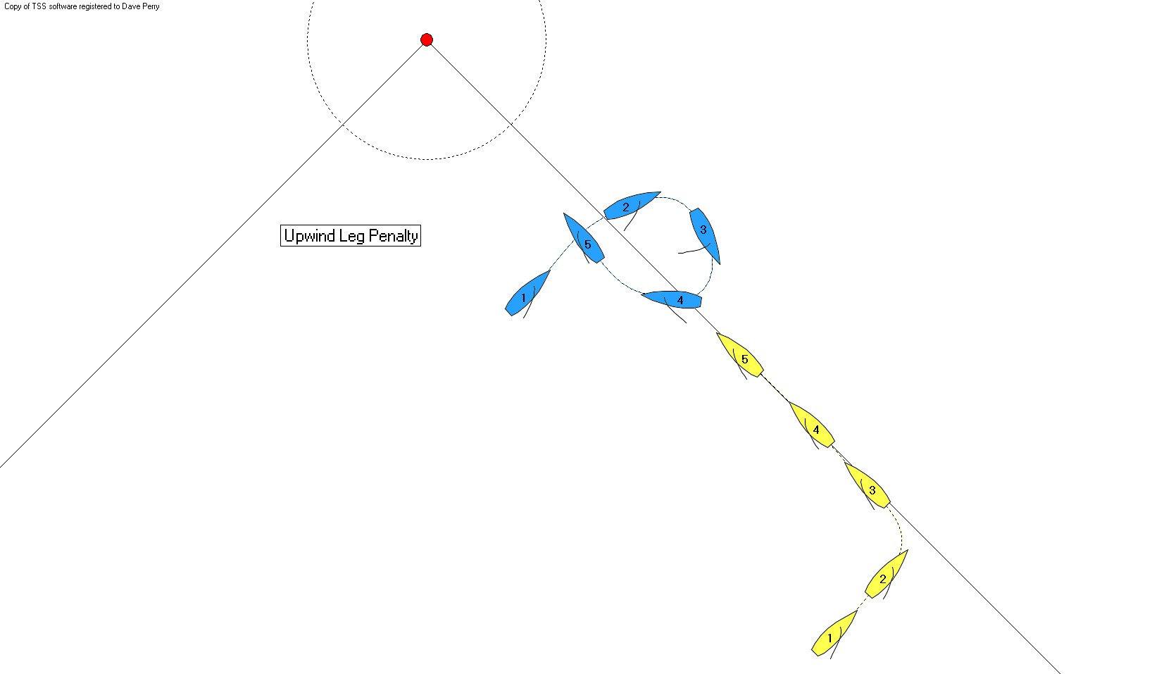

- if you do it on a downwind leg (leg 2 or 4)
- you need about a 4-5 length lead (~ 12-15 seconds) to be able to remain ahead of opponent

- you can do it right after exiting the zone of the windward mark (“10 & Tack”); this gives you the starboard advantage and the entire leg to pass the other boat if they pass you while taking your penalty. To be sure you do not re-enter the zone while taking the penalty, simply start counting as your bow passes the mark, and time it so you are saying “3” when your stern passes it. Then maintain that cadence until you say “10”, and tack around. (See MR Call E9.)
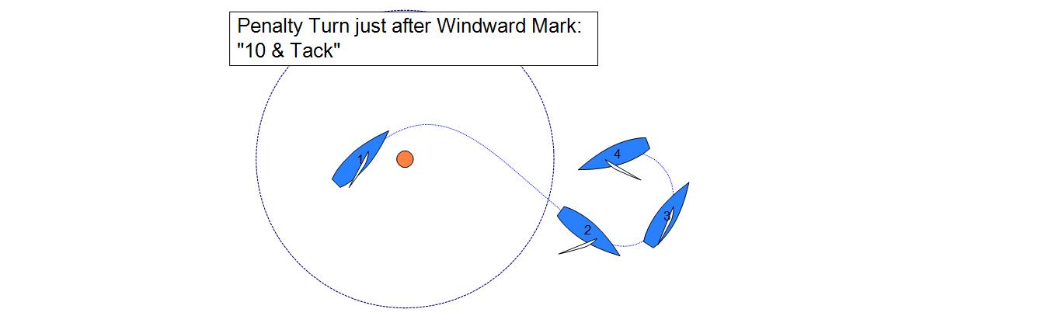

- or you can do it at the finishing line in one of two ways:

- approach the finishing pin mark on starboard tack, and enter the zone aiming about a length to the left of the mark. Drop your spinnaker (be sure the head is below the gooseneck!) and tack just as your bow crosses the finishing line (you don’t “finish” until you cross the finishing line *after* you have completed your penalty). If you are in a boat over 26 feet you might choose to tack around the pin instead. Be sure your entire boat and your sails and spars are on the course side of the finishing line after you are below a beam reach on port tack and before you cross the line. Throughout your turn you are entitled to mark-room under rule 18.2(a)(1), but you are required to keep clear of the other boat until you are below 90 degrees to the true wind under rule 22.2. Once you are below 90 degrees and the umpires have lowered your penalty flag, your opponent needs to continue to give you mark-room but you need to continue turning towards the mark. The safest thing to do is to gybe around the mark.

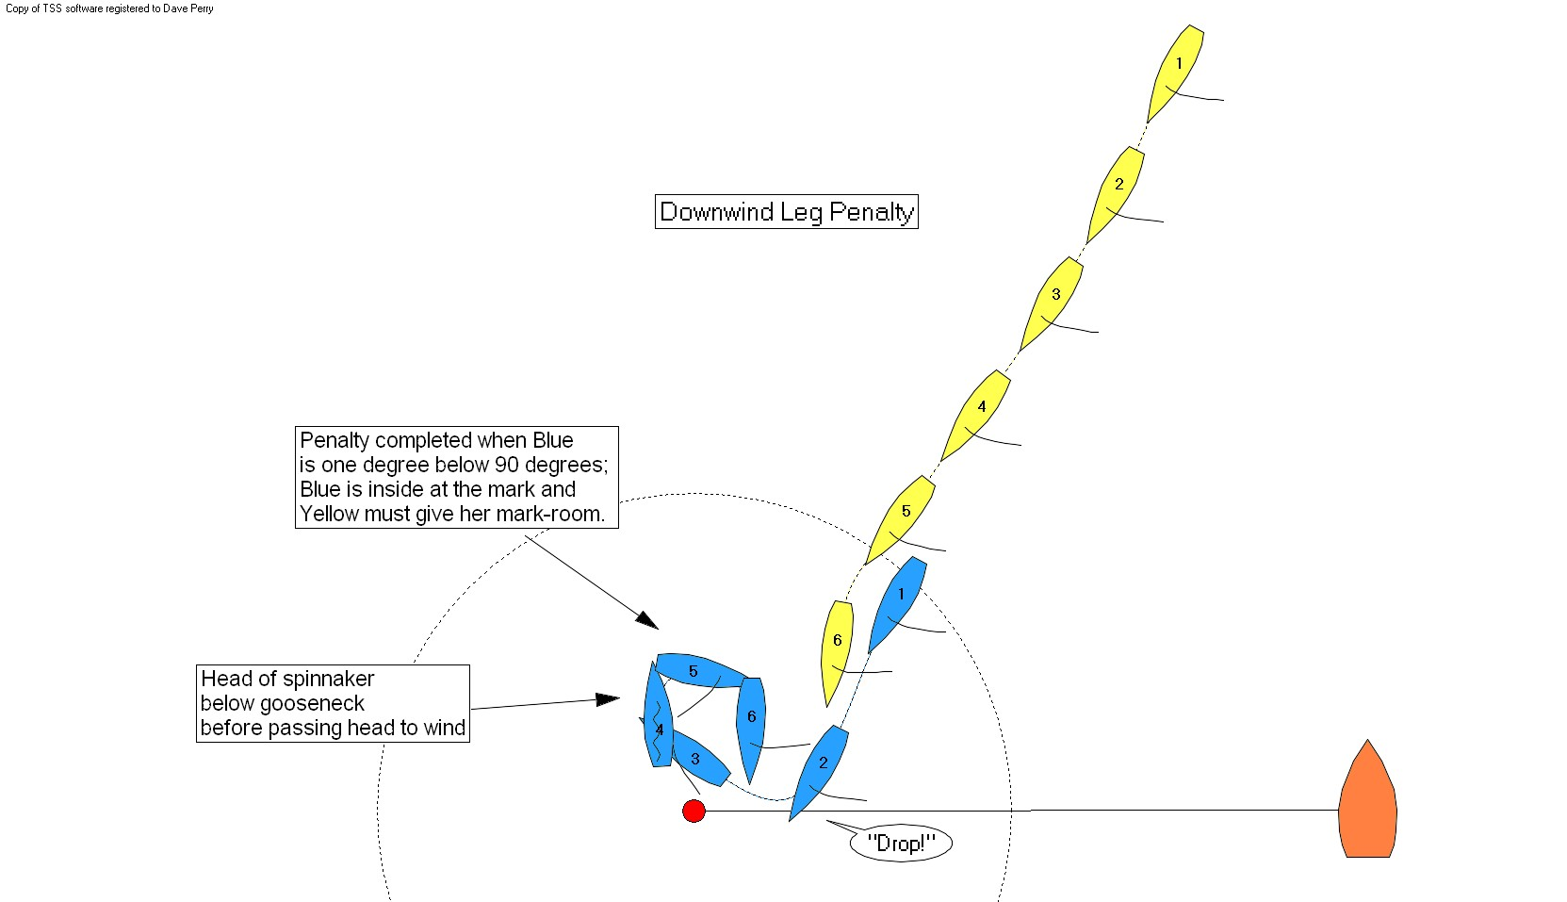
- approach the Committee Boat end on port tack. When about a length from the finishing line, drop your
spinnaker (head below the gooseneck). As your bow crosses the finishing line, tack. Be sure your entire boat and your sails and spars are on the course side of the finishing line after you are below a beam reach on starboard tack and before you cross the line. Once you are past a beam reach and the umpires have lowered your flag, you have the right-of-way as a starboard-tack boat.

Defense for trailing boat
- sail a straight line directly astern of boat taking penalty. While she is in the zone, and even while she is taking her penalty, you need to give her mark-room under rule 18.2(a)(2). If you need to alter course to avoid contact before she gets below a beam reach, she will get a second penalty (rule 22.2); or
- sail fast for the most upwind end of the finishing line and finish ahead of opponent

If you do not have enough lead to take penalty and remain ahead of opponent
Halfway up the second beat (leg 3) make the decision regarding if you have enough lead to take the penalty and remain ahead. If you do not, then decide if you are willing to take your penalty knowing you will end up close behind with the remainder of the race to pass your opponent back. If you do not want to take this risk (and my preference is to not give up the lead), then here are some plays you can try to spin or offset your penalty and remain in the lead (“Spin & Win”).

Pin Past Layline
This works best when the boats are on starboard tack, and the leader (A) is to windward and astern of the trailer (B) such that B cannot tack without fouling. A sails well past the port layline and then gybes (takes her penalty). A needs to be sure she comes all the way up to close-hauled, and sees the umpires lower her penalty flag, before bearing away to the mark.

Coaching Point: A (with the penalty) should set up to B’s right on the leg. The more to windward and astern A can be, the better. B should not let herself get to the left of the leader. If B is on starboard tack and passing astern of the leader, she should tack the moment she can sail in clear air on the windward hip of A.

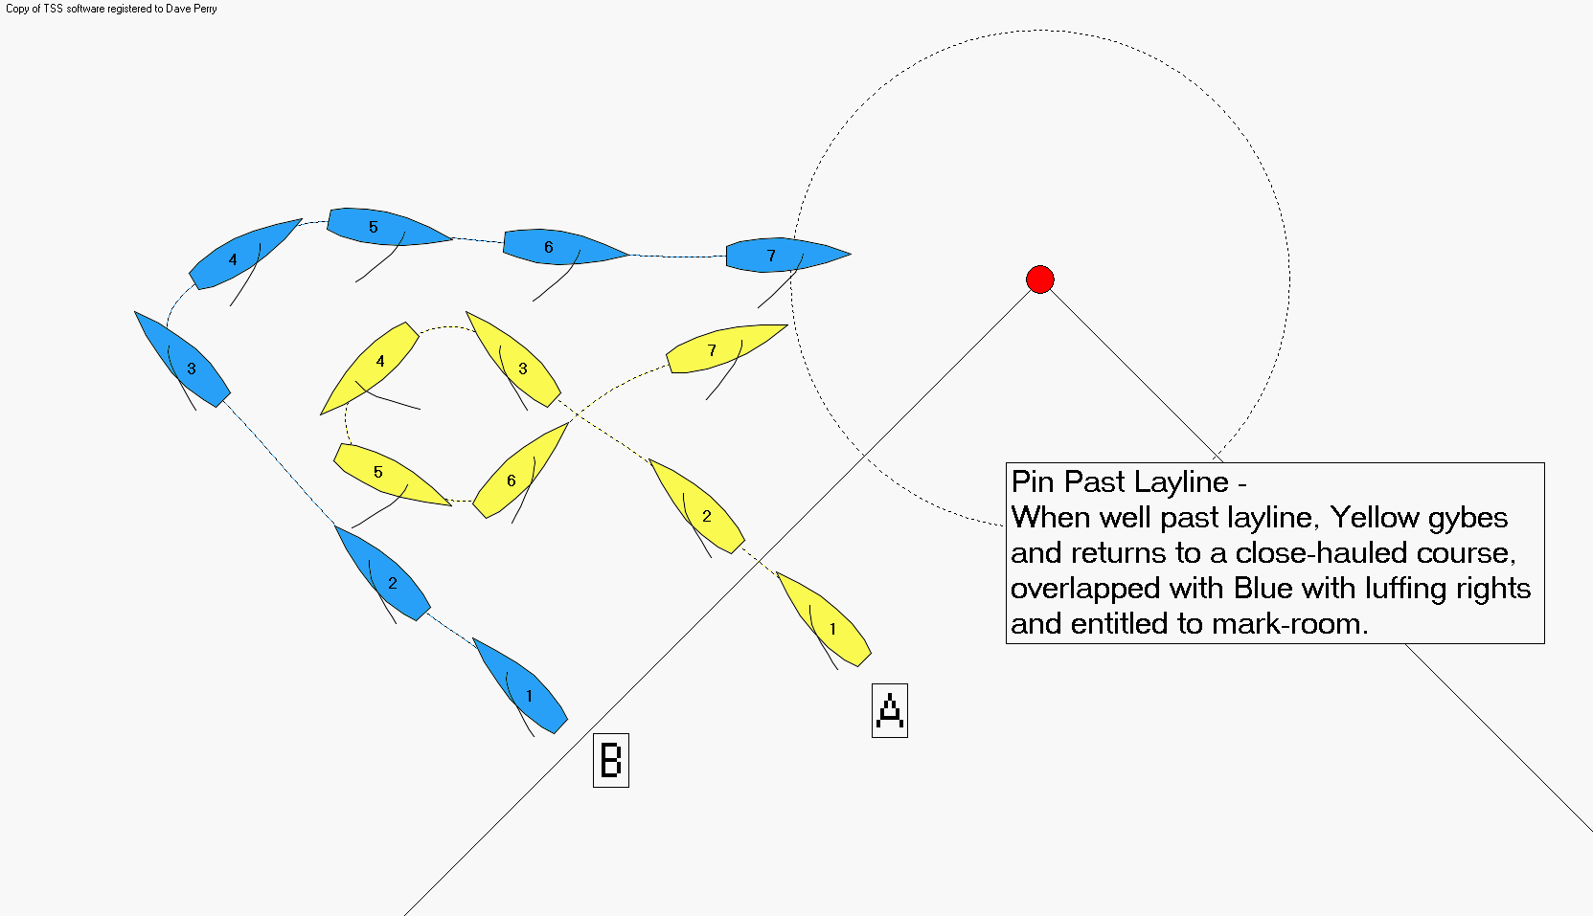

Draw Them In
Once A has decided to not take the penalty, she must then get the boats close. Her goal is to enter the zone of the windward mark with B just a couple of feet astern. From here, if B gets overlapped to windward, A can luff and stop them and maybe get an offsetting penalty. And at least the boats will start the downwind leg with B right behind A in the most vulnerable position.

Coaching Point:
- A should arrive on the layline and then luff her sails allowing B to catch up. The closer B is, the more powerful A is! B should keep two (2) boat lengths back at all times. If A luffs her sails, B does the same and keeps her safe distance back. If B is on A’s stern as A rounds the windward mark, B can widen and delay her turn to drop two (2) boat lengths back.
- Once A’s bow crosses an imaginary line drawn from the leeward mark through the windward mark, she is on leg 2 or 4, and her penalty becomes a tack.

Luff & Spin or Reach & Gybe
As A rounds the windward mark, and provided B is directly behind her, normally A should *not* set her spinnaker! If B does set, it is a great opportunity for A to luff her and get an offsetting penalty. (The one exception is if there is a gap between the boats and the trailer could do a quick set and gybe and pass the leader on the right.)

Plays:
- A should sail low and slow. If B overlaps A to windward, A can luff; and if B over-rotates in response, A can continue into a tack and take her penalty (Luff & Spin). If B overlaps her to leeward, A can gybe and, after giving B room to gybe, luff her in the same way. (see diagram)

- If B is not catching up to A, A can head up to a beam reach. If B stays away, A can gybe and go towards B (Reach & Gybe).
  - If B cannot pass to windward of A, B will have to gybe, putting A into a strong position to leeward on starboard tack.
  - If B luffs to pass A to windward, and if A can do a Dial Up, her tack will clear her penalty (see diagram).
  - If A cannot dial B up, then A has to gybe immediately to keep to B’s left (looking downwind). A then sails low and slow again, waits for B to do the same, and then reaches up on port and the game continues. If when A gybes back to port, B gets locked to windward of her, A can try a Luff & Spin.

Coaching Point:
- A has to really get B close behind her for this to work. B has to really stay back two lengths so it won’t work (“Play 2”). A needs to be sure she stays to B’s left looking downwind to preserve her starboard tack advantage. B should try to get to A’s left, which will give her the starboard advantage and effectively end the race! All of this typically happens with both boats sailing very downspeed.

- Also A needs to be aware of where the starboard layline to the finishing line Pin is. Once B passes that line, she could try to gybe and beat A to the finishing line.

