North U Playbook
Match Race Drills

Solo Work - Pre-start

1) Entry Loop
Start a 5:00 minute countdown.
Sail a figure-8 course passing buoy.
On each minute, “enter”.
Practice entries leaving buoy in both directions.
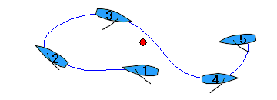

2) Stop & Sit by Buoy
Beam reach towards a buoy.
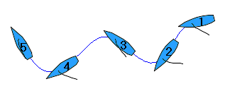
Stop and hold position as close to buoy as possible, for one minute or more.
- to leeward of buoy
- to windward of buoy
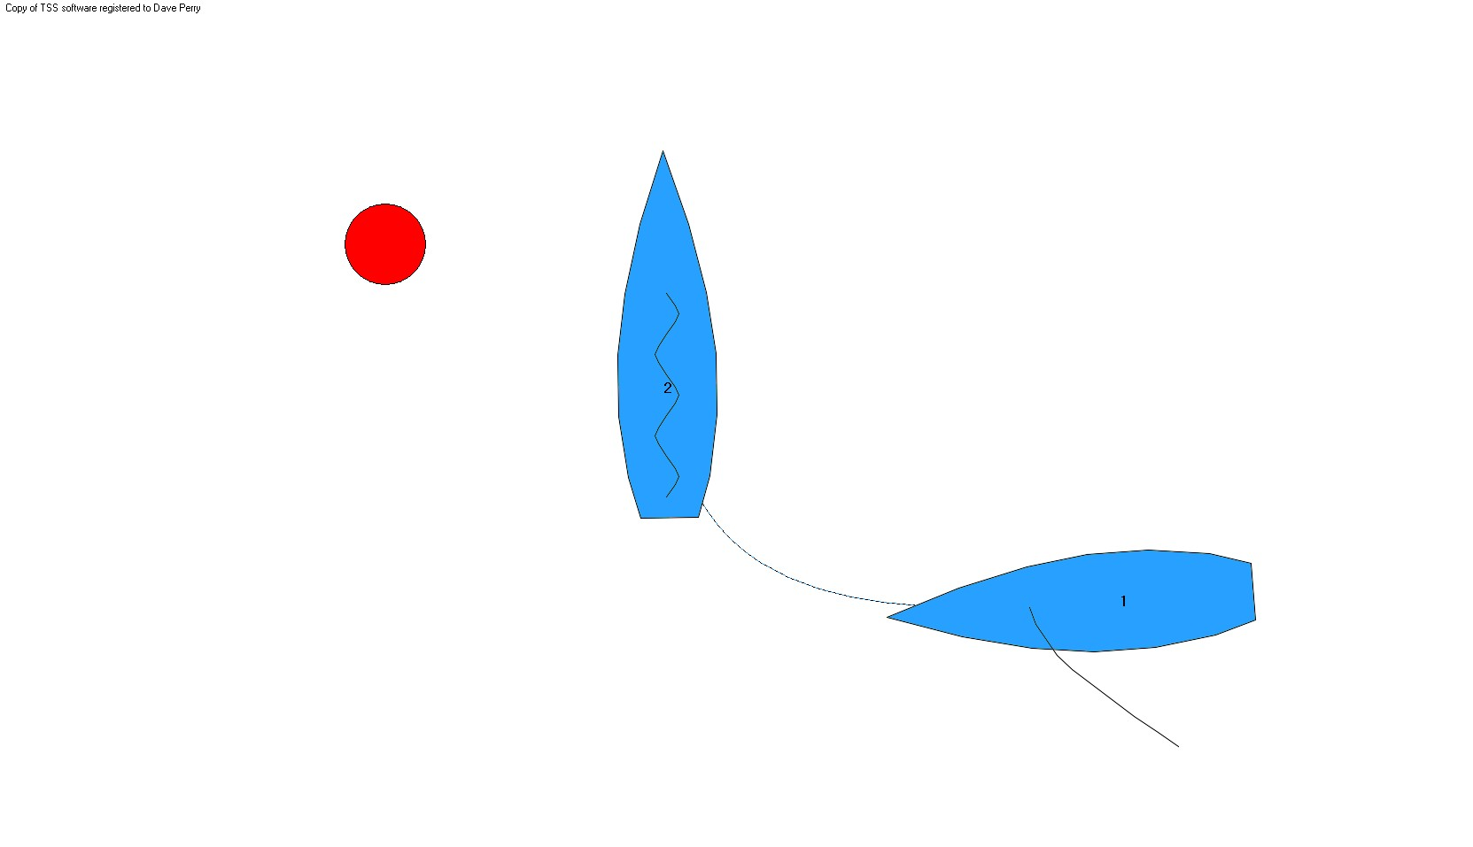
3) Exit Work
Sail head to wind and hold until slow or stopped. Then sail on:
- port tack and accelerate quickly
- starboard tack and tack or gybe as soon as possible
Repeat.
If coming from port tack, bear away to a
close-hauled course on starboard tack,
then luff back up to head to wind.
Can be done with Stop & Sit by Buoy Drill
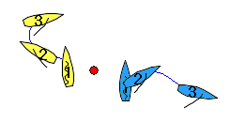

4) Reverse Sailing
Sail head to wind. Begin sailing in reverse. Exit on port or starboard tack.
Repeat.
Can be done with Stop & Sit by Buoy Drill
5) Circling Work
Sail in ovals, both clockwise and counter-clockwise.
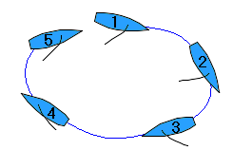

6) Fishtailing Work
On starboard and port tack, do repeated “up” and “down” turns, also slowing and accelerating along the way. Do some with helmsman looking aft the entire time.

7) 2:00 Minute Drills
- sail by buoy on a broad reach and start a 2:00 minute countdown on watch. Do one gybe. Be just to the left of the buoy at full speed at 0:00.
- do (a), but with one or two circles after beginning the 2:00 minute countdown.
- Do (a) or (b), but be just to the right of the buoy at 0:00.
- Do (a), but do one gybe and then one tack, and be just to the left of the buoy on port tack at 0:00.
