North U Playbook
Match Race Drills

PAIRS WORK – Pre-start

1) Dial Up Work
Do Repeated Dial Ups
    - Start watch at 1:00; enter at 0:00
    - After exit, start watch at 1:00; enter at 0:00
    - Switch ends
    - Options:
      - Yellow holds for 30 seconds and tacks to port; Blue follows on port
      - If Yellow forward: Yellow holds for 30 seconds then sails on starboard and tacks as soon as possible; Blue matches
      - If Yellow forward: Blue tacks first and goes below Yellow; Yellow sails on starboard and gybes
      - If Blue forward, Blue sails on starboard and Yellow matches
      - Go in reverse (sailing backwards)

2) Lead/Push (2:00 Drill)
  - Set Up:
    - The two boats reach along the starting line on port tack.
    - When the leading boat nears the Committee Boat or right hand end, the trailing boat counts down to start watches at 2:00 minutes.
    - After passing the Committee Boat, the leading boat sails on a broad reach; the trailing boat stays about two lengths back
    - There is no circling. The leading boat chooses when to turn back for the Final Approach to the line, and the trailing boat chooses whether to Lead or to Push
    - Switch leading and trailing boat and repeat

  - Options:
    - Get best start possible
    - Both try to win the right
    - Both try to win the left (pin favored, if possible)

Note 1: Coach can add a “Turn Back” buoy (a small buoy placed on a broad reach angle about 30-40 seconds from the Committee Boat). If “Turn Back” buoy is in use, the leading boat must gybe around the “Turn Back” buoy for Final Approach (the other boat can decide whether she wants to Lead back or Push)

Note 2: Coach can state the time that the leading boat must gybe and turn back for Final Approach, e.g. 1:20 to start

Note 3: Coach can raise a flag each time a boat crosses the starting line, to give instant feedback on how far from line boat was at start (early or late)
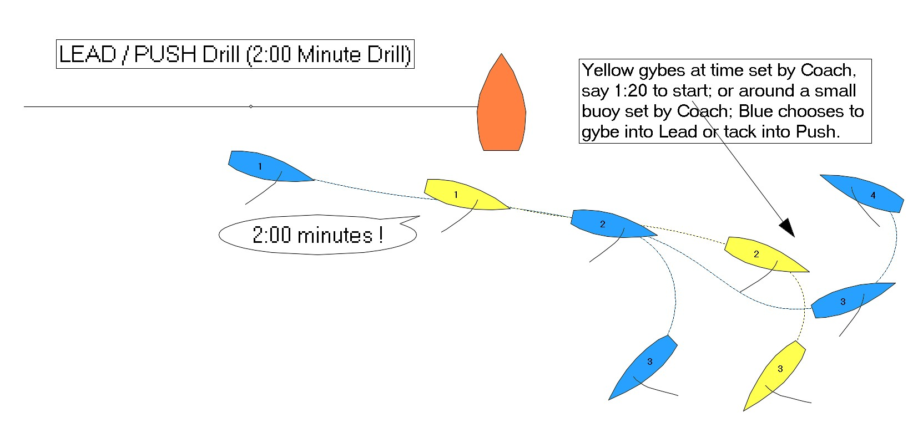

3) Circling / Houdini (3:00 Drill)
  - Set Up:
    - The two boats reach along the starting line on port tack.
    - When the leading boat nears the Committee Boat or right hand end, the trailing boat counts down to start watches at 3:00 minutes.
  - Circling
    - The trailing boat stays about two lengths back
    - The leading boat passes to leeward of the Committee Boat and starts circling
    - Each boat must circle at least once; at the appropriate time whichever boat is leading will gybe and turn back for Final Approach; the other boat will choose to Lead or Push
    - If “Turn Back” buoy is in use, the leading boat must gybe around the “Turn Back” buoy for Final Approach (the other boat can decide whether they want to Lead back or Push)
    - Switch leading and trailing boat

  - Houdini
    - The trailing boat gets right behind the leading boat
    - The leading boat passes to windward of the Committee Boat, goes two lengths (about 5 seconds) and stops (head to wind, main backwinded)
    - The leading boat tries to escape and set up for best start; the trailing boat tries to maintain control and get best start

  - Options:
    - Get best start possible
    - Both try to win the right
    - Both try to win the left (pin favored, if possible)

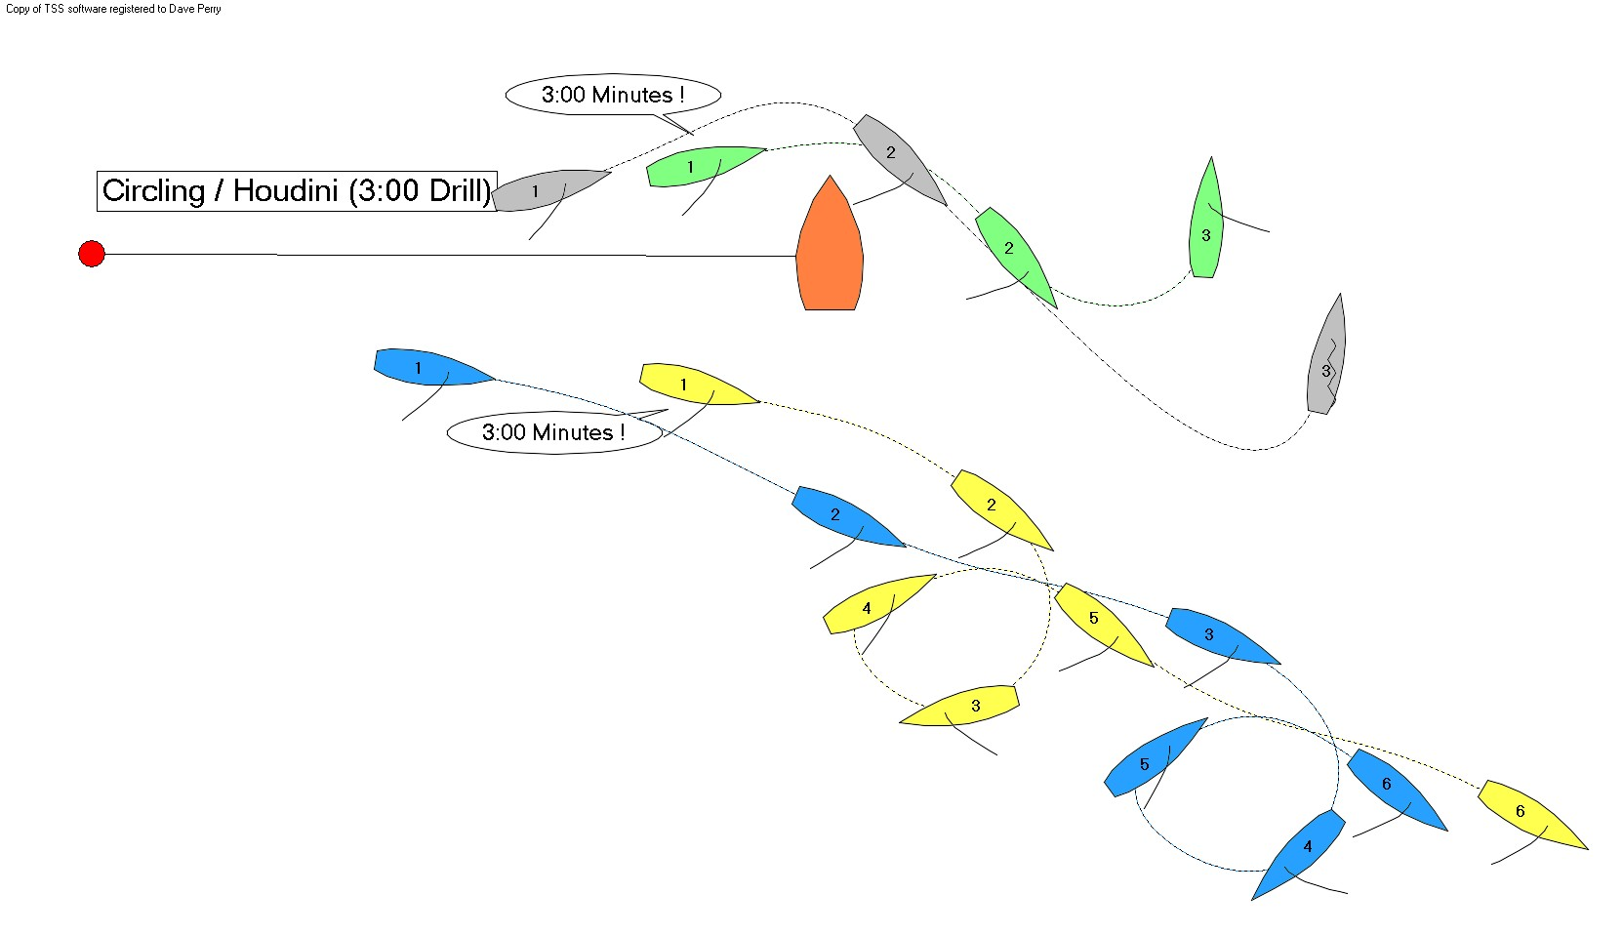
4) Crossing
Set Up:
- Blue and Yellow do normal entry.
- Yellow lets Blue cross either to leeward or to windward.
- Exit drill when Blue escapes or after about 1 minute
- Repeat drill
- Switch ends
- Note: this drill sets up better if Yellow enters late or if one end is favored (further upwind or downwind)

5) Control / Escape
Set Up:
- two boats start beam reaching about a length apart, on either tack
- boat in front’s goal: get onto other tack as quickly as possible
- boat behind’s goal: prevent other boat from getting onto other tack for as long as possible
- change boat ahead and behind

